Shared Values Frameworks, their Narratives and a list of their Values Statements from
INDONESIA East Lombok, December 2019

- Teachers of 3-6 year olds
- Mothers
- Mothers
- Mothers
- Teachers
- Mothers
- Mothers
- Mothers
- Fathers

The Values Statements, the Narratives and their English translations have been jointly worked on by the UK Brighton WeValue Hub team and members of the Indonesian Hub. This is the reference set, approved for sending out to the rest of the Hub by Ibu Risa K.

20191221_WeValue_1_am_Teacher group
As per the numbers in the photo:

- Masyarakat Lotim saling menghargai dan menghormati supaya tidak ada perpecahan antara warga yang satu dg yg lain sehingga tercipta kenyamanan dan kedamaian.
that we have mutual respect and appreciation to prevent disunity and have a calm and peaceful society avoid divergence in order to have a peaceful and convenience life.
- Penting bagi guru untuk pengenalan IPTEK
that teachers are capable to teach science & technology.
- Penting bagi guru untuk mendapatkan pendidikan yg lebih baik dan yang lebih tinggi.
It is important for teachers to have a better and higher education.
- Penting bagi guru untuk pengenalan budaya dg cara bermain peran.
That teachers to introduce culture through role-play.
- Penting bagi guru untuk menanamkan sikap gotong royong.
That teachers to instil an attitude of mutual cooperation..
- Penting bagi kami para guru untuk mengenalkan sopan santun dalam berinteraksi/berbicara.
teachers introduce good manners through example.
- Penting bagi guru untuk mendapatkan pendapatan yang sesuai.
that teachers to get appropriate income.
- Penting bagi seorang guru untuk memiliki latar belakang menjadi seorang guru.
- that teachers have formal pedagogic trainig. Menerapkan sikap disiplin yang tidak hanya kepada anak, tapi diterapkan dulu pada diri kita sebagai guru.
Teachers show self-discipline themselves before teaching the children.Applying the attitude of discipline not only to children, but first applied to ourselves as teachers.
- Masyarakat Lombok Timur selalu menjunjung tinggi nilai agama dari segala aspek kehidupan bermasyarakat.
we always uphold the religious values of all aspects of social life.
- Penting bagi saya untuk tetap mengajarkan nilai agama meskipun tidak ada di kurikulum.
It is important for me to emphasize religious values even though they are not clearly stated in the curriculum.
- Penting untuk guru untuk melihat wajah anak-anak yang ceria.
for teachers to see the cheerful faces of the children.
- Penting bagi seorang guru untuk kebahagiaan, keceriaan. Itu selalu bisa kita lihat saat datang ke sekolah.
for teachers to look happy and cheerful whenever we come to school.
- Penting untuk memberikan dampak positif kepada anak sampai akhir hayat.
for teachers to think about their life-long impact on the children’s lives.
- Peran orang tua dan guru sangat penting dalam membimbing anak.
Both parents and teachers should take their roleto guide children seriously
- (extra, no number on the list, located on the top of number 8 on the framework)
Penting bagi guru untuk berjuang dalam mencapai cita-citanya.
that teachers to make a great effort in achieving their dreams.

Narrative | Recording Info: 191221_WeValue_1_AM_Teacher group_R1_PE+TLD+VFC 02:17:00

Because they the teachers have the purpose of having a peaceful life by showing respect so they need to start with having a discipline and very good moral and the religious view and collaborative work, and every teacher should make sure that they do their continuous professional development learning and by having the supports coming from the parents as well. They believe the goal will be achieved by creating a very cheerful environment among the teachers and kids by showing happy faces. The teachers need to have the ability of ICT and proper higher education background and it’s important that they (the teacher) to introduce the culture by doing the role play, mutual cooperation and collaborative work.

91221_WeValue_2_PM_Mother group
Top to the bottom, left to the right arrangement.

- Kita dapat memberikan pengalaman dengan baik.
mothers provide the best life -experience that we can for the children
- Pentingnya gotong royong karena sangat membantu bagi tetangga dan bermasyarakat.
that mutual cooperation is considered a foundation for neighbours and society.
- Pergi liburan untuk anak biar dia tidak bosan di rumah.
We go on holiday so our children are refreshed.
- Keluarga sangat penting bagi kami karena keluarga juga adalah salah satu penyemangat, motivasi dalam kehidupan.
That family is highly valued because it is the source of encouragement and motivation in life.
- Kita harus menjaga kesehatannya dengan cara memasak sayur-sayuran yang kita mampu.
mothers maintain children’s health by cooking vegetables that they can afford
- Walaupun ada masalah kita harus tetap menjaga kerukunan karena tanpa keluarga kita tidak bisa hidup.
Even during hard-ship we must maintain family bonds as we cannot live without family.
- Utuhnya keluarga untuk masa depan anak-anak.
try to keep the family together for the sake of the children, even in difficulties.
- Sekolah penting untuk anak-anak bagi agama, nusa dan bangsa juga untuk masa depan anak-anak.
School is regarded as a foundation for the future development of religion, homeland and nation.
- Kita perlu saling menghargai karena yang terpenting dalam masyarakat adalah akhlak dan nada bicara harus sopan kepada yang lebih tua, sederajat maupun yang lebih kecil.

- We need to interact respectfully with each other, older and younger, and be mindful of tone of speech;
- Mempertahankan diri dalam keadaan sulit atau musibah.
That rotect ourselves in difficult or disastrous circumstances, for the family
- Mengenal huruf membaca al Qur’an.
that the children know the (Arabic) letters (in order to be able to) read the Qur'an.
- Menghormati orang tua yang lebih baik.
We respect elderly people.
- Kebahagiaan anak sangat penting.
We value our children and do not neglect them.
- Adanya pengorbanan seorang Ibu untuk anaknya.
A mother makes sacrifices for her child.

Narrative | Recording Info: 191221_WeValue_2_PM_Mother group_R1_VFC+PEX 00:12:00

The foundation is that a mother should be able to sacrifice her life for her kids and the mother would like to have a kid who is useful for her environment. Also, happiness is the most important to kids and the ability to survive is the heart of everything because we need to struggle so the mothers need to support the kids.
The kids’ happiness comes from the good conditions of living, the education and the home. For the family side, whatever happened we need to be able to be united as a whole family , we need to have the (sense of) forgiveness for the sake of the children. For compassion showing by the parents, they need to get close emotionally especially between mother and kids. We need to be able to introduce the collaborative work to the kids so they can later have a good environment when we may not be able to fight for them on our own then the society will help the kids.
At the very end, we can give a very good care to our kids by doing all these.

191222_WeValue_3_AM_Mother group
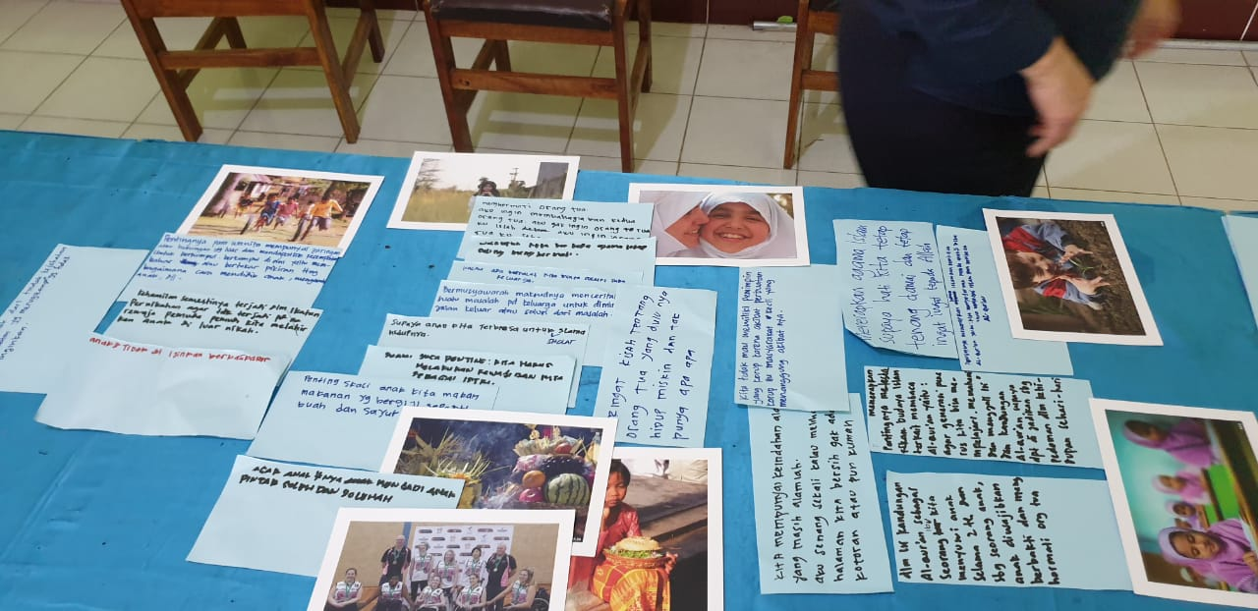
Top to the bottom, left to the right arrangement
- Melindungi anak dari tindak kejahatan atau perbuatan yang merugikan yang tidak kita inginkan
Protect children from crime or harmful actions that we do not want.
- Pentingnya para wanita mempunyai jaringan atau hubungan yang luas dan mendapatkan kesempatan untuk berkumpul. Berkumpul di sini yaitu membahas atau bertukar pikiran tentang bagaimana cara mendidik, mengasuh anak, dll
It is important for women having extensive networks or relationships or community to get opportunities to gather. Gather here is to discuss or exchange ideas about how to educate, nurture children, etc.
that women have extensive networks or relationships or community for opportunities to gather: to discuss or exchange ideas about how to educate, nurture children, etc.
- Kehamilan semestinya terjadi dalam ikatan pernikahan agar tidak terjadi pada remaja / pemuda pemudi kita melahirkan anak di luar nikah
Pregnancy should be within a marriage bond. She hopes for teenagers / young women are not giving birth before marriage
Pregnancy should be within a marriage bond, especially for teenagers and young women.
- Anak-anak tidak diijinkan berkata kasar
Children are not permitted to speak harshly.
- Menghormati orangtua. Aku ingin membahagiakan kedua oarangtua. Aku gak ingin orangtua ku lelah.
Respect parents. I want to make my parents happy. I don't want my parents to be tired.
- Walaupun berbeda agama tetap saling menghormati
different religions still respect each other.
- Kalau ada masalah kita minta solusi pada keluarga
If there is a problem we automatically turn to the family for advice and support
- Bermusyawarah maksudnya menceritakan suatu masalah pada keluarga untuk diminta jalan keluar atau solusi dari masalah
Musyawarah - Consultation means telling a problem to the family to be asked for a way out or a solution to the problem We use collective decision-making in the family when we have a problem.
- Supaya anak kita terbiasa untuk sholat selama hidupnya
So that our children are accustomed / used to praying throughout their lives
That we develop and instil the habit of praying in our children, for their whole life
- Suami juga penting : kita harus melakukan kewajiban sebagai istri
Husband is also important: we must do our duty as a wife.
- Penting sekali anak kita makan makanan yag bergizi seperti buah dan sayur
that our children eat nutritious foods such as fruits and vegetables.
- Agar anak-anak menjadi anak yang pintar soleh dan solehah
that the children become smart and develop good religious character
- Teringat kisah orangtua yang dulunya hidup miskin dan tidak punya apa-apa
Remember the story of parents who used to live in poverty and have nothing.
- Kita mempunya keindahan alam yang masih alamiah. Senang sekali kalua melihat halaman kita bersih dan tidak ada kotoran / kuman
We have a beautiful natural environment that is still natural.
It's nice to see clean and tidy yards.
- Kita tidak memiliki pemimpin yang korup karena akibat perbuatan korup itu masyarakat kecil yang menanggung akibatnya
to not have a corrupt leader because the poor or community who will bear the consequences
- Dalam isi kandungan Al-Quran sebagai seorang ibu kita menyusui anak selama 2 th dan sebagai seorang anak diwajibkan berbakti dan menghormati orangtua
that a mother should breastfeed the child for 2 years (The Quran states this). That children really do serve and respect parents (years (The Quran states this).
- Menerapkan pentingnya melestarikan budaya Islam terkait membaca Al Quran yaitu agar generasi penerus kita bias mempelajari, memahami dan menggali isi dan kandungan Al Quran supaya dapat dijadikan sebagai pedoman dalam kehidupan sehari-hari
We emphasize preserving (Lombok) Islamic culture, particularly in reading the Quran, so that our next generation will understand meaning of the Quran so that it can be used as a guide in everyday life.
- Pentingnya menerapkan ajaran Islam dan membaca Al Quran yaitu : kita mengajarkan pada anak-anak untuk memahami Islam dan membaca Al Quran
: we thoroughly teach children to read the Quran and practice Islam, and embed this in their lives.
- Menerapkan agama islam supaya hati kita tetap tenang damai dan tetap ingat kepada Allah
practice Islam to keep our hearts at peace and to remember God.

Narrative | Recording Info: 191222_WeValue_3_AM_Mother group_R1_PE+TLD+VFC 1:21:43

(Rita summarized for the ptpts and they can add if they have opinions)
So practice of the Islam is the foundation by introducing it to the children, the way to practice is by recite the Quran and do praying.
What we want in the process is all activities are not against the Quran, we will life healthily by taking care of the environment and we also respect each other (among mothers), the husband and also children. Without forgetting that our environment should be healthy and clean, and have the women community where kids are engaged with the mothers.
So the one we are going to achieve is the healthy mother as well as the children, so for all the things we are going to achieve is our children can be protected.

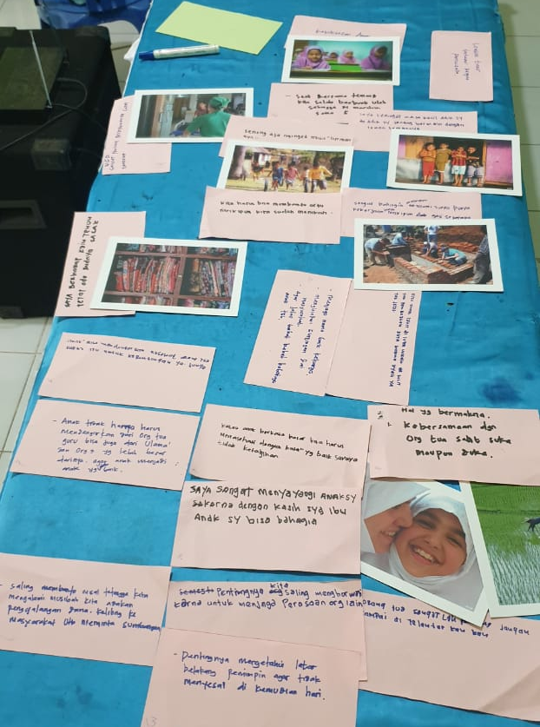
191222_WeValue_4_PM_Mother group
Top to the bottom, left to the right arrangement
- Kesuksesan anak
Children have successful lives.
- Lombok Timur banyak tempat pariwisata
East Lombok has many places of natural beauty for recreation .
- UGD, sangat senang pelayanan cepat dan sigap
That our emergency services are quick and good services.
- Saat bersama teman, kita selalu berbuat salah dan dimarahi guru
That it is OK for children to make mistakes at school.

- Saya teringat masa kecil saat saya bermain bersama teman teman
children have friends to play with.
- Senang saja mengingatkan masa bermain dulu
that children have time to play
- Kita harus bisa membantu ortu walaupun kita sudah menikah
We help parents even though we are married
- Sangat bahagia dengan suami saya apapun pekerjaannya dan gaji tidak seberapa
That I am very happy with my husband whatever his job and even though his salary is not much
- Sangat berharap kain tenun tetap ada budaya Sasak
that traditional hand weaving will remain in Sasak culture
- Tidak memiliki anak di luar nikah agar anak memiliki akta kelahiran dan ayah yang jelas
To not have children out of marriage so that they have a birth certificate and identified father
- Menjaga nama baik keluarga, menghindari gunjingan dari masyrakat, agar jelas bebet bibit bobotnya anak tersebut
To not have children out of marriage , to maintain the good name of the family, and avoid gossip from the community, so that the line of descent of the child is clear
- Anak tidak hanya harus mendengar dari orangtua, guru bias juga dari ulama dan orang orang yang lebih besar darinya agar anak menjadi anak yang baik
Children don’t accept advice only from parents and teachers but also from religious leaders and elders .
- Kalau ada berkata kasar, ibu harus menasehati dengan kata-kata yang baik
If the child speaks with harsh words, the mother must advise with good words.
- Saya sangat menyanyangi anak saya karena dengan kasih sayang ibu, anak saya bias bahagia
I love my son very much because mother’s love will make the bond stronger..
- Hal yang bermakna kebersamaan bersama orangtua saat suka maupun duka
to be together with, and support, parents during happy or sad times.
- Saling membantu misal tetangga kita mengalami musibah kita adakan pengggalangan dana, keliling ke masyarakat untuk meminta sumbangan
We help our neighbours during difficult times, and go around the community to solicit donations
- Pentingnya kita saling menghormati untuk menjaga perasaan orang lain
to have mutual respect in order to be aware of each other’s feelings
- Orangtua sangatlah penting, jangan sampai ditelantarkan
parents are considered very important, and not neglected
- Pentingnya mengetahui latar belakang pemimpin agar tidak menyesal di kemudian hari
to know the background of the leader, before we regret later.

Narrative | Recording Info: 191222_WeValue_4_PM_Mother group_R1_PE+TLD+VFC 1:27:07

The first, we need to check the background of the leader and (it’s important) not the corrupt one. We need to help each other when in trouble and the others are the same. About mother’s compassion to the children by giving advice, kids also need to listen to parents’ advice for their own future. If they don’t listen to parents’ advice, there will be possibility pre-marital pregnancy happened, which will affect so much to the family. The affect is going to be ruining the good name, honor and family dignity. When the children were born outside the marriage, she or he will have many difficulties like getting birth certificate, hard time when registering to school or family linkage (to the father) due to the unclear identity. We need to take care the parents and save money from our income to be given to the parents. The reminiscent of the childhood time and school time are also important to them. It means a lot to them, sometimes they missed the family and the bothers and sisters.

The final goal is the success of our children, all the parents want their children to be successful. The East Lombok society wants the culture of the weaving to continue.

For the health care, they want the doctors and nurses in the hospitals can give quick response and good service.

191224_WeValue_5_AM_Teacher group
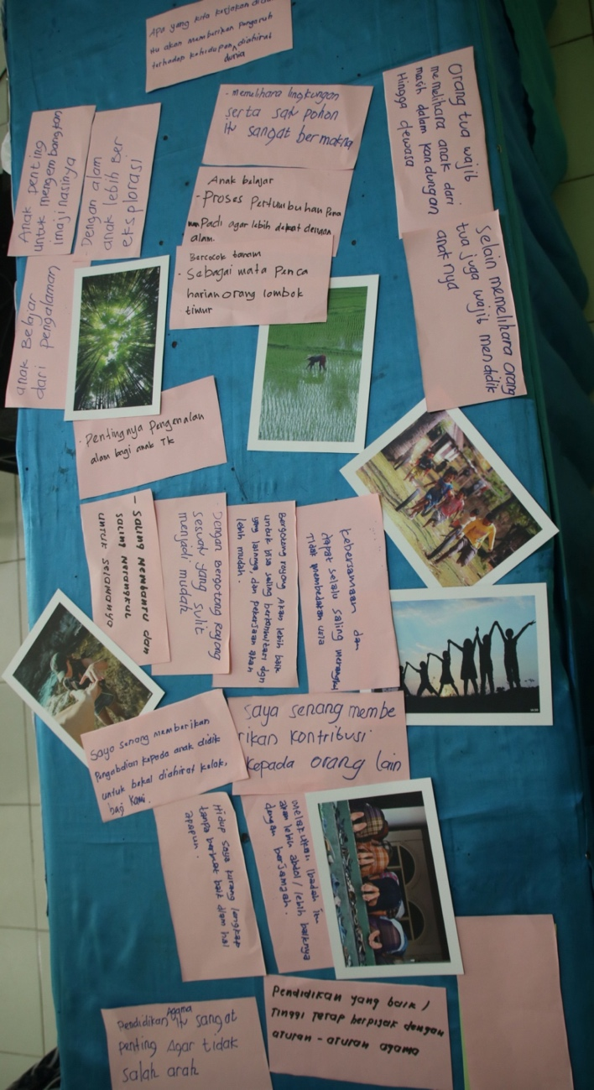
(Top to Bottom, Left to Right)
- whatever we do in this world will affect our life in this world and the next world.
- children can develop their imagination
- children have more opportunities to explore nature
- we actively preserve the environment
- children learn about the growing of rice so they can be closer to nature
- agriculture is a way of living in East Lombok
- parents take good care of their children from pregnancy to adulthood
- everyone takes care of parents as well their children
- we introduce nature to children at an early age
- help each other and draw close to each other.
- Have many opportunities to collaboratively consult and advise each other, so tasks or duties can be easier
- We draw together and have togetherness despite any differences
- We give devotion to children for our good afterlife
- we contribute to the fabric of community life
- my life is not complete without doing good deeds for other people
- I value religious education to help me stay on the right path
- That higher education is based on religious principles.

Narrative | Recording Info: 191224_WeValue_5_AM_Teacher group_R1_PE+TLD+VFC 1:04:20
With the religion as our foundation, the religion education is very important so we are not going to the wrong way, so we follow the religion. So from the foundation, we can do some worship together and we feel incomplete without doing something good in our life. So to achieve our goals, we need to devote ourselves for our students and then contribute to others. By giving contribution we can do many things, by doing thing together hand-in-hand with others, we are not going to see the difference we have rather than doing something together so we can make some consultation. As a teacher, we need to be able to introduce the nature to our kids, as a way of the whole process, they can create their imagination and explore and so they could preserve their environment so that they will be able to take care their environment and preserve that. We also need to work together with the parents because parents have the obligation to educate and nurture the kids since the day they were born up to grown up, so we as teachers we perform as parents at schools, so we make sure we give them support, we are not only performing as teachers at schools but also parents. So in doing such a way, our goal that what we do in the world is actually giving something good in the hereafter.

191224_WeValue_6_PM_Mother group

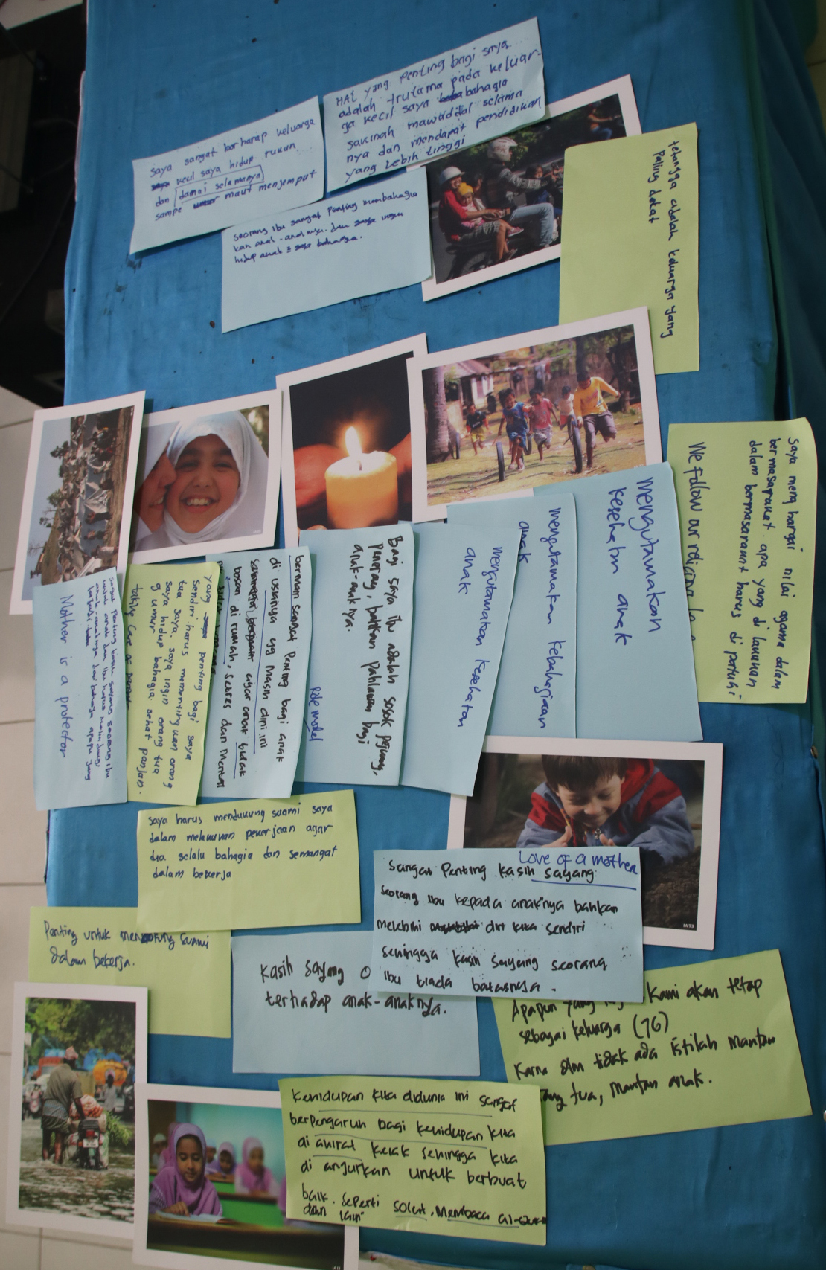
(Top to Bottom, Left to Right)

- My family is strongly united ad peaceful.
- My family is blessed and has a higher education
- my children to have joy in their life
- My neighbour is like my closest family
- Mothers protect their children from any dangers.
- I can take care of my parents, and theyhave long and happy life.
- Young children need to play so they don't get bored, distressed, or mentally disturbed.
- The Mother is a fighter, light bringer, even hero for her children
- Mothers Prioritize the child's health
- Mothers Prioritize the child's education
- people respect religion and society’s values, and obey social rules.
- I support and motivate my husband so he is always happy in doing his job
- A mother loves her children more than herself.
- Love of parents to their children is highly valued by society.
- we are a family, no matter what happens. There's no thing as ex-parents or ex-children.
- our life in this world affects our life in hereafter, so we need to do good deeds like prayers, and reciting Quran.

Narrative | Recording Info: 191224_WeValue_6_PM_Mother group_R1_PE+TLD+VFC 00:52:40
For foundation, the love of the parents to the kids is eternal and whatever happened we are going to be a family and stay strong because we don’t have any ex-parents or ex-children, so even when some difficulties happened, inside the family, we need the support coming from the husband. Because fathers, they struggle a lot, we as wife need to support the husband to achieve our goal, so we need to work hand-in-hand between husband and wife. (another ptpts came in and continue with the process) So the process to achieve our goal is important, we need to appreciate the religious value in the community, we follow our religious leaders. For me, a mother is a fighter even a hero to the kids so the mother is the role model of the kids and so that they could feel happy. A mother is important for the kids, and it’s important to have a very happy family and peaceful life.

East Lombok Shared Values 25 December 2019

- K Kebersamaan dalam keluarga dan lingkungan
We have togetherness in my family and community.
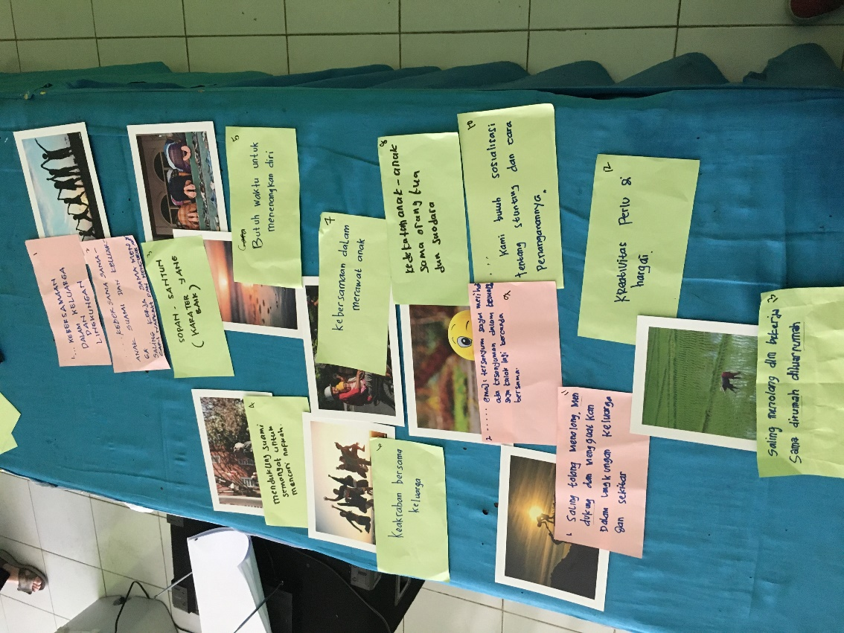
- Kebersamaan sama anak, suami dan keluarga. Saling kerja sama mencari nafkah dan mengurus anak
We have togetherness with my children, husband and relatives. Working together to earn money and take care of our children.
- Sopan-santun (karakter yang baik)
Well mannered (Good character and manners are valued.
- Mendukung suami untuk semangat mencari nafkah
Give moral support to my husband to keep up his spirit in earning money
- Butuh waktu untuk menenangkan diri
I take time and opportunities to calm down
- Keakraban bersama keluarga
I have an intimate relationship with my family and extended family members.
- Kebersamaan dalam merawat anak
All the family support each other in taking care of children.
- Kedekatan anak-anak sama orang tua dan saudara
To have closeness among children, parents and siblings.
- Emoji tersenyum saya melihat senyuman dalam keluarga saya kalau lagi bercanda bersama
that my family has fun together
- Kami butuh sosialisasi tentang stunting dan cara penanganannya
We need more disseminated information about stunting and how to prevent it
- Saling tolong-menolong, mendukung dan menguatkan dalam lingkungan keluarga dan sekitar
That we Help, support and empower each other in my family and community
- Kreativitas perlu dihargai
Creativity is valued
- Saling menolong dalam bekerja sama di rumah di luar rumah
That we Help each other in the home and communty wherever possible

Narrative | Recording Info: 191225_WeValue_7_AM_Mother group_R1_PE+TLD+VFC 01:38:25
The goal is the togetherness in family and environment (wider society). When the mothers are doing good with the kids and the husbands, there is a good collaboration in family. After the kids are able to collaborate, then we teach them manners as they are expected to have good characters. The wife needs to support the husband to earn a living to support the family. Sometimes the wives need to have some time alone out of routines (me time) to calm down. Next, togetherness and the close relationship in family, between parents and children, so we have to build up closeness and connection so children can express their feelings to parents. The obligation of the fathers is not only to provide the living but also have to help to take care of the children, this is how he makes a contribution to the family. It is the kids’ right to have fun in the family, togetherness in the family. The nutrition provided by the parents is based on the need of the children. We have to know what is important nutrition for our children. We have to appreciate the children’s activities so they have confidence in the society. In the neighbourhood, the children will help each other. Then the children will be able to help each other without someone asking or telling them to do so.

#8

- Supaya anak kita menjadi anak yang berguna bagi nusa, bangsa dan agama
My children can contribute to the people, nation and religion.
- Harapan saya, saya ingin anak saya mendapatkan pendidikan yang tinggi
that my children achieve a higher education than I did.
- Saya ingin anak-anak senang, keluarga senang, itu udah bisa buat ku bahagia
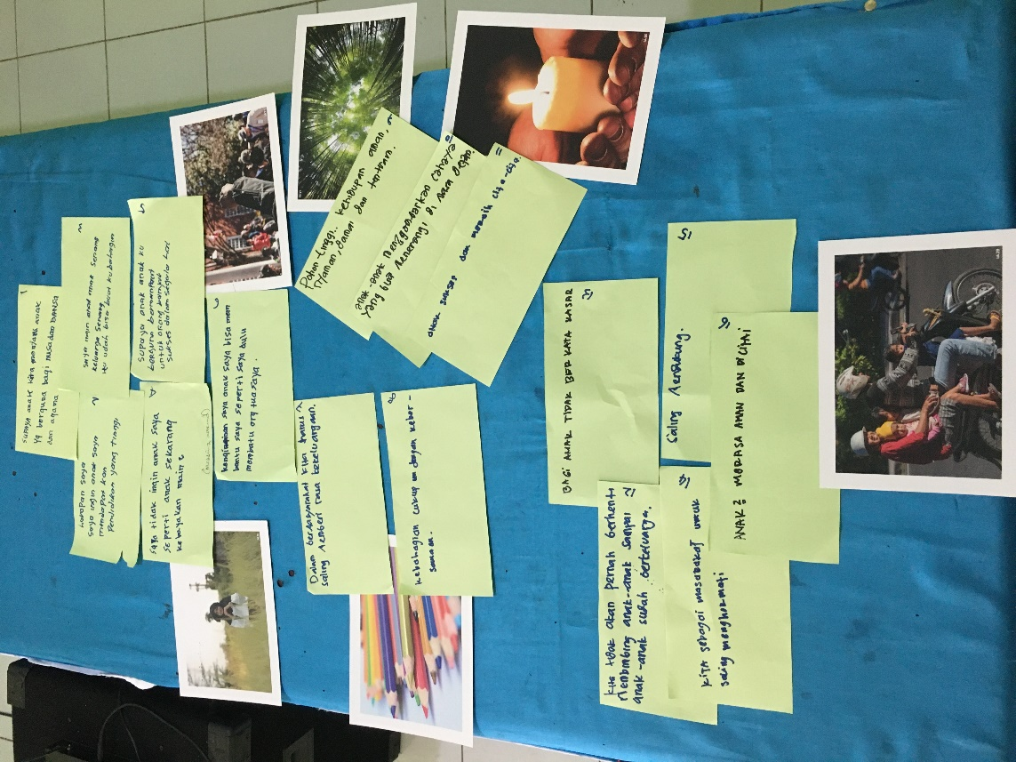
my children and family have joy in life: that’s my joy.
- Saya tidak ingin anak saya seperti anak sekarang kebanyakan main-main
my children do not mess around with useless activities.
- Supaya anak-anak ku berguna bermanfaat untuk orang banyak sukses dalam segala hal
That My children can be worthwhile to our society, successful in many aspects.
- Keinginan saya anak saya bisa membantu saya seperti saya dulu membantu orang tua saya
my children can help me like what I did to my parents.
- Dalam bermasyarakat kita harus saling memberi rasa kekeluargaan
that we have the sense of kinship throughout our society
- Kebahagiaan cukup dengan kebersamaan
We have togetherness as mothers.
- Pohon tinggi… kehidupan aman, nyaman, damai dan tentram
That we have Nature: a tree represents peace and calm in life.
- Anak-anak menggambarkan cahaya yang menerangi di masa depan
Children represent the lights that will shine in the future
- Anak sukses dan meraih cita-cita
Children become successful and their dreams come true
- Kita tidak akan pernah berhenti membimbing anak-anak sampai anak-anak sudah berkeluarga
We never stop guiding our children even after they get married.
- Bagi anak tidak berkata kasar
Children don’t speak harsh words.
- Kita sebagai masyarakat untuk saling menghormati
Everyone is respectful to each other in our society.
- Saling mendukung
Everyone in our society supports each other
- Anak-anak merasa aman dan dicintai
Children feel safe and loved

Narrative | Recording Info 191225_WeValue_8_PM_Mother group_R1_PE+TLD+VFC 01:08:50
Nowadays we want children to have good manners and say no harsh words, we don’t allow them to have harsh words. To have good manner and be polite. (few discussion came in) As parents, we have to support the children to have good behaviours, polite and good manners. The basic is from the parents, so the children can be better. (MKH: is it foundation or goal? Ptpts: Foundation.) (One statement is treated different…) To equip the children so the children can be better people in the future, succeed and have a peaceful life. (MKH: so this is on the left hand side, how about the right hand side?) We can support the education for the children in the society. If the environment of the society is good, with God’s will, it will bring good effects upon the education. The goals are the parents’ hope that the kids have more contribution to the country and society. (All those statements belong to one group as the goal)

#9
- Anak saya lebih baik dari saya baik agamanya
My children achieve better than me in terms of religious aspects.
- Pendidikanya lebih baik
My children achieve higher education than I did.
- Anak saya ingin menjadi sukses ekonominya daripada saya
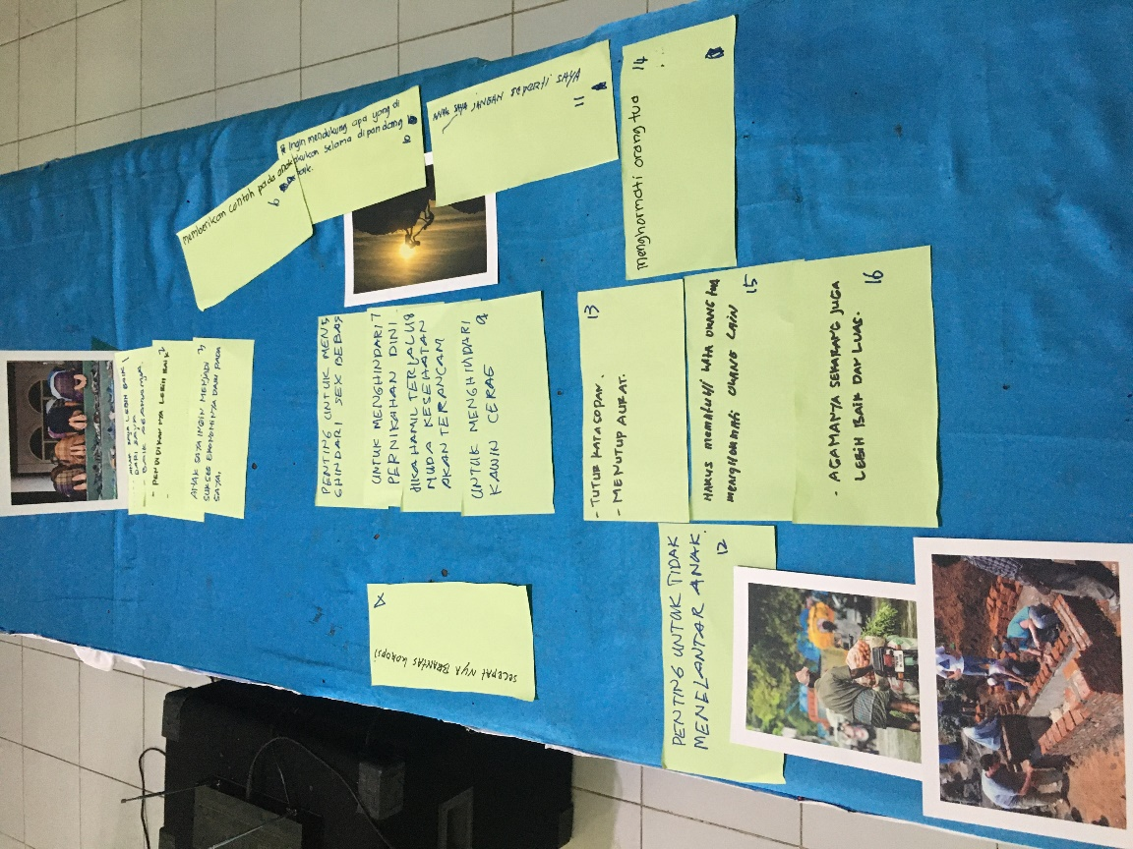
My children become more successful financially than I am.
- Secepatnya berantas korupsi
That we e corruption is eradicated as soon as possible!
- Penting untuk menghindari sex bebas
It is important (for the younger generation - especially) to avoid free sex.
- Memberikan contoh pada anak
To be an exemplary person for my children.
- Untuk menghindari pernikahan dini
To avoid early marriage (for mental health reasons).
- Jika hamil terlalu muda kesehatan akan terancam
Pregnancy from early marriage can be harmful to mothers’ health
- Untuk menghindari kawin cerai
To avoid divorce.
- Ingin mendukung apa yang dilakukan selama dipandang baik
to be supportive of good deeds.
- Anak saya jangan seperti saya
that my children don’t follow my way of life in the past.
- Penting untuk tidak menelantarkan anak
that children are not neglected.
- Tutur kata sopan dan menutup aurat
Children are well-mannered and properly modest
- Menghormati orang tua
Children are respectful to parents
- Harus mematuhi kata orang tua, menghormati orang lain
It is considered imperative to hear and obey the advice of parents
- Agamanya sekarang juga lebih baik dan luas
Children have wider and deeper Islamic religious knowledge and practice.

Narrative | Recording Info: 191225_WeValue_9_PM_Father group_R1_PE+TLD+VFC 1:00:00
So the bottom line is that as parents, we need to prepare their (kids) religious views we hope that it is going to be better from us. And with god’s will, if religion has already been good, he will be able to speak politely and still be kind to others. And to avoid the divorce thing which we actually have this kind of problems in East Lombok, as parents we need to try to educate and then try to make sure that our children to avoid getting married in a very young age and moreover having free sex so that they will not get pregnant before the marriage so that they could be successful both in academic and in the religious aspect because it is import for them. And it is important for us to give them examples as a role model in their lives.

