PI MK Harder, University of Brighton
HarderFoF-2 GPI 2963
This report’s main author was Elona Hoover

Capturing values-based legacies of community-led development with Genuine Progress Indicators in Thailand

Summary

This project is the fruitful outcome of the partnership between the University of Brighton and GPIAtlantic and aims to demonstrate the usefulness and relevance of values-based approaches to evaluating cultural legacies of projects for asset-based community development. The project has transferred approaches developed in the 'Starting from Values: Evaluating Intangible Legacies' Connected Communities project to GPIAtlantic’s established programme.

The project has embedded values-based approaches to identifying legacies within GPIAtlantic, Bhutan’s Youth Development Fund (YDF), the Thai Volunteer Service (TVS), as well as the TVS supported GNH youth movement in Thailand and neighbouring countries in the Mekong, and GNH aligned community projects in Thailand. These projects are part of the wider programme of developing Gross National Happiness pioneered in Bhutan with support from GPIAtlantic and disseminated in other parts of the world including through GNH conferences held in Thailand (2007) and Canada (2005).

Within this process, we have trained youth leaders from Canada, Cambodia, Laos, Myanmar, Thailand and Vietnam, as well as GPI, TVS and YDF staff from Canada, Thailand and Bhutan respectively, most of whom are involved in delivering action research projects for community wellbeing. We have co-developed an approach to evaluating legacies of these projects in the countries concerned.

This initiative serves as a practical example that demonstrates the usefulness of the values-based approach in other regions. It has contributed to development of a partnership with GPIAtlantic, a global leader in indicators for development, which is facilitating the transfer of this learning into an established global network of policy-makers, funders and assessors of genuine progress and wellbeing.

To assist with AHRC reporting: some of the intended elements are maintained in round bracketed italics and the corresponding actual information supplied in square brackets in the text below.

Achievement of Aims

- We have been successful in transferring learning about values-based approaches to a community of practitioners in international development, through co-development, demonstration, confirmation and embedding of these approaches with an important established member in community-led development, GPIAtlantic.

- We have developed a partnership with a specific global leader in indicators for development who has access to pathways enabling even greater and wider future co-developed uses and impacts of the values-based approaches into an established global network of policy-makers, funders and assessors of genuine progress and wellbeing. We have effectively prepared GPI Atlantic, a leader in indicator development, to integrate values-based approaches into their work and share their learning throughout their network and we will maintain our relationship with them and be prepared to support them fully in their implementation and dissemination efforts.

Outputs

The main outputs of the research:

Case Study Material
Expertise gained through the application of research in a non-academic environment
Materials capturing the new adaptation of the values-based approach co-developed in this application, for communication to other practitioners.

Background

The AHRC Connected Communities ‘Starting from Values’ project developed an approach for identifying and articulating the legacies of partnership projects – in particular university-community projects. The notion of legacy is based on subjective values of the people identifying it, and legacies of a project are typically viewed using the same values-lens as the project and its outcomes. But they can also be identified and viewed through a variety of different lenses, including those of the participants, and beneficiaries. In this previous AHRC project, University of Brighton (UoB) and its partners showed that by starting from eliciting and articulating local values, using our specialised approaches, it is possible to identify a broader spectrum of outcomes from projects, to open spaces for examining deeply personal and ‘intangible’ aspects, and finally to articulate cultural legacies of projects from these different values perspectives – in a rigorous and systematized way.

Our results also indicated that it is necessary to make use of arts and humanities approaches to identify and capture such legacies. With carefully facilitated arts and humanities approaches, and by starting with values, we can elicit, collect – even take measures of – more representative and inclusive legacies. This approach, developed both empirically and theoretically through the Starting from Values project allows us to go beyond objectively measurable outcomes by capturing measures of legacy that require an explicit recognition of embedded multi-subjectivity and values-judgements.

Furthermore, we found that participants in partnership projects who might initially have a difficulty in articulating well-defined indicators of achievements were more easily able to do so after following our values-based approach to legacies. In other words, when partners were facilitated to articulate their legacies with our approach, this proved excellent preparation for them to then develop local appropriate indicators for assessment. This initially subtle point is what stood out as an important innovation to our new partners in international development projects.

University of Brighton developed a partnership with GPIAtlantic, a Canadian NGO with 15 years’ experience in asset-based community development and operationalisation of the Genuine Progress Index (GPI) at an international level. GPI Atlantic are global leaders in the development of GPI, an alternative measure for societal wellbeing which is used by many cities and regional governments worldwide, e.g. in New Zealand and Canada and most notably in Bhutan with the Bhutan Gross National Happiness Index (GNH).

GPIAtlantic expressed a clear need for capturing and evidencing cultural legacies of their projects. They had not previously been able to develop indicators for their work at community level, other than with time-consuming bespoke projects in each location. They already used a participatory, contextually-sensitive approach to partnership and program development, but without the rigorous development UoB have achieved to take that on to produce measures: they thus had a well-defined need which they immediately recognised that our approach could solve.

UoB and GPIAtlantic discussed possible opportunities to co-develop the approach for GPI’s context, first identifying the possibility of working with GPIAtlantic’s partners in Bhutan. When practical obstacles related to visas for entry into Bhutan could not be overcome, the focus switched to work with another of GPIAtlantic’s partners, Thai Volunteer Service (TVS) in Thailand. This turned out to be a positive outcome as TVS was supporting a GNH youth movement, which was in turn playing a role in the development of GNH aligned projects in rural communities in Thailand.

Activities

Preparation and pre-fieldwork
The activities were designed to demonstrate that our values-based approaches were applicable on the ground with an established international development practitioner, transferable for use by local project partners, and possible to incorporate into global programs designed to be localised in different contexts. The successful demonstration needed to be followed by individualised dissemination to other stakeholders. UoB and GPIAtlantic co-designed a twelve-month programme incorporating these elements, with field activities integrated into existing opportunities. After initial attempts to work in Bhutan, we seized the opportunity of working with TVS to assess the legacy of the GNH youth movement that emerged from the GNH3 conference ten years earlier and the associated work in community-level projects that reflected GNH principles.

With a few months’ notice, the partners UoB, GPIAtlantic and TVS organised a training programme to be held in northern Thailand with participants from the Mekong region. UoB and GPIAtlantic had virtual meetings in order to prepare for implementing the GPI Values Tool, and training workshop participants in the tool. Initially the GPI team collaborated with UoB team members to draft a new values list based on GPI’s previous work in community-based development and GNH measures, Several other training materials were assembled ahead of intensive co-design on site. GPIAtlantic and TVS led on the actual organisation and recruitment of participants.

Fieldwork in Thailand – co-design and trialling approach
All partners met for several days in Chiang Mai, Thailand to co-design a training programme that integrated GNH and WeValue (as UoB’s values-based approach has come to be known) into the GPI Values Tool, as well as translating materials into Thai for Mekong-region participants with limited English. (See co-design schedule in Appendix 1)
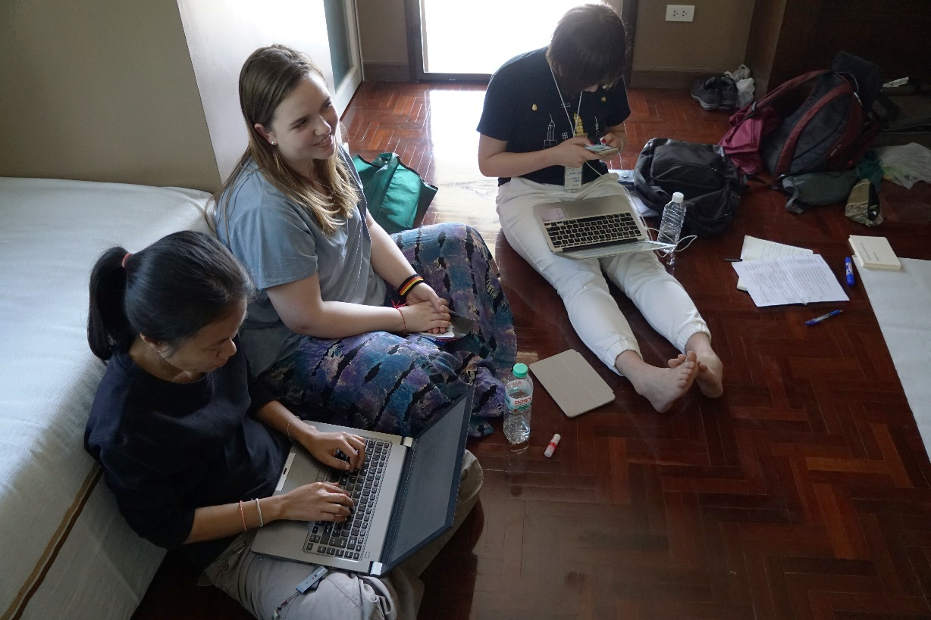
Co-designing - UoB, GPIAtlantic and TVS.

We also used this time to introduce the WeValue approach to identifying values and legacies to GPIAtlantic and TVS. In more limited time than anticipated, partners from GPI (Gwen, H, Nora, Ryan, Alana) and TVS (Kr, Sam, N) took part in two workshops, the first introducing them to the concept of values-based approach to legacies, and the second going through a values elicitation and triggering process. The latter was also used to reflect on the triggers developed for the training programme, and gain feedback from all partners in the process.

Part of the purpose of ‘experiencing’ the approach was to also define the most relevant shared context for the partners, and for participants in the training that was to come (given that we were going to have a much more diverse group than originally planned, with participants from diverse organisations). After discussion, we agreed the shared context for discussing values would be being part of a GNH Youth Movement. This values lens was then to be used to examine legacies, so we also needed to redefine which legacies we would be focusing on (previously being based on GPI work in Bhutan). The partners decided the initial focus should be on the GNH3 conference, which brought together GPIAtlantic, TVS and YDF (among others), and was identified as the catalyst for continued collaboration 10 years on. The third GNH conference took place in Thailand in 2007, the first one happened in Bhutan, and the second one in Canada (organized by GPIAtlantic).

On the final day of the co-design phase, partners from YDF joined the group and took part in a session identifying legacies of the GNH3 conference, starting from values-based statements identified by GPIAtlantic and TVS in the context of the GNH Youth Movement. This was also used as a learning opportunity for GPIAtlantic co-facilitators to use the values-based approach for identifying legacies.
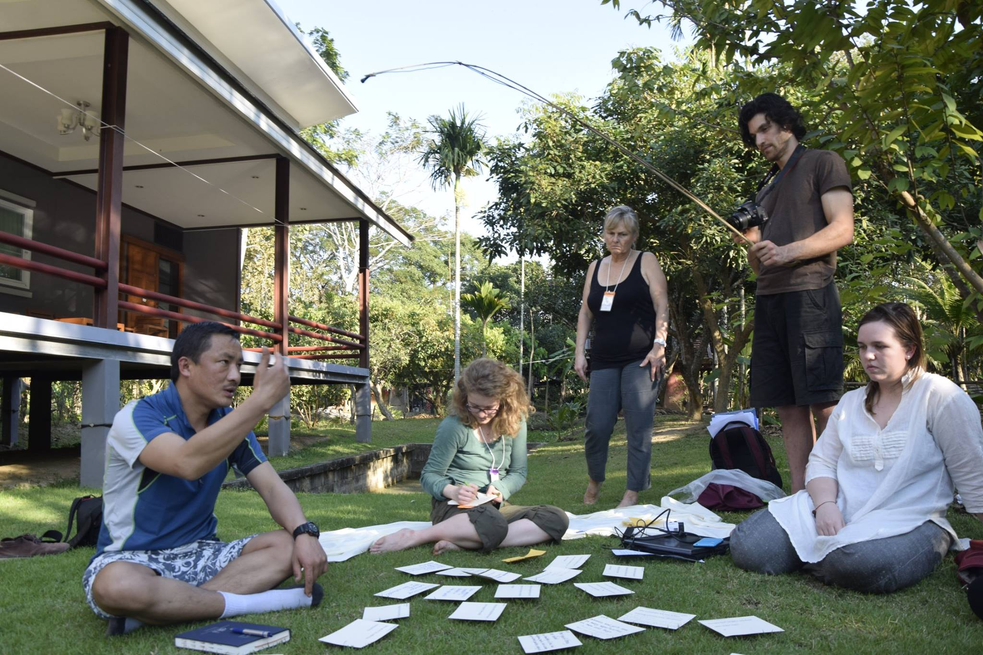
Eliciting values-based legacies with Bhutanese Youth Development Fund and GPIAtlantic

Fieldwork – co-training
We piloted this training programme over the course of a week in Chiang Mai with participants from Bhutan, Cambodia, Canada, Laos, Thailand and Vietnam (a number of whom identified as members of the GNH youth movement mentioned above). The training was led by facilitators from UoB and GPIAtlantic with participants accepting the invitation to take the lead on some activities. (See training schedule in Appendix). The training was well received and participants declared their intention to apply it in their own contexts. They provided feedback on how to improve future training, as well as the resources that would be useful to support their future work (see Appendix 4 for full details of feedback from participants). Some resources are already available to them on the WeValue web site and others are being developed and will be made available on a dedicated ‘GPI Values’ Facebook page.
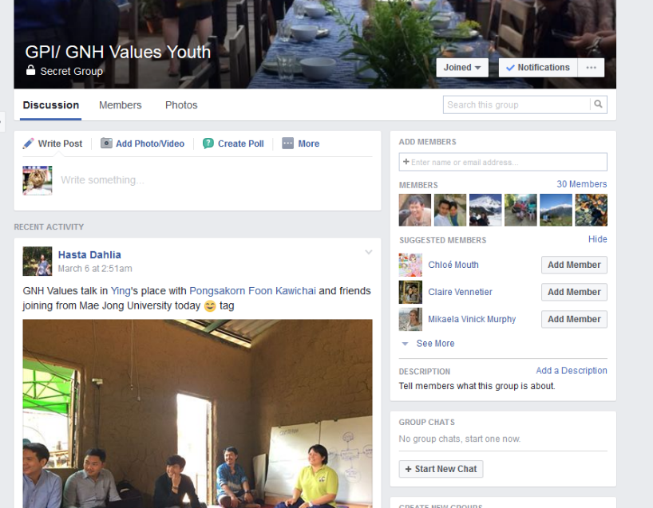 screenshot of private facebook group
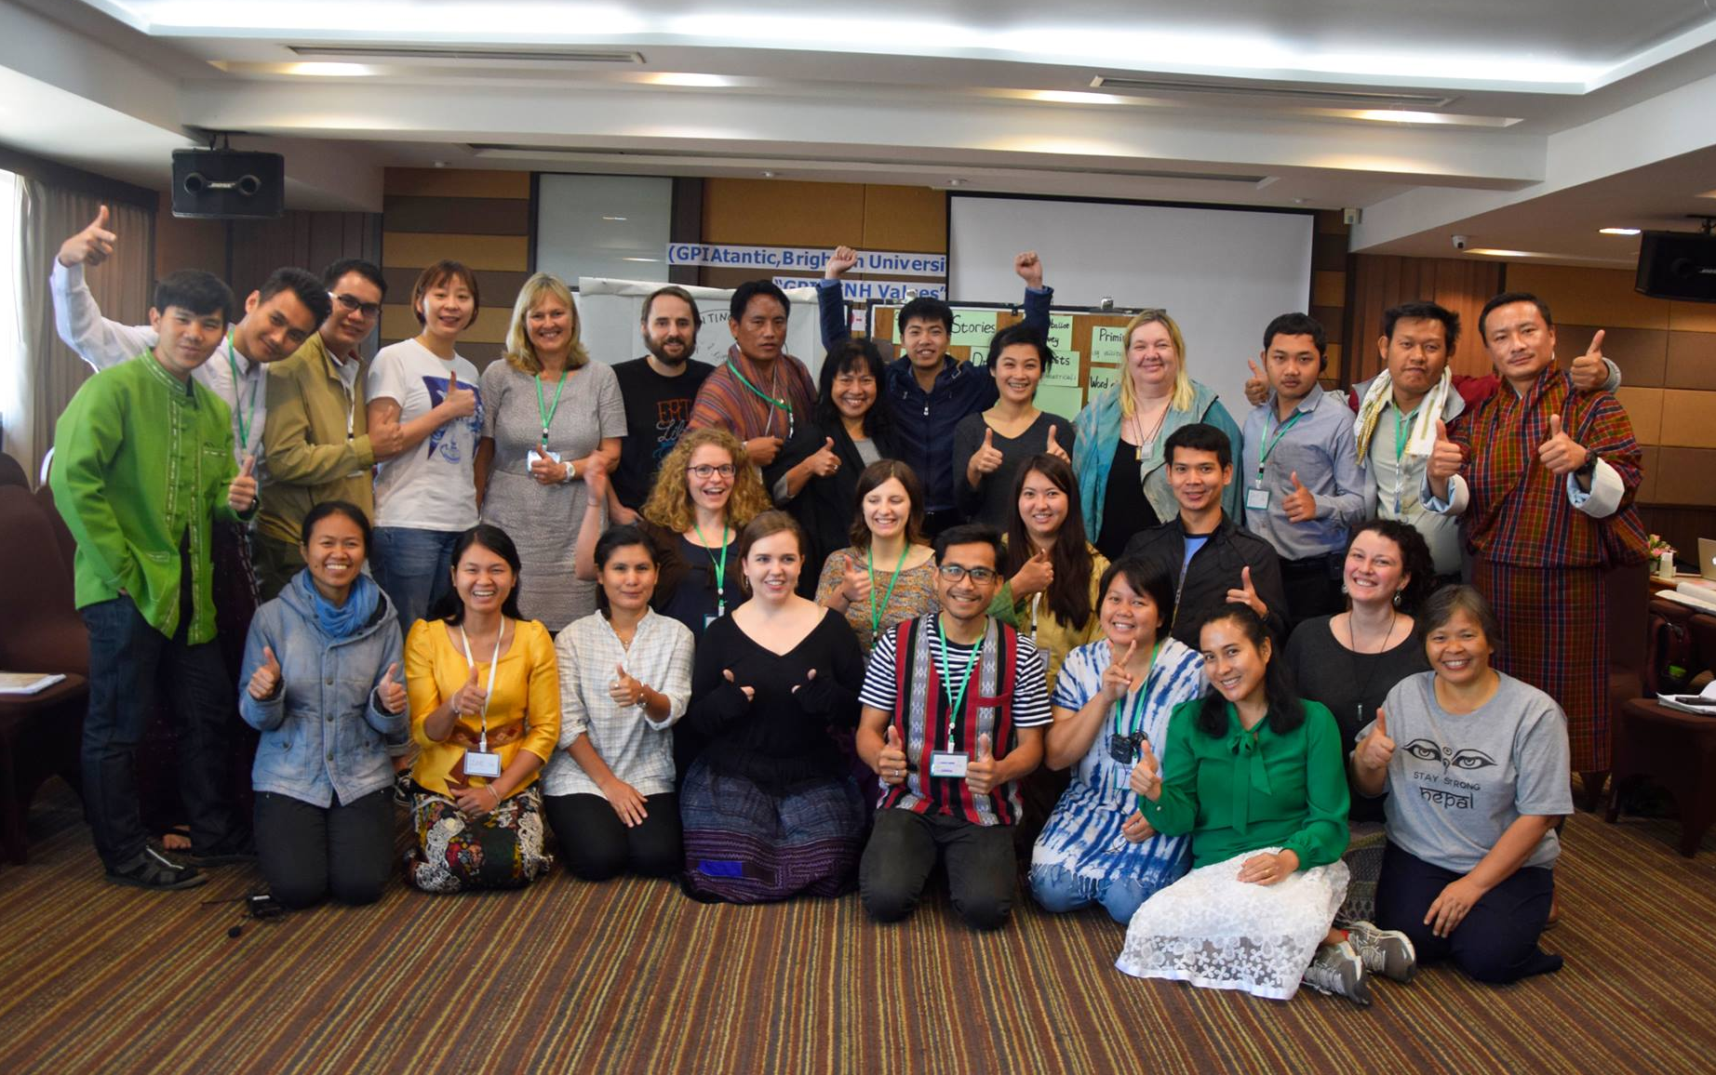
Training event group photograph
(note some participants are missing as this is on the second day)

The training included two day visits to nearby ‘happiness villages’ where community members were engaged in a variety of initiatives that corresponded to their own visions for their community, which aligned with GNH principles either implicitly or explicitly. Participants and workshop leaders were split into two groups with one group visiting Mae-tha known for its organic agriculture, value added sustainable product development and successful cooperative, which has provided much needed financing and other supports over many years. The other group visited Huai-e-kang where the emphasis was on ‘local wisdom’ and which was known for its sustainable coffee production. These visits were an excellent addition to the more formal training activities, providing a manifestation of the values and legacies that had been discussed during the training and helping participants to think about how they might work with their own communities.

Near the end of our training, two participants were asked to lead a training of local youth leaders and a values-based assessment of GNH legacies in their own communities with support from a member of the research team/GPI volunteers and a TVS translator, and at least one community leader who participated in our training. One of these communities had served as a model for the Bhutanese ‘Gothkad’ (happiness) villages thus helping to close the loop with respect to the origins of GNH. This work was scheduled for early March 2017. In the following months the local youth leaders will use the new concepts and vocabulary in their ongoing work in the villages, and document points of learning to be reported back at various times, ultimately collected before the end of the project in December 2017.

After the training, the UoB and GPIAtlantic team met over a couple of days to de-brief and clarify any issues before work began on laying out training materials, guidance notes, case studies and findings, a well as initial products to be developed from the extensive video footage collected during the various stage of the project. Discussions also covered how follow up projects would be undertaken and supported in Bhutan, Thailand, the other Mekong countries and Canada. Plans were made for on-line resources and broader dissemination.

Fieldwork in Thailand – Community learning visits
The community visits after the training changed from the original plan for a few reasons: (1) members of the communities were not able to participate in the training, so there was not a direct connection and we could not organise workshops or activities based on community members’ learning; (2) the timeline given to TVS for organising and constraints on local communities in terms of their ability to host us mean that the visits were shorter than planned, lasting 1.5 days and 1 night; (3) activities in the villages were set up by TVS and local partners who decided they wanted to do them as practical learning visits to accompany the training.

Despite this very different format, the community visits were an excellent complement to the training because the work of these communities manifested a values based approach and a vision that included a strong focus on happiness. Many of the dynamics and challenges that participants spoke about during the training were visible during the community visits and this allowed us to deepen our understanding of the context and stimulated further discussion about things that had come up during the training:
“The village and local wisdom centre also added value. I have been a good listener in the village, and in the village it is really a GNH village, a happy village, all the pillars are carefully preserved without it formally being a GNH project. We had a good guide who translated and shared the community’s work with us. The weaving centre was very close and similar to what we practice in Bhutan.” Ri, YDF

“From the first time in the workshop, I don’t understand everything, but I understood clearly when we went to the communities and saw what we were discussing in practice. I was really impressed by Maeta, strong community leader and research project that led to the development of the community project. It gave me hope and inspiration to continue my own project.” Lea, Laos

In order to assess the usefulness of the values-based tool in assessing the legacy of two community-based projects, the GPI, TVS and UoB team members worked with two Thai participants (Y & A) who expressed interest in adapting the values approach to their context. Y’s community is located in Lamphun province, close to Chiang Mai and A’s in Surat Thani in the South of Thailand. The latter has the added advantage of having served as a model for the Bhutanese Gothkad Village projects. H, Alanna, and Ryan (from GPI) and N (TVS affiliate) were fortunately able to arrange travel to the relevant communities to support A and Y in undertaking values-based workshops and legacies work, and to document the process.

Fieldwork in Thailand – Community visits and follow-up
Work will continue over the coming months involving UoB and GPIAtlantic in identifying key findings and insights that can be communicated to other organisations and international bodies. GPI plans to advertise that they have co-developed a useful tool for a large and defined need.

Outcomes

Case study material

Values-based legacy findings from GNH3 conference

This section outlines initial outcomes from the process of identifying values for GPIAtlantic and TVS in the context of the GNH Youth Movement, and using values statements identified to identify legacies of the GNH3 conference. This was done in three steps, and the findings presented below are preliminary as not all concerned parties were able to be present throughout the process.

STEP 1 involved a workshop on 6th February 2017. Participants from GPI: Gwen, H, Nora, Ryan, Alana; Participants from TVS: K,S,N

After introducing the concept of values-based legacies, we elicited values through a photo elicitation activity. The facilitators noted down comments from participants during the photo elicitation on orange post-it notes (in photo below) – as the workshop was after a long day, it was decided this would be the best way to encourage maximum input from participants.

After sharing the outcome of the photo elicitation, we moved onto the trigger list. Large cards with already amended triggers from the co-design process were placed on the floor in front of people, and people were invited to select the three that they thought were most important to them in the context of the GNH Youth Movement. The facilitator noted when people wanted to take the same card. Participants then placed all of the statement cards and were invited to choose one to start a discussion (we started with something that we knew would be complex from our previous co-design discussion, i.e. the karma statement). Once the discussion took place, the group was asked to show how important it is for them by moving their hands (high: very important to GNH youth movement, middle for somewhat important and low down for not important).

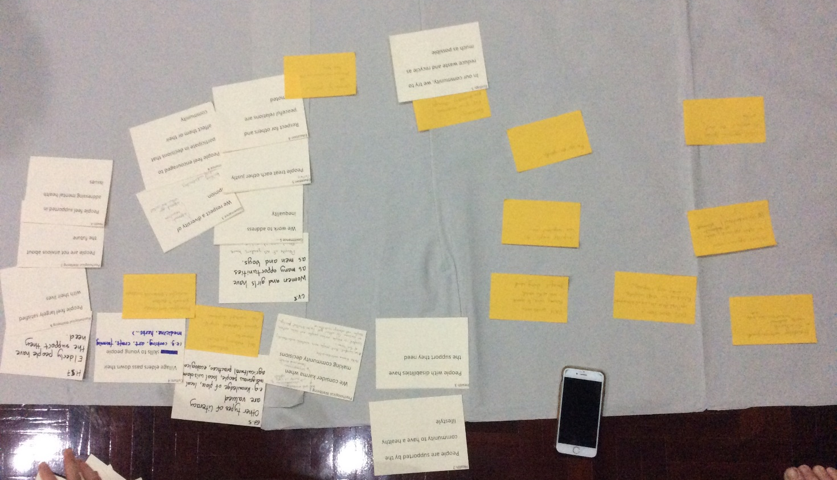
Prioritised values statements from GPIAtlantic and TVS, photo elicitation and triggering.

Figure 1: Values Statements 1.0 - from GPIAtlantic and TVS in the context of GNH Youth Movement. Shaded boxes represent statements developed from photo elicitation, white ones from ‘triggers’.
A holistic approach to community development, people can understand through different elements
Ecological awareness and environmental protection (e.g. through gardening)
Creating self-sustaining livelihoods in one’s own communities
Valuing traditional ways of life
Community members welcome strangers into their home
GNH comes from a spiritual place – we understand that we are all interdependent
Youth are powerful and strong, can raise their voice to speak to the rest of the world
People inspire each other, and everyone has an important role
Friendship between youth in the network – creating personal connections can help to act
Promoting and sustaining meaningful and sustainable livelihoods
GNH approaches speak to people in the ‘real world’
We work to address inequality
People are not anxious about the future
People feel largely satisfied with their lives
We consider karma (cause and consequences of actions, ripple effects) when making community decisions
People of all genders have equal opportunities
Other types of literacy are valued, e.g. knowledge of place, local indigenous people, local wisdom, agricultural practices, ecological …
People treat each other justly
People with disabilities have the support they need
We respect a diversity of opinions (building mutual understanding to promote peace)
In our community, we try to reduce waste and recycle as much as possible
People are supported by the community to have a healthy lifestyle
Village elders pass down their skills to young people (e.g. cooking, craft, farming)
People feel supported in addressing mental health issues
People are encouraged to participate in decisions that affect them or their community
Respect for others and peaceful relations are promoted

The group discussed most of the values statements prioritised by the group. One of the important discussions was about the concept of karma which was used in the trigger ‘we consider karma when making community decisions’. In particular, the group first deconstructed what they understood by karma, for instance as the interconnectedness of things, and thus understanding relational interactions of cause and consequence, or ‘ripple effects’. The example of full cost accounting was also used as an example of a ‘karmic’ approach. The group noted that a challenge might be to make the concept of karma understandable to people who might not use it, but that in South East Asia it was likely that people would know this term well. The group also noted that the term is used for two quite opposing purposes, for instance, it is often used as an excuse for not taking action, or for others to be treated poorly: ‘oh it’s because they have bad karma’. As a result of this discussion, we agreed to keep this trigger (proto-indicator) for the menu to be presented to participants.

The group also discussed the wording of some of the triggers around gender, and suggested to make them less gender normative, i.e. ‘all genders’ instead of ‘women’.

Here is a summary of the Legacies of GNH3 discussed by GPIAtlantic and TVS participants during the workshop
GPI staff and ‘youth’ who took part in the GNH3 conference are present at the present training event – showing a longstanding commitment to GNH approaches, GPI’s work, and inspiration from the conference event itself.
Similarly, ex-TVS volunteers who have taken part in the GNH3 conference are present at our training event, and helping with organisation (translation, co-design, meditation retreat section).
A very famous and respectable monk is learning about GPI and GNH, and developing retreat around the concept of happiness – also rescheduled another retreat and came especially to be here. This was seen as particularly important for the Thai partners, as this monk has a large following in the Thai community nationally and abroad.
Generosity of TVS and their partners, e.g. giving the space and food for meditation retreat and our meetings for free, because they believe in the work we are doing. This was seen as legacy of the GNH3 conference in that it was the context in which GPIAtlantic and TVS first collaborated.
Connection between GPI’s work and Thai work
Formative development experience for youth who attended the conference – which informed future career choices and studies.
Forming of the Happy Seeds network (even though it has not been named as such for last 10 years) – maybe could now be called GNH youth movement
Long-term involvement of Canadian youth who attended the GNH3 conference in GPI work: all who attended are still involved as volunteers or project staff.
The GNH3 conference brought together youth movements in Thailand and the Mekong, cementing a regional network (which TVS drew on to recruit participants)
Better awareness of GNH for TVS and their network(s). Becoming more familiar with the GNH approach through the conference helped to link existing practices to it and make them more formal/communicable – from TVS perspective: “GNH is not something new” – “awareness for changing society is growing”
Youth started taking part in community work as a result of being inspired by GNH3
Individuals involved in GNH3 mentioned it led to spiritual growth for them as individuals. For instance, it led to the development of a new world view at a crucial point in one of the Canadian youth’s life.
Development of career paths for youth involved in the conference: at least 2 present started working within TVS and GPI following on from the conference (N, Alana).
This was linked to creating clarity of desired career path and identification of passion for working with youth and environmental education, and being inspired to think that youth can be powerful.
Shift in research approach (for academic researcher) to join together research and community development.
Concept paper published by the OECD on plan for working on indicators for community wellbeing
As a result of the conference, TVS staff and volunteers went on at least 3 GNH study tours to Bhutan with YDF, and Bhutanese are present at this TVS-hosted training programme.
Ron Colman (GPI) worked with TVS and university in Bangkok to develop indicators for Thailand sufficiency economy approach.
Local wisdom, organic agriculture and restauration of the dignity of labour projects were developed with Happy Seeds network
Development of the GNH and Mind training camp in Bhutan (led by YDF in collaboration with GPIAtlantic) as a result of GNH3.

STEP 2 involved using the values statements in figure 1to trigger further legacy stories. Here, Rin, Ch and Na were able to participate. Although they had not contributed to the development of the values statements, they were at ease when reflecting with the statements, and using the statements to reflect on the legacies of the GNH3 conference and their work since then.
It is important here to point out that activities and developments in Gakhid Village projects were identified as legacies of the GNH3 conference, as the concept of the Gakhid Village itself was born from YDF’s participation in the conference in Thailand and visits to TVS network communities.

Values statement: “Promoting and sustaining meaningful and sustainable livelihoods”
This led to YDF identifying a number of legacies from their work with GPI in the Gakhid village projects, the first around ecotourism initiatives:
“YDF had been involving the youth in that community and trying to promote livelihood. We have come up with projects like ‘ecotourism’: we try to revive the ancient trail that they had. We had a very divine madman, known to the Western world as the ‘Divine Madman’, so YDF revived that trek route and now that has become a kind of livelihood for the community, where all the tourists come for trekking on that route and at the same time they also have an opportunity to develop their own community by making homestay, by growing organic vegetables at home where the tourists come and live there in the community. That is one [legacy].”
Ri, YDF
Further legacies of Gakhid Village work include local agriculture projects and employment opportunities for young people:
“We also have a tea project, because in that particular locality there are two different types of local tea which can be produced. [The community] harvest the tea, process it and then they sell it to YDF. YDF buy that product, so we do the packaging and everything and then we sell it up in the market. And now what happens is that youth who left the village, who left the community, they started coming back to the village, whereby they could start their own meaningful livelihood in the community because there is opportunity. So we have created some opportunity, that is one [legacy].”
Ri, YDF

Other opportunities arise through training offered, on the basis of identified needs, including computer skills and tailoring:
“directly or indirectly this particular training has given an opportunity for these young youth to open their cooperative tailoring unit, where the community can bring their things to this particular cooperative tailoring unit and do their necessary stitching. And youths there, they can now stitch the dress that is worn by men and even the blouse. So they were trained within three months to stitch all these things. And now they are very ready and they are prepared to go to the market and get themselves employed.. So this is a very big project, it’s happening now in Punakha district. And we have started with that project. So now we see that these things are becoming very successful, so now we might be taking this to another district where we will be looking at some areas where things can be developed very well for the community. This is one project for the promotion of ‘meaningful livelihoods’, so this is happening just now under our guidance.”
Ri, YDF
But these opportunities are beyond just employment, and are about preserving and passing on local wisdom by allowing young people to return to their communities and ask questions:
“So we have given opportunities for the students to go there and explore, and then note some of the dying local wisdoms. In a way it also gives a two-way benefit, and it’s starting to link with our Gross National Happiness” Ch, YDF

In a country where there is massive rural to urban migration, the Ri’s Gakhid village project actually sees youth staying on:
“So my Gakhid village has employed many out-of-school youth in that particular community. So this is a very successful story where we can share, and the Gakhid village is becoming very good in that particular community. So I should say that now YDF will be planning for another Gakhid village in the future.” Ri, YDF
H then reflected on how the stories of the Gakhid village projects were inspiring for her, and led her to apply for funding in order to collaborate with YDF and start a new Gakhid village project:
“So in 2013 I got this grant from the Davis Project for Peace, it’s a graduate student grant, and I brought the money to Bhutan and we all went to G (in Southern Bhutan), Pooja went also, and Ro and I, and we did training with the Y-VIA in participative action research, using the assessment and mapping tools. The project was just starting when I had to leave because I was only there for three months, but the idea was that I would start many of the things that had been successful in other villages”. H, GPIYouth
The values statement promoting sustainable livelihoods led to discussions not only about the legacies of Gakhid village projects in more concrete terms, but also in how the actions taken, projects developed and experience shared led to broader changes and long-term involvement from those involved, for instance seeking to develop further projects.

Values statement: “People inspire each other, and everyone has an important role”
Another legacy identified for YDF in terms of the Y-VIA program is continued inspiration for young people:
“…every year they conduct [the Y-VIA] program, so this is how some of the youth are inspired to become volunteers and that’s how they’re into the community, helping the community, and people are really satisfied with what Y-VIAs are doing at that stage.”
as well as the impact the program has on their ability to engage more fully in their community, to take initiative and broaden their perspectives:
“And they all get involved into, you know, whenever there is a festival some of the Y-VIAs go and help the oldest people to come and visit the festival. They try to give them shelter, they try to give them water, whatever they need. So these are some of the volunteer activities that YVA has been doing now with this program, because their capacity has been built, their leadership qualities. Their minds have been broadened, where they can give more assistance to the community. So this is what it has become, and YVIA has been playing a very important role in our community.” Ri, YDF

This experience is not limited to Bhutanese youth who are trained in the Y-VIA programme, but also to Canadian interns who work alongside YDF and their youth:
“it’s very inspiring for me and others to see that people at young ages are making huge impacts in their community, through the guidance of the leaders, but also what I’ve seen is that the experience that our interns have in the communities has really affected their choice of employment. So they’ve come into this thinking, ‘OK, I’m going to go into this program when I’m done, this is a way to have a year experience’, and actually their whole… their interests solidify around helping communities, or working within communities, in participatory ways, and actually go on to programs or work that’s related to what they’ve experienced.” Nora, GPIAtlantic

After reflecting on the legacies in relation to the values statements identified by the group, at least one area where missing legacies were identified: self-determination (of communities).

STEP 3 – preliminary analysis of legacies
After the field visits, researchers looked thematically across the legacies mentioned and stories told by participants. Five initial legacy themes were identified:

Individual growth - personal and professional growth, from attending GNH3 or indirectly through actions taken in community, learning, or development of network activities:
“I was very inspired when I heard the stories of how successful it was, so when I was studying I applied for a funding to bring more partnerships from GPI to YDF and do that program.” H, GPIYouth
“at that time [GNH3 Conference], I’d just graduated. I was helping TVS just as a translator, I just get the thing done and then finish, I don’t think too much about changing the world or anything. But after this conference, I got a job from TVS and I continued working until seven years. And then along the way, through the seven years… how to say… my awareness for changing society has been rising, and I am clear about what I’m doing.” N, ex-TVS
“And now what happens is that youth who left the village, who left the community, they started coming back to the village, whereby they could start their own meaningful livelihood in the community because there is opportunity.” Ri, YDF
inspiring others (should this be a separate point?) –
Perhaps it should be, given the importance of “network” to the Bhutan and Thai projects and continued use of that sort of domino effect that can be initiated by conferences and then sustained through networks.

Community learning – and development of livelihoods, employment and wellbeing. Examples include sections above on developing ecotourism activities, new opportunities for employment through tea plantations, tailoring and other Gakhid village projects activities.
Community learning from the conference itself includes the ongoing networks developed and connections.

Taking action - individual and/or community level or even organizations taking action as a direct result of taking part in the conference, or indirectly through growth and learning that has happened as a result of related activities. The following notes from our conversation on legacies highlights the importance of long-term actions and commitments:
GPI staff and ‘youth’ who took part in the GNH3 conference are present at the present training event – showing a longstanding commitment to GNH approaches, GPI’s work, and inspiration from the conference event itself.
Similarly, ex-TVS volunteers who have taken part in the GNH3 conference are present at our training event, and helping with organisation (translation, co-design, meditation retreat section).
This following section shows how taking action and personal growth were intimately connected legacies from the GNH3 conference:
“I think it’s interesting that we’re coming from two different locations, and maybe have different backgrounds and things, but that the outcomes, the legacies from GNH 3, there’s a lot of similarities for me, as you said, so it resonates with me what you said about career paths, and working with youth, and feeling a passion for social change and having personal growth in a lot of ways, and working with other people to help develop that too so it’s interesting that even though we haven’t talked for ten year we’ve had these similar legacies come out of that!” Nora, GPIAtlantic

GNH knowledge - Better understanding of Gross National Happiness concepts, and confidence/ability to connect them with other ‘happiness’ and ‘wellbeing’ approaches to living and/or community development. For instance, projects specifically on local wisdom, organic agriculture and restauration of the dignity of labour projects were developed through the TVS Mekong network of projects. The ability to see that, in some cases, “GNH is not something new, it’s something we already practice” (N, ex-TVS) is part of that learning process. Another interesting legacy was that a very famous and respectable Thai monk started learning about GNH and was interested in collaborating and developing retreat around the concept of happiness. This was seen as particularly important for the Thai partners, as this monk has a large following in the Thai community nationally and abroad.
Other examples include the publication of a concept paper for the OECD on indicators for community wellbeing.

Developing connections - New, wider or stronger networks, providing space for learning across regional and international borders. For instance, the GNH3 conference brought together youth movements in Thailand and the Mekong, cementing a regional network (which TVS drew on to recruit participants). The generosity of TVS and their partners – e.g. giving the space and food for meditation retreat and our meetings for free, because they believe in the work we are doing - was seen as legacy of the GNH3 conference in that it was the context in which GPIAtlantic and TVS first collaborated. The legacy of developing regional and international networks continues:
“And I think GPI Atlantic and GNH TVS will be working on this issue, provide a space for the young people not only in our home countries but in the regions, which is very, very important.” Kr, TVS

Exploring values of the GNH Youth Movement with participants
As mentioned above, a lowest common denominator needed to be identified in order to run the training programme with opportunities for experiential learning through group activities and workshops. The common context identified was that all participants could identify themselves as being part of a GNH Youth Movement. Although not everyone was familiar with GNH, this proposal was discussed with the whole group on the first day, and on the understanding that all were working towards community wellbeing, happiness or alternative understandings of progress, this was agreed as a common context.

The process led to outcomes (values statements, proto-indicators, prioritization and clusters), but the whole process was primarily used as a learning tool for training purposes, as part of the action learning cycles. Indeed, although the participants shared a common commitment, not all were familiar with GNH or GPI, and we thus realized it would not have been entirely appropriate to focus on developing an output for this group in itself and the learning process was prioritized over polishing or perfecting the outcome.

Within this context, participants were asked to identify values through the following steps:
- A photo elicitation activity (Day 1) | 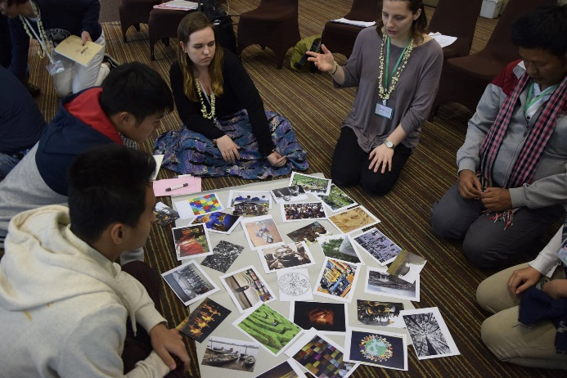
- Triggering, using a selection of 30 values statements which facilitators had identified as complementing the statements identified during the elicitation activity (Day 2) | 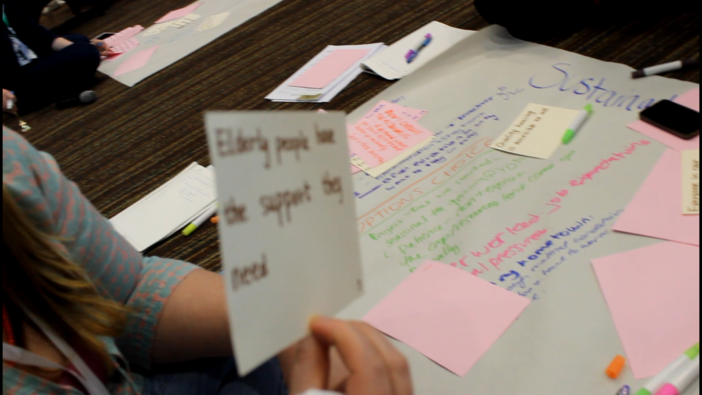
- Prioritisation with a dot-mocracy exercise where participants were asked to vote for their top 5 statements (Day 3) | 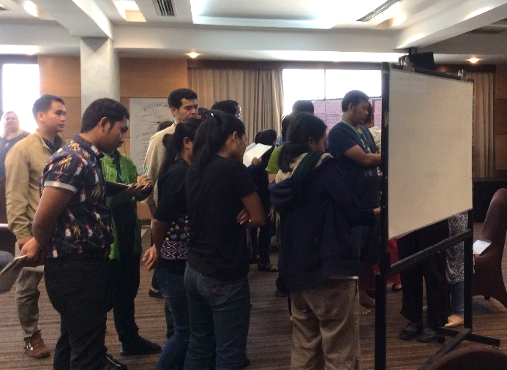
- Discussion of result and clustering – clustering was done with a subset of the statements in groups, and different ways of clustering were explored (process/outcome; type of stakeholder; values).  Clustering of the whole set (as seen in appendix 2) was led by facilitators (Day 3) | 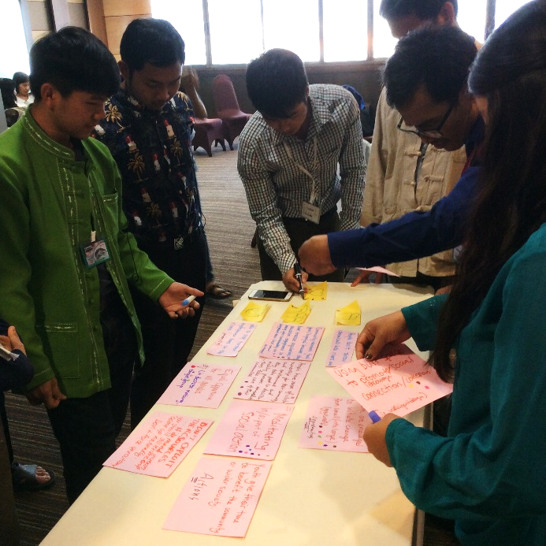

As a result of using the process as part of learning cycles, many of the values statements developed through the elicitation or triggering steps were either too vague or contain too many concepts. This helped, however, to use examples for identifying criteria for the formulation and development of values-based proto-indicator statements by the participants (see Appendix 5 for the full list of criteria).

For instance, “Community members feel good/hopeful because they have trusted regulations, education, engagement in looking after (sustainably use + safeguard) their (local) natural environment” was used to show a statement that had too many ideas to be a proto-indicator (let alone an indicator), one of the participants noted ‘it looks like a theory of change’. In contrast, the statement ‘local people have access to nature and use it properly’ was identified as being much closer to a proto-indicator which needed only more definition in the concept of ‘properly’.

The clustering activities were purposefully done as smaller groups, to provide an opportunity for deep engagement with different ways of organizing values-based information (in the form of more or less well formulated proto-indicators). The experience of clustering by values after clustering in other ways was revealing not only of the process of clustering, but of the WeValue approach as a whole:
“when we think about clustering, we need to think about the purpose of doing this and it will influence the way in which we cluster, for instance our demand is to protect the forest” S
“When we work sometimes we forget the values of ourselves and also the value of our work, we think we are an NGO and we forgot. But this activity is to emphasise the real meaning of the values, to bring you back to the meaning behind what you are working or what you are fighting for” Ying

The learning from the process was then applied in the last section of the training, as participants were asked to develop values-based proto-indicators and indicators for their own projects or contexts.

Notes on usefulness, scalability and transferability of the values-based approach

Materials developed to adapt the values-based approach to the context of community-led development for wellbeing (GNH)
In addition to the notes on co-design above, specific outcomes for adapting the approach include the co-design of a participatory training approach co-designed by GPIAtlantic, University of Brighton and TVS. This included deliberate space for participants to contribute, learn from each other, and learn from local community projects (see Appendix 1 for programme).

Materials were adapted from previous activities with WeValue and the Starting from Values project, and collated into a resource pack for participants (see project website resources section). This included a newly co-developed list of triggers developed from the WeValue approach, but specifically for the context of GNH and their use in the Mekong (initially) (see Appendix 6 for 3 successive versions, including the latest one, version 3).

Further materials will be developed in conversation with participants and based on need. Given the intensive nature of the programme, further time would be beneficial in order to better understand specific local need.
See process page
Note on applying to community context from community visit report and transferability notes.

Expertise gained by community partners and participants

The participatory and action-based learning approach applied to the training program revealed some expertise gained by community partners and participants.

The table below summarises different expertise gained by all project partners.

Phase 1

Expertise gained | Who? | Explanation
Using photo-elicitation | GPIAtlantic co-facilitators  Participants | GPIAtlantic partners and 2-3 participants had used photo elicitation, but not in this specific context.  At least 4 participants reported that they already had ideas of how to integrate this method into their activities.  Photo-elicitation was used by both of the community leader/participants in the follow-up community-based work.
Ethical considerations in research and community-led evaluation processes | Participants | Such a detailed and systematic consideration of ethical issues was new to nearly all participants. While some already consider ethical issues due to the nature of their work, they had not reflected on this in the context of research or data collection.
Developing values-based proto-indicators | GPIAtlantic co-facilitators  Participants | Statements developed were used as examples for identifying criteria for the formulation and development of values-based proto-indicator statements by the participants (see Appendix 5 for the full list of criteria). This learning was then applied when participants were asked to develop values-based indicators for their own projects.
Prioritisation methods | UoB and GPIAtlantic  co-facilitators  Participants | The workshop gave participants an opportunity to learn from each other. While some participants offered methods or had used some, none had done so in a context of conversations around values, and most participants said that these methods were new for them.
Clustering | GPIAtlantic co-facilitators  Participants
Assessing legacies
Working with values in South-East Asian context | UoB and GPIAtlantic  co-facilitators
Happiness-based approach to WeValue indicator development (GNH inspired) | UoB and GPIAtlantic  co-facilitators
Delivering WeValue approach in a youth/community-development context | UoB and GPIAtlantic  co-facilitators
A systemic understanding of values | GPIAtlantic co-facilitators  Participants | By deconstructing the meaning of values into separate statements, the participants also started to see the connections between the different values, and how the separation into statements is in fact a tool, something to facilitate discussion and measurement rather than a way to define values.
Definitely more to be added here.

Impact

[GNH values – common foundation for this group – facebook group]

- This project is enhancing and extending internationally the pathways to impact identified in the ‘Starting from Values: Evaluating Intangible legacies’ project by working with a new partner to demonstrate the relevance of the values-based approach to capturing legacies in the context of asset-based community development based in principles of action research.
- The project is taking place in a context where multiple languages co-exist and translation and transposing have been needed, which has demonstrated the usefulness of the approach in a most challenging environment.
- The project was designed to take advantage of the networked structure of GPIAtlantic as an organisation as well as of the projects that they deliver, ensuring the work delivered through this project has a broader international reach than the specific case of Thailand.

Collaborators and participants have benefitted from the project in the following ways:
- TVS youth leaders and key staff have a new approach to evaluating legacies of their projects.
- The workshop gave participants a common vocabulary to speak about values and values-based processes and has given them new tools to integrate into their work.
- A number of participants noted that the tools they acquired in the workshop would be very relevant to their work with youth and intended to apply them in their contexts.
- Participants appreciated the discussion of ethics in participatory research and said that this would influence how they carried out research in future.
- Participants stated that they had been very inspired by the workshop and field visits and this would provide additional motivation and food for thought in their personal lives and their work.
- Both workshop and field visits stimulated reflection about the role of values within participants’ own work and that of their organisations. One leader of an organisation (Myanmar 2) expressed the intention to use what he had learned to work with the staff of his organisation to rethink their overall approach.
- The workshop and field visits allowed participants to explore the concept of ‘happiness’ in some depth, noting its encapsulation of wellbeing, simplicity, self-determination, relationships and spirituality. Several people said that they would incorporate happiness more explicitly into their work and noted that the GNH framework integrated with the value-based approaches would serve to effectively implement this objective. Participants from one organisation (Myanmar) expressed an intention to use GNH domains to frame their forthcoming assembly.
- Bhutanese participants who work with GNH as a national strategy said that the workshop and field visits had stimulated them to think more deeply about GNH. The values lens served as a vehicle to reinvigorate the concept.

Longer-term benefits:
- Project beneficiaries and participants within villages may gain insights into their values and the legacies of these projects.
- GPIAtlantic research staff and volunteers, as well as TVS youth leaders, will develop expertise in using a new values-based tool for community-level assessment of their projects.
- GPIAtlantic and TVS may be able to demonstrate the cultural legacies of the GNH youth movement and GNH aligned community initiatives to other organisations, funders, governments by lending authority to different forms of knowledge.
- GPIAtlantic has the ingredients for developing a new approach that can bridge community and regional-level assessments of community wellbeing.
- The University of Brighton will benefit from wider impacts of their work and insights into the usefulness of this approach for practitioners in community-led development.

- The benefits for GPIAtlantic and their partners in Bhutan, Thailand and other countries is key to enhancing the impact of the work by ensuring continued and further use of values-based approaches in their own projects in these and other regions as well as dissemination to key development agencies and organisations. This is key to potentially transforming current approaches to assessing progress at the community level globally and community partners adopting a new mechanism for evidencing the benefits of asset-based community development approaches and helping to move towards such approaches being standard ‘development’ practice in future. In addition, ensuring real benefit for all community partners and participants in their programmes is an important dimension of our ethical commitment to doing research with communities for mutual benefit. Furthermore, it speaks to an ethical question which the original research on legacies seeks to address, namely shifting authority so that communities themselves can take charge of evaluating the cultural legacies of their programmes and collect their own data.

Learning
This final section summarises some of the learning from the project team after reflecting on the training process.

- Legacies vs. evaluation. legacies as difficult to translate

- GNH values framework? Works best from perspective of GNH lens (more general and directly relevant to community context) Problem of ‘cultural preservation’ (note: rephrased in lens)…GNH coming from Bhutan, very specific view of development and cultural identity

- Efficiency? Not the best for youth leadership context. values take time, don’t want to rush

- We’ve learned indirectly where slow learning and happening over and in-between other events. Similar to ARN. Meditation

- Usefulness of the triggers?? Vs elicitation. how people use or interact with trigger statements, challenges of wording

- Community standards >> elicitation to trigger statements. Reflections from H and Alana. Importance of trying to lead a bit first before leading a group

- Making values statements: easy in English language, separation of concepts rather than systemic way of telling things (like Chinese)

- Integrating participatory learning – co-design and co-delivery

- Completeness – need for facilitation

- Clarity of process- need for more information upfront and a guide to the process.

  - This relates to the context of working with community development leaders – they are familiar with many of the methods employed in eliciting and refining value statements. It’s important to tailor the experience to their expertise for them to stay engaged.

APPENDIX 1: Co-designed training schedule

GPI VALUES - DETAILED PROGRAM FOR FACILITATORS

THURSDAY, FEBRUARY 9TH – Training starts!
10:00am -12:00pm  12:00 – 1:15pm  1:30 -2:15pm  2:15 – 3:30pm  3:30 -3:45pm  3:45 - 4:15 pm  4:15 - 5:00pm  5:00 – 6:00 pm  6:30  7:30 | Ceremonial Opening – Welcome – Space Of Gratitude  TVS lead - Ceremonial flowers and bracelets - maybe Chat will come (1hr)  Kr and Gwen - Introduce GNH youth movement (why we are all here, why they were invited, our objective of the program – see notes from Nora and H.) (15 min)  Janice and Elona - Introduction to WeValue (5min)  H leads - Personal introductions/icebreaker /check in  Say your name, where you’re from, your hope and do a movement, everyone has to memorize name, place, and movement. (40min)  Lunch - Somkid [!] - Lunch meditation -  Alana leads - Developing Community Standards -  Janice and Nora - Research Ethics: participatory approaches vs. others: consent, ownership; cultural and contextual sensitivity  Tea break  Gwen leads - Energizer - Values game/ spatial game (use 4 pillars and trigger statements)  Janice and Elona lead with H and Nora– Introducing WeValue concept – hats activity  GROUPS - 4 groups (put Thai that need translation into two of those groups)  Introductions to the whole group – define ‘legacy’, and values as often implicit.  Context: Creating / maintaining (GNH) Youth Networks  Instruction: everyone to share 1 thing that they think has happened as a result of creating/being part of GNH youth network. Then have hats, each participants has a hat – ask, what do you think is the most important legacy from what you have said – or if another thing that is missing.  Make sure everyone has a chance to speak and that the concept of values as subjective is introduced – notice if people have brought up different legacies and where there might be overlap.  Nora - Review of the day and check-out  The purpose was to get comfortable with values concepts and each other.  Explanation of Rest of program  Ask for: volunteers for leading energizers or group check-ins and activities and draw 4 GNH pillars!  Check out and questions  Dinner  Ryan host - Film (Economics of Happiness – just show the first half). and if people want to watch the whole film or have discussion after

FRIDAY, FEBRUARY 10TH - Training
7-8 am  8-8:45 am  9:00 – 9:45am  9:45- 10:45am  10:45 – 11:00  11:00 – 12:00  12:15 - 1:15  1:30-2:00pm  2:00 – 5:00 pm  2-2:30  2:30-3:30  3:30 - 3:45 pm  3:45 - 4:45  4:45 – 5:30 pm  5:30 – 6:00 pm  6:30 pm  7:30 pm | Breakfast  [Somkid CHECK] Morning Meditation  Elona and H - Welcome, overview of day  ice-breaker?  How GNH relates to We Value – more elaborate than day 1 - talking about practical tools.  Here’s a tool, we’re going go through it Define ‘indicator’  We will have the next 2 days to explain-experience- reflect / link to relevance  Elona lead with Janice, H and Nora - Values Elicitation  Visual elicitation for value “statements” – (show example of values-based indicators)  - Context/boundary: Think of your involvement with GNH youth movement (TVS, YDF, GPI…)  - Instruction: Look at the photos – choose one (max 2) that represents what is meaningful, valuable, important to you about being part of this movement [try to do in silence]  Facilitators will prompt to get more specific statements. Once the statement is specific enough (for instance that you think it could be assessed in some way, or the participants can relate it to their context), ask participant to write down on card (ask for help from Thai translator to write in both languages if in multilingual group – facilitator can write if this helps)  Tea Break  Elona and Janice facilitate - Reflect/ Relevance  Process of elicitation – reflection on facilitation from participants – what did they observe? Basically, talking about the facilitation process and how it is useful  Activity – thinking about different questions for elicitation and how these are different. (10min) Knowing how to talk about values discussion (15min) Different elicitation methods (5min)  Starting to introduce next steps: how statements can become indicators for monitoring and evaluation/assessment or even decision-making  Lunch – including  [__________]Lunch meditation from 12:00-12:15  ___________ volunteer-led - Energizer  Elona lead - Trigger statements with four pillars – World Café  4 tables: Nora and Gwen – H - Janice – Elona. half hour per table  Introduction (30min): Introduce 4 pillars [Bhutanese?? TVS Laos??] ; How World café works (Nora), Trigger statements (Elona)  (Elona) When you use visual methods and other processes to elicit values it’s a fun bottom up process, and then the triggers help make sure you address topics/values you might not have thought about before. Important to get familiar with this facilitation tool.  Instructions for tables: you will have a selection of triggers that we purposefully chose as things that didn’t clearly come up in this morning’s elicitation. we want them to make you discuss issues, and come up with more specific statements, like in the morning session.  Context/boundary: same as the morning, member of GNH youth movement.  Instructions: Participants first to have time to read statements silently (2min). For each statement, discuss:  - What do you think is the main emphasis of this statement? Do you have different ways of understanding within the group?  - Each person choose 1 which is most important (mark with pen) Explain why, be specific – can you collectively develop more specific statement for the ones that were chosen?  2 first rounds  Break  2 next round  Elona and Janice - Bringing the morning and afternoon sessions together  (Elona) How the elicitation can lead to statements which can lead to measurable things, the same is true from the triggering. Then we come up with a selection of things and prioritize things into a ‘fuzzy’ framework, which is what we will do tomorrow. Putting this in the context of whole program  (Janice) revisiting methods: Do you see how this could be used in your communities? What are other resources do you have, or would need?  […………. Bhutanese/volutneers?] - Check out  How are people feeling?  Dinner  Film showing : N’s film Mekong Nomad  .

SATURDAY, FEBRUARY 11TH - Training
7-8  8-8:45  9:00 - 9:30  9:30- 11:00  11:00 – 12:00  12:00 – 1:15  1:15-2:45  3:00  5:30  7:00  7:30 | Breakfast  Sam/Gwen/Alana - Morning Meditation  H - Intro to the day – check in  Important to link best-practices exchange to the value tool and how they are interrelated. – link to action plan and talk about some common challenges and issues that we are facing .  Take group photo  Nora leads - Facilitation/best practice exchange  Include piece about youth-community partnerships – possible topics:  - organic farming – youth/elder partnerships – research in communities – activism – supporting youth-led projects … ??  Kr: “Each group discussion will lead to realizing common challenges and common issues. We can pick up the commonalities from each group and then write up something and also link it to our action plan.”  Check in –Want more discussion time? We will have a networking and exchange session at 7:30pm  Elona and Janice - ‘Fuzzy’ Frameworks/ Clustering  Use statements from day2. Big group – agree on representatives?? [other strategy?]  Prioritisation: Dot-mocracy – put a dot on the top 2 statements that are what you value most. (15min)  Clustering: select the ones that have more than 2 dots (or more depending on numbers) and ask to cluster by values – ‘reps’ do clustering, people can modify – facilitators help. (15min)  Activity (in smaller groups?): cluster in terms of processes or outcomes / in terms of external or internal / in terms of similar values. You notice a difference? One person share back to group (10min)  Reflection piece: also explaining how to use the tool. Actually you want to have a lot of discussion to identify what is shared – do you use facilitation techniques in your work to get to agreements?  Potentially introduce other prioritisation tools, e.g. mapping (like concentric circles)  Lunch – Sam/Alana/Gwen? – Meditation from 12-12:14  Elona and Janice - Legacies  How to use the framework to look at and evaluate how the values are reflected in the outcomes and activities of youth network projects and reveal hidden legacies/values.  Introduce concept of legacies again – what questions do we ask when ‘identifying’ legacies?  Concept of the thread that can be traced from the ‘original event’ to say ‘this is a legacy of X’  Some activities around questions to ask, how to gather data about legacies. important to describe this ‘thread’ or ‘string’ that connects.  Do activity using one of the values statements from morning session. Hold string to visualise and ask someone to tell a story about something that has resulted from being part of the GNH youth movement that is related to / strengthens this value statement.  Facilitated discussion: How can you represent this story? Introduce concept of mapping  Leave for Local Wisdom School Visit  Eat Dinner  Return to Hotel  Networking Exchange – free time  Values and legacies

SUNDAY, FEBRUARY 12TH - Training
7-8  8-8:45  9-9:30  9:30 – 10:30  10:30-10:45  10:45 – 12:00  12:00 - 1:15  1:30 – 1:40  1:40 – 3:00  3:00 – 3:15  3:15 – 4:30  5:00 – 6:00  6:30 |  | Breakfast  [ …..… ] Morning Meditation  Gwen and TVS – welcome to the last day and check-in  Today focus on your context, and how you can take this forward. (10-15min)  Check-in – how are people feeling, any requests for the last day?  (TVS) – introduce to communities we will visit in next 2 days.  H, Janice, and Elona lead - Review of methods and ‘value tool’  Review of what we have learned so far – with input from group.  Leads into how to develop indicators and measure them – give some further examples.  Use assessment method cards and brainstorm some measurement from indicators developed in previous sessions.  Weave in ethics – Janice and Nora to look out for issues throughout  Tea break  Ctd. Adapting / using in your context: We are looking at how to do this in the village visits in coming days – but limited time…  (Janice) How do you think you can use these methods in your context?  Working in partnership – youth and the community (re from the Gakhid village project)  Appreciative inquiry – the fishbowl, i.e. “we are noticing this…”  Lunch - with […………..] leading Meditation from 12:00 – 12:15  [volunteer _______] Energizer (short 10min / physical warmup)  Elona and H and Janice lead - How you would use this tool in your local context  And Planning for the Village visits  Important issues/ things to think about: How to do this in a non-workshop environment, in the villages. Making it interactive.  Practical point: Splitting people up into the two groups, going to the villages. [do we pre-assign people??]  Break  Nora and TVS - Evaluations - Apple and Onions  And paper evaluation form  Gwen leads - Closing Expressions of Gratitude: Cultural offerings of song, dance and poetry  *invite Chachuwan [?]  Dinner

MONDAY, FEBRUARY 13TH – morning WEDNESDAY, FEBRUARY 15TH - Visits
Village Visits, 2 groups to visit separate villages
-- Local Wisdom village
-- Organic Agriculture village

FEBRUARY 15/ 16
Return to Chiang Mai

APPENDIX 2: Values statements developed by the participants.
The workshop focused more on learning from this process in order to develop indicators for people’s own contexts, as the lack of shared context was limiting and would have needed significantly more time to work through values statements in depth. The clusters presented here are thus broad and do not have a name or explanation as this step was not considered appropriate given the context and time in the workshop.

The statements were also used to reflect on more and less effective ways of wording proto-indicators (see appendix 5), and thus some are closer to proto-indicator format, and others more vague.

The table below presents the outcome of the processes used in the workshop, where ‘T’ denotes the values statement was developed from a trigger, and ‘E’ from elicitation. not

 | DRAFT VALUES STATEMENT (some in proto-indicator format) | Vote | CLUSTER
T20 | People feel connected to each other’s and share cultural value. | 4 | A
T21 | People have sense of collective ownership for their community and environment and they take part in decision making process. They take care of their communities. | 4 | A
T28 | People have a community spirit | 0 | A
T29 | People dedicate time to celebrating cultures in a way that fosters unity. | 0 | A
E30 | Collaborative learnings get implemented in projects. | 5 | B
E20 | Making closer friendships to help further social development. | 4 | B
E5 | Together we can new organizations/groups in one pace promote values actively. | 2 | B
E10 | Happy youth are able to persuade friends to participate | 2 | B
E11 | People (different groups) are involved in the projects and help each other. | 2 | B
T8 | People can share and help each other to have better life. (i.e. farmers in a village, they live and produce agriculture together) | 2 | B
T9 | Listen to the talk until the end. No interrupt. Listen with heart and without bias and prejudice. | 2 | B
E15 | Fertile environment for learning and growing as a community. | 1 | B
E26 | Experiential learning as fundamental to community development, especially for activities/project leaders. | 1 | B
T5 | When developing new programs/projects people feel welcome to offer ideas and the ideas are respected. | 1 | B
E14 | Creating the space for the young people to come and learn avout farming food. | 0 | B
T2 | Local health knowledge is valued. (this includes spiritual practice) | 6 | C
E19 | Youth learning values/promotes /includes cultural diversity (religions, race, experiences…) (including learning about, with) | 4 | C
T1 | Everyone in the team feel safe and trust to share what they feel. | 3 | C
T3 | Minorities, people with disabilities have equal access to events, activities, services… | 3 | C
E2 | Girls feel/know/are recognized that they can be feminine and tough. | 2 | C
E6 | Providing opportunities for ethnic & indigenous minority youth. | 2 | C
E7 | Youth have easy access to media platforms that can provide positive community outreach. | 2 | C
E27 | Overcoming barriers for girls and women. | 1 | C
T24 | When organisations work with communities they have no hidden purpose. | 9 | D
T23 | Every time when we make decision, we have to review the goal of our team. | 7 | D
E31 | Equal opportunities for all genders. (in decision making, target group) | 5 | D
E8 | Future generations are considered in all project decisions and community initiatives. | 2 | D
T27 | Determine the role or principle of participants together before taking action or doing things such as forestry management, we have to set role or common agreement before cutting the trees, tree planting etc. | 1 | D
T11 | Projects documentation & financial report are mode and shown to projects members and community. | 0 | D
T12 | Project team and community team need to consult each other at the same time and same level. | 0 | D
T13 | Farmers choose their produce technique to get high quality product and save environment…/People think about chain of consequences when making decisions. | 0 | D
T14 | Community creates regulation that is enforced | 0 | D
T16 | People in higher position don't look down on lower level staff/volunteer. | 0 | D
T4 | People in the community are educated and advocate for preservation and sustainably use the nature environment and river. | 7 | E
T19 | People feel responsible and have the belief in their power of protecting the forest. | 4 | E
T30 | Community members feel good/hopeful because they have trusted regulations, education, engagement in looking after (sustainably use + safeguard) their (local) natural environment. | 4 | E
T31 | Local people have access to nature and use it properly. | 4 | E
T17 | People don't throw chemicals into rivers and also to stop further hydropower dams on the rivers. | 1 | E
T18 | We use the resource and we preserve it at the same time - "give and take approach" | 1 | E
T10 | Don't exploit the resources…if demand increases you should still let the crop come up naturally…Don't force the outcome | 0 | E
T25 | People are aware they must give back to the river and not just take. =looking after river | 0 | E
E12 | Youth are encouraged to initiate change from small (eventually to large) (grassroots level) | 6 | F
E29 | Parents and senior generations teach youth the value of self-sufficiency. | 4 | F
E1 | Youth challenge/influence established norms OR dominant systems/values | 3 | F
E18 | Organisations/parents provide support for youth to rise up even in hard/struggle times. | 1 | F
E13 | Youth give their time to benefit the community or wider society. | 0 | F
E24 | Parents and senior generations/relevant organizations/nature teach youth to preserve ecological systems. | 0 | F
T7 | Young people have options for meaningful employment. | 2 | G
E17 | All members of the community have the opportunity to balance their time. (Leisure/social time) | 1 | G
T6 | If they stay in rural/local places (i.e. home/village) they can have meaningful employment there. | 1 | G
T22 | People don't feel pressured to work all the time. (no overwork) | 1 | G
T26 | If they come to the city, they can find good job and feel free from expectations for them to go home/to the rural areas. (i.e. after finishing their studies) | 0 | G
E28 | Youth consider meditating in/as part of social action. | 7 | I
E9 | People work together with their hands. Experiencing inner happiness. | 2 | I
E16 | People who feel the spark (of inner power and wisdom) continue to be illuminated. Their light does not fade over time. | 1 | I
T15 | In community/youth projects, local wisdom is integral (key/important) to programs. | 1 | I
E21 | Promoting tolerance through spiritual practice (& meditation) i.e. when difficulties or conflict occur | 0 | I
E22 | People in the community feel a candle is lighted inside them and they are able to ignite this feeling in others. | 0 | I
E23 | Youth feel happiness. They become more cheerful. The shy are able to talk. | 0 | I
E25 | Youth/NGO activities promote solidarity not materialism OR as a result of youth/ NGO activities, youth put less emphasis on materialism/material wealth. | 0 | J
E3 | Traditional lifestyle* is recognized and promoted as a sustainable life-style. *culture | 3 | M
E4 | Using built space to promote/encourage social connection/cohesion (i.e. intelligent design) | 3 | M

APPENDIX 3: Comments on research expertise/experience in own contexts

APPENDIX 4: Feedback notes on overall training from participants

[H HAS FEEDBACK FORMS FROM PARTICIPANTS]

Rough notes from feedback session on 15.02.17

S - Cambodia 1: important learning from the visit was a strong sense of solidarity and specific core values. Core values were that people have an initial idea and want to use natural resources in a sustainable way
Strong youth leaders, inspiring to learn from him, the desire to have independence and self-determination.

G - Bhutan 1: I came here with an empty mind. We started with the mediation training with Buddhist monk. We have the basic idea of what GNH is but we never thought about how they could be linked together (the pillars). So now I feel we have very good knowledge about that.
We also have new strategies as youth workers, and all, very new strategies and new knowledge, for us and for them.
I have been doing some research in Bhutan, but this provided added value, especially details and time to reflect on research ethics and methods.
The village and local wisdom centre also added value. I have been a good listener in the village, and in the village it is really a GNH village, a happy village, all the pillars are carefully preserved without it formally being a GNH project. We had a good guide who translated and shared the community’s work with us. The weaving centre was very close and similar to what we practice in Bhutan.
Twenty of us have received rich knowledge from what is happening in different countries.

L – Laos 1: from the first time in the workshop, I don’t understand everything, but I understood clearly when we went to the communities and saw what we were discussing in practice. I was really impressed by Maeta, strong community leader and research project that led to the development of the community project. It gave me hope and inspiration to continue my own project.

N – Thailand 1: It helped me to improve my understanding of sustainable development and improved my English. In the community, I learned to deeply connect to the earth, and share again what we need in life. I got more power and ideas to develop my own community farm back home.

A – Thailand a: I was a volunteer with TVS 33 years ago. I wish I could have joined the whole programme, but I focused on helping to bring the group to Nhongtao. We were with the workshop for two days prior to that to observe and make the connection. I couldn’t understand the whole picture but understood something about shared values we learn about, and can relate this to my experience. In Nhongtao community, it was inspiring to hear Pati Johnny want to leave a message for the younger generations, to have a wider vision. We are all brothers and sisters, we understand each other and learn fromeach other. Each ofus is a being in the centre of the universe, this is the true value that Pati Johnny reminds us and the true value of happiness/ GNH. This is just a beginning and a good start for further collaboration.

H – Laos 2: I understand more about GNH, even if I don’t know it I practice it. I realize I do projects related to this. Maeta, I have been once before and this time my mission is the same. All of them are …have a strong vision to help us. Within this year, they have to go to my country. Even oldpeople have an open mind, use local wisdom to preserve the community.
I hope people in my country will open their mind. [The political situation is better now, we have hope]

K – Thailand 2: I feel relaxed. The first day, I wondered why I was feeling so relaxed. There are so many hands, quite different from other workshops that we have run. There was a real balance with the meditation, trying to balance life and work together. In the four-day workshop we learned, but when we talked about GNH it was more abstract and how to turn it into practice. We were introduced to tools we will continue to learn and use the tools.
Community visits: Karens preserve their homeland and community self determination, knowledge and experiences are accepted somehow. Their efforts and strong network for many years, and don’t work alone but alongside NGOs and different sectors/actors. Having strong people in the movement is very important especially in a military democracy. That’s why we’ve been empowering the young generation for social change and we are reminded that it’s the right direction. What we can do is to open space for facilitation and connection. The next generation will be able to cope. Since 2010 TVS works in the Mekong regions, we have more friends and are already connected. We have the same parents no matter where we are. We will keep working

T – Vietnam 1: this is the first time I learn about GPI, GNH. Thank you for giving me the chance to improve myself, I have a lot of new friends here. It is the first time coming here, and everyone was very friendly and open. I feel like you are the people of my hometown. I was very impressed with the leader in the community. I am a lazy boy too “I don’t want to wake up so early and if I don’t come in time they will fire me!”. He inspired me for the way to look for what I want in my life.

B – Myanmar 1: I am grateful to learn about values now in a deeper and clearer understanding, what is shared, not shared, contested. We have a very deep discussion with my colleague on how to bring values into our practice and programs, and how to develop indicators. We know GNH, but have not used it explicitly, so we are thinking why don’t we put GNH domains into our forthcoming assembly. We are already familiar but we don’t know the term GNH. We have traditional food exchange and we can organise a GNH youth conference in Myanmar very soon! We will be happy to welcome GPI interns. We have good tools we can apply to our youth groups. I got inspiration from the local organic garden. Thank you to Brighton University and Nora, it was good to learn about ethics and to apply them to participatory monitoring and evaluation.

A – GPI1: I was impressed with how many networks you are working with. The method for me was a way of reminding us what our values are and we can see how the WeValue tool can be applied in our participatory monitoring and evaluation.

S – Myanmar 2: I learn more and more new things. More tools applicable to youth groups in Myanmar in the four day workshop. Some tools are very powerful and can make significant changes to our youth groups. The villages: not very significant difference to my region in Myanmar, but the transition and political contexts is beautiful and different from us. I also learn from TVS work, the training approach and strategy to support movements for social change. I want to bring my young farmers from Myanmar to Thailand and want them to get inspired by the Thai situation. I am ready to apply all lessons learned. I will share and apply. My feeling is at a climax!

G – GPI2: I was watching the filmfromGNH3 and was struck at how the same people are here and we are stil doing this. It gave me a renewed understanding that we are on the right track.

N – GPI 3: we have plans to use this approach in some of our projects already. It felt like home, an approach to learning through doing, self-determination and deciding your own direction in your projects but also in the training approach. In the community visit, we met elders who were very wise and led community research and then purposefully engaged other groups in ways that would work for them. There was mutual learning, elders open to fostering involvement of youth, integrating new and old learning.
Thankful to the group for enthusiasm and curiosity from everyone, there was no guarding of knowledge. Can see we all have the same motivation to help others.

N – Bhutan 2: it was really last minute for me to join the training. It was inspiring to meet community leaders, and see GNH everywhere. You know, even if we have GNH, we are not all happy in Bhutan! And also, we had fun.

Y – Brighton 1: At the beginning I thought I was here to observe and learn, but it has given me a lot to learn about wevalue and also the translation work in terms of bringing back this approach to China. I came here as a researcher but now I feel happy with a smile inside.

R – Bhutan 3: before I came it was a blank what this workshop will be. Now I feel learning took place, lots of things I am taking home, and advise program officers about. You all might be looking high upon us, but we are also in the process of learning what GNH is, but coming to know really late, government officers are only now putting GNH into policy. This program was opening for me, I have learned so much from a small workshop, especially research methodology. That was helpful. Before my office work, I did research but this is another opening for me to learn about this, I am learning, how to approach people, approach sensitive issues. Even the country presentations, we can exchange programs: some good ideas and philosophies we can implement in our own country. I was very impressed with the Thai Volunteers, fighting against chemical farming. In our country, we are doing our best and I think the kind of inspiration you have shown is inspiring for us. Maeta was an enriching experience, I was inspired by the work they are doing, lots of organic vegetables and methods, lots of fertilizers made organically and different methods for preserving seeds which I can take back to my hometown. The cooperative farming was also interesting: elders struggled a lot, how they take care of their members, the community gasoline station. In our country we don’t work in that way.

APPENDIX 5: Criteria for developing values-based proto-indicator statements

- Active voice (not passive)
- Contain a subject, place, activity, or clear context
- Specify relevant subjects or ‘stakeholders’: is it youth, community members, staff, …?
- Try to have a single idea or concept
- Something that can be related to a ‘real’ context
- Applicable: something that people who read it can relate to, don’t feel disempowered by (it can be challenging, but not something completely outside of the realm of possibility)

We contrasted these criteria with the ‘SMART’ approach to indicator development (Specific, Measurable, Achievable, Reasonable, Time-bound). Values-based proto-indicators do not necessarily need to be time-bound, unless developed into a specific measurable indicator for an evaluation purpose. Furthermore, they do not necessarily need to be achievable (immediately at least), as they should be able to inspire a vision, or ideal situation within a realistic context.

APPENDIX 6: GNH values statements (triggers) co-developed for the training programme
We include the 3 versions as developed. Note that version 3 is not final.

VERSION 1 TRIGGER LIST FOR THAILAND GNH VALUES
29/01/2017 - H

 | Domain | Value Statement
 | Psychological Wellbeing 1 | We consider karma when making community decisions.
 | Psychological Wellbeing 2 | People engage in spiritual practice regularly
 | Psychological Wellbeing 3 | People are not anxious about the future.
 | Psychological Wellbeing 4 | In our community there is a sense of forgiveness. People forgive easily.
 | Health 1 | Health and healthy living is valued.
 | Health 2 | People are supported by the community to have a healthy lifestyle.
 | Health 3 | People with disabilities have the support they need.
 | Health 4 | People feel supported in addressing mental health issues.
 | Education 1 | People are taught to read and write
 | Education 2 | We support enhancing literacy and education for all.
 | Education 3 | Traditional sons and dances are frequently celebrated in my community
 | Education 4 | People know the old stories
 | Education 5 | We value the social relations of the community
 | Education 6 | People treat each other justly.
 | Culture 1 | We speak our local dialect.
 | Culture 2 | We value our local history and language.
 | Culture 3 | People dedicate time to celebrating local culture including by organizing festivals.
 | Culture 4 | Village elders pass down their artisan skills to young people.
 | Governance 1 | We work to address inequality
 | Governance 2 | All community projects are transparent in nature.
 | Governance 3 | We respect a diversity of opinion.
 | Community Vitality 1 | People donate their time and money to community initiatives.
 | Community Vitality 2 | People feel they belong here.
 | Community Vitality 3 | We trust our neighbors and feel close ties in our community.
 | Community Vitality 4 | People feel able to communicate openly with their families.
 | Community Vitality 5 | People spend quality time with their families
 | Community Vitality 6 | People feel safe (in our community).
 | Ecology 1 | We take care not to pollute our rivers.
 | Ecology 2 | We don't litter.
 | Ecology 3 | We feel responsible for preserving the natural environment.
 | Ecology 4 | People take care of the local ecosystems (e.g. air, water, soil, trees).
 | Ecology 5 | In our community, we try to reduce waste and recycle as much as possible.
 | Living Standards 1 | Local assets contribute to a good standard of living for all.
 | Living Standards 2 | Quality housing is accessible to all.
 | Living Standards 3 | Each household can support itself with an adequate income.
 | Time Use 1 | Everyone in our village gets enough sleep.
 | Time Use 2 | People don't have to work long hours.
 | Time Use 3 | We have a good balance between work and leisure time.

VERSION 2 TRIGGER LIST
6 February 2017 – GPI and Brighton teams
Consider safety – Gender - Local wisdom, organic agriculture, - Dying well is very important in Bhutan
 | Psychological wellbeing | People feel happy
 | Psychological Wellbeing 1 | We consider karma when making community decisions
 | Psychological Wellbeing 2 | People engage in spiritual practice regularly
 | Psychological Wellbeing 3 | People are not anxious about the future / people
 |  | People are supported by our community at the end of their lives
 | Psychological Wellbeing 4 | In our community there is a sense of forgiveness. People forgive easily
 | Psychological Wellbeing 5 | People feel largely satisfied with their lives
 | Health 1 | People have/have access to the knowledge needed to stay healthy
 | Health 2 | People are supported by the community to have a healthy lifestyle
 | Health 3 | People with disabilities have the support they need
 |  | Elderly people have the support they need
 | Health 4 | People feel supported in addressing mental health issues
 |  | People have tools to reduce and cope with stress
 |  | People in our community have access to health resources
 | Education 1 | We support enhancing literacy and education for all
 |  | Other types of literacy are valued, such as knowledge of place, knowledge of indigenous people of a place, local wisdom, skillsets such as appropriate technologies, organic agriculture, ecological / environmental
 | Education 2 | Traditional songs and dances are frequently celebrated in our community
 | Education 3 | People know the old stories
 | Education 4 | Respect for others and peaceful relations are promoted
 | Education 6 | People are equipped with the knowledge they need to thrive in their current context (e.g. HIV/AIDS transmission)
 | Culture 1 | People don’t feel constrained by their cultural identities
 |  | People feel proud of their culture (promote)
 | Culture 2 | We value our local history and language (or dialects)
 | Culture 3 | People dedicate time to celebrating culture(s), for instance by organizing festivals
 | Culture 4 | Village elders pass down their skills to young people (e.g. cooking, art, craft, farming, medicine, herbs…)
 | Governance 1 | We work to address inequality
 | Governance 2 | All community projects are transparent in nature ??
 | Governance 3 | We respect a diversity of opinion
 | Governance 4 | People feel encouraged to participate in decisions that affect them or their community
 |  | We look after the needs of our community, including food security
 |  | Community wellbeing/happiness is more important than economic/monetary/material wealth
 |  | People treat each other justly
 | Community Vitality 1 | People donate their time and/or money to community initiatives
 | Community Vitality 2 | People feel they belong (in their community)
 | Community Vitality 3 | We know and trust our neighbours
 | Community Vitality 4 | People feel able to communicate openly with their families or kinship groups / loved ones / friends
 | Community Vitality 5 | People spend quality time with their families or kinship groups/ loved ones / friends
 | Community Vitality 6 | People feel safe (in our community)
 |  | Our community is a happy place to grow up
 |  | Women and girls have as many opportunities as men and boys
 | Ecology 1 | We take care not to pollute our rivers
 | Ecology 2 | We don't litter
 | Ecology 3 | We feel responsible for preserving the natural environment
 |  | We learn about how to keep the environment healthy
 | Ecology 4 | People take care of the local ecosystems (e.g. air, water, soil, trees)
 | Ecology 5 | In our community, we try to reduce waste and recycle as much as possible
 | Ecology 6 | We strive to coexist (in harmony) with other members of our ecosystems
 |  | People have access to nature / natural spaces
 | Living Standards 1 | Infrastructure (e.g. transportation, hospitals, libraries, electricity, clean water and sanitation) contributes to a good quality of life for all
 | Living Standards 2 | Quality housing is accessible to all
 | Living Standards 3 | Each household can support itself with an adequate income
 | Living Standards 4 | Community projects support the development of meaningful livelihoods
 | Time Use 1 | Everyone in our village gets enough sleep
 | Time Use 2 | People are not obliged to work long hours
 | Time Use 3 | We have a good balance between work and leisure time

VERSION 3 TRIGGER LIST WITH TRANSLATION (used in training)

TRIGGERS FOR GNH VALUES
WITH THAI TRANSLATION
 | Community members feel happy | สมาชิกในชุมชนมีความสุข
 | We consider karma when making community decisions | เมื่อมีการตัดสินใจร่วมกันในชุมชน สมาชิกทุกคนต้องยึดหลักกฎแห่งกรรม
 | Community members feel good and hopeful for the future | สมาชิกในชุมชน รู้สึกดีและมีความหวังต่ออนาคตของตน
 | In our community, there is a sense of forgiveness. People forgive easily | สมาชิกในชุมชนรู้สึกถึงการให้อภัย ทุกคนให้อภัยคนอื่นง่าย
 | Community members feel largely satisfied with their lives | สมาชิกในชุมชนส่วนใหญรู้สึกพอใจกับชีวิตของตนเอง
 | Members are supported by our community at the end of their lives | สมาชิกในชุมชนได้รับความช่วยเหลือโดยชุมชนเมื่อถึงวาระสุดท้ายของชีวิต
 | Community members have the knowledge needed to stay healthy | สมาชิกในชุมชน สามารถเข้าถึงชุดความรู้ที่จำเป็นต่อการทำให้ตนเองสุขภาพแข็งแรง
 | Members are supported by the community to have a healthy lifestyle | สมาชิกในชุมชน ได้รับการสนับสนุนให้มีวิถีชีวิตที่เป็นสมบูรณ์แข็งแรง
 | Community members with disabilities can access what they need | สมาชิกในชุมชนที่มีความพิการ สามารถเข้าถึงสิ่งที่เขาต้องการให้ช่วยเหลือและสนับสนุน
 | Community members feel comfortable with talking about and seeking help for mental health issues | สมาชิกในชุมชน รู้สึกสบายใจกับการพูดคุยและขอความช่วยเหลือด้านสุขภาพจิต
 | Community members have the resources to reduce and cope with stress | สมาชิกในชุมชน มีชุดความรู้ในการลดและจัดการกับความเครียด
 | People in our community have access to health resources | สมาชิกในชุมชน สามารถเข้าถึงแหล่งการบริการด้านการรักษาสุขภาพ  (เช่น โรงพยาบาล หมอพื้นบ้าน แพทย์ผู้เชี่ยวชาญเฉพาะทาง เครื่องมือทางการแพทย์)
 | Elderly people have the support they need | ผู้สูงอายุในชุมชนได้รับความช่วยเหลือที่จำเป็น
 | Everybody in the community has access to education and everyone participates in creating a learning space for the community | สมาชิกทุกคนในชุมชนเข้าถึงการศึกษา และ ทุกคนส่วนร่วมในการสร้างพื้นที่ในการเรียนรู้ของชุมชน
 | Traditional culture is frequently celebrated in our community | สมาชิกในชุมชนนำเพลงและการละเล่นพื้นบ้านมาใช้ในงานเฉลิมฉลองของชุมชน
 | Community members know the traditional stories of the community e.g. folk tales | สมาชิกในชุมชน รู้เรื่องเล่าของชุมชน เช่น นิทานพื้นบ้าน
 | Community members promote peaceful relations and respect of others | สมาชิกในชุมชนส่งเสริมความสัมพันธ์อันนำมาสู่สันติสุข และเคารพผู้อื่น
 | Other types of literacy are valued. (for example, knowledge of place, local wisdom, appropriate technologies, organic agriculture, ecological / environmental knowledge | สมาชิกในชุมชน ให้คุณค่าและมีความรู้ด้านอื่นๆ เช่น ความรู้เรื่องสถานที่ต่างๆ ในชุมชน ความรู้เกี่ยวกับชนเผ่าพื้นเมือง ภูมิปัญญาท้องถิ่น ชุดความรู้ด้านต่างๆ เช่น เทคโนโลยีที่เหมาะสม การทำเกษตรอินทรีย์ และความรู้ด้านนิเวศวิทยา  และความสามารถนำความรู้เหล่านี้มาปรับใช้ในชีวิตประจำวัน
 | Community members have the knowledge to solve issues faced by their community. | สมาชิกในชุมชน มีความรู้ในการแก้ปัญหาที่ชุมชนกำลังเผชิญ
 | Community members don’t feel pressured by cultural expectations | สมาชิกในชุมชน ไม่รู้สึกกดดันจากความคาดหวังทางวัฒนธรรม
 | Community members are proud to promote their culture | สมาชิกในชุมชน มีความภูมิใจในการโปรโมทวัฒนธรรมของตน
 | Community members value local history and language | สมาชิกในชุมชนให้คุณค่าประวัติศาสตร์และภาษาท้องถิ่น
 | People dedicate time to celebrating culture(s), for instance by organizing festivals | สมาชิกในชุมชน อุทิศเวลาเพื่อการเฉลิมฉลองงานด้านวัฒนธรรม เช่น การจัดเทศกาลงานประเพณี
 | Village elders pass down their skills to young people (e.g. cooking, art, craft, farming, medicine, herbs…) | ผู้สูงอายุในชุมชน ส่งต่อทักษะด้านต่างๆ ให้กับคนหนุ่มสาว เช่น การทำอาหาร งานศิลปะ งานฝีมือ การทำเกษตร ยารักษาโรค และพีชสมุนไพร
 | We work to address inequality | สมาชิกในชุมชน ทำงานเพื่อเรียกร้องความไม่เท่าเทียม
 | All community projects are transparent in nature | ทุกโครงการในชุมชนต้องเป็นมิตรและเป็นธรรมต่อธรรมชาติและสิ่งแวดล้อม
 | We respect a diversity of opinions | สมาชิกในชุมชน เคารพความเห็นที่หลากหลายของผู้อื่น
 | People feel encouraged to participate in decisions that affect them or their community | สมาชิกในชุมชน ได้รับพลังกระตุ้นในการมีส่วนร่วมตัดสินใจต่อผลกระทบ  ที่เกิดกับตนเองหรือชุมชน
 | We look after the needs of our community, including food security | สมาชิกในชุมชน ช่วยดูแลความจำเป็นและปัญหาของชุมชน รวมไปถึง ความมั่งคงทางอาหาร
 | Community wellbeing/happiness is more important than economic/monetary/material wealth | สมาชิกในชุมชนมีสุขภาวะที่ดี ความสุขสำคัญกว่าเงินตราและความมั่งคั่งทางด้านวัฒนิยม
 | People treat each other justly | สมาชิกในชุมชน ปฎิบัติต่อกันอย่างเป็นธรรม
 | People donate their time and/or money to community initiatives | สมาชิกในชุมชน สละเวลา หรือ บริจาคเงินให้โปรเจ็คหรือกิจกรรมที่ริเริ่มในชุมชน
 | People feel they belong | สมาชิกในชุมชน มีความรู้สึกเป็นเจ้าของชุมชน
 | We know and trust our neighbours | สมาชิกในชุมชน รู้จักและไว้ใจเพื่อนบ้าน
 | People feel able to communicate openly in their community | สมาชิกในชุมชน สามารถที่สื่อสารอย่างเปิดเผยกับคนในคนในชุมชน
 | People spend quality time within their community | สมาชิกในชุนชม ใช้เวลากับคนในชุมชน ได้อย่างมีคุณภาพ
 | People feel safe (in our community) | สมาชิกในชุมชุน รู้สึกถึงความปลอดภัยในชุมชนตนเอง
 | Our community is a happy place to grow up | ชุมชน คือ พื้นที่ที่สมาชิกในชุมชนอยู่แล้วมีความสุขในการใช้ชีวิตและเติบโต
 | People of all genders have equal opportunities
 | We take care not to pollute our rivers | สมาชิกในชุมชน ช่วยกันดูแลรักษาแม่น้ำ ไม่สร้างมลพิษให้กับสายน้ำ (check translation)
 | We don't litter | สมาชิกในชุมชน ไม่ทิ้งขยะ
 | We feel responsible for preserving the natural environment | สมาชิกในชุมชน ตระหนักถึงความรับผิดชอบ ในการอนุรักษ์ธรรมชาติและสิ่งแวดล้อม
 | People take care of the local ecosystems (e.g. air, water, soil, trees) | สมาชิกในชุมชน ช่วยกันดูแลรักษาระบบนิเวศท้องถิ่น เช่น น้ำ ดิน และ ต้นไม้
 | In our community, we try to reduce waste and recycle as much as possible | สมาชิกในชุมชน พยายามลดขยะของเสีย และนำกลับมาใช้ใหม่ (รีไซเคิล)  ให้มากที่สุดเท่าที่จะทำได้
 | We work to live with other living things in our ecosystem | สมาชิกในชุมชน ใช้ชีวิตให้สอดคล้องกับสิ่งมีชีวิตอื่นๆ ในระบบนิเวศในชุมชนของเรา
 | People have access to nature | สมาชิกในชุมชน สามารถเข้าถึงแหล่งธรรมชาติ
 | Community members know how to take care of the environment and nature | สมาชิกในชุมชน เรียนรู้วิธีการดูแลรักษาธรรมชาติและสิ่งแวดล้อมให้อุดมสมบูรณ์
 | Infrastructure (e.g. transportation, hospitals, libraries, electricity, clean water and sanitation) contributes to a good quality of life for all | สาธารณูปโภค เช่น การชนส่ง โรงพยาบาล ห้องสมุด การไฟฟ้า น้ำที่สะอาดและถูกสุขลักษณะ ช่วยสร้างคุณภาพชีวิตที่ดีสำหรับสมาชิกทุกคนในชุมชน
 | Quality housing is accessible to all | สมาชิกในชุมชน สามารถเข้าถึงบ้านพักที่อยู่อาศัยที่มีคุณภาพ
 | Each household can support itself with an adequate income | แต่ละครัวเรือนในชุมชน สามารถสนับสนุนตัวเองให้มีรายได้ที่เพียงพอ
 | Community projects support the development of meaningful livelihoods | โครงการ หรือ โปรเจ็คของชุมชน ช่วยสนับสนุนให้เกิดการพัฒนาชีวิตความเป็นอยู่ที่มีความหมาย
 | Everyone in our village gets enough sleep | สมาชิกทุกคนในชุมชน นอนหลับพักผ่อนอย่างเพียงพอ
 | People are not obliged to work long hours | ในแต่ละวัน สมาชิกในชุมชน ไม่มีความจำเป็นที่ต้องทำงานหลายชั่วโมง
 | We have a good balance between work and leisure time | สมาชิกในชุมชน สามารถปรับสมดุลระหว่างการทำงานและเวลาว่างได้ดี
 | People have time for regular spiritual / religious practice | สมาชิกในชุมชน มีเวลาให้การฝึกปฎิบัติกิจกรรมทางจิตวิญญาณเป็นประจำ

