Loop Heat Pipe Simulation - Condenser Development

Marco Bernagozziª, Anastasios Georgoulasª, Ileana Malavasi^{b, a}, Nicolas Michèª, Marco Marengoª

ª University of Brighton, School of Computing, Engineering and Mathematics, Lewes Road, BN2 4GJ Brighton, UK

^{b} Department of Engineering and Applied Sciences, University of Bergamo, Viale Marconi 5, 24044 Dalmine, Italy

Abstract

LOOPER is an INNOVATE UK project involving Tata Motors European Technical Centre (TMETC) and University of Brighton. It aims to demonstrate and evaluate the possibility to implement a new system of thermal control for an electric vehicle comprising Heat Pumps and Loop Heat Pipes. In the present work a 1-D Lumped Parameter Model has been developed, able to predict the behaviour of the device in response of varying boundary conditions. A novel procedure for the condenser analysis has been found, describing the phase change with the time derivative of the vapour quality, bypassing the theoretical mistake that would have been committed if considering the specific heat. This model has been implemented in Octave programming language and it has gone through validation procedure showing how the code can capture correctly the trends of the most important physical variables, even without a complete knowledge of the geometrical parameters.

Nomenclature

$$H$$ | Total enthalpy | $$\overline{r}$$ | Medium pore radius
$$T$$ | Temperature | $$χ$$ | Wick tuning parameter
$$P$$ | Pressure | $$thick_{ev}$$ | Evaporator wall thickness
$$V$$ | Volume | $$k$$ | Thermal conductivity
$$T_{sat}$$ | Saturation temperature | $$h_{c}$$ | Convection coefficient
$$h_{LV}$$ | Specific enthalpy of vaporisation | $$μ$$ | Viscosity
$$u$$ | Specific internal energy | $$A$$ | Exchange surface
$${\dot{Q}}_{ext}$$ | External power | $$k_{g}$$ | Adiabatic index
$$m$$ | Mass | $$g$$ | Gravity
$$r$$ | Radius | $$z$$ | Height
$$\dot{q}$$ | Heat balance resultant | $$v$$ | Fluid velocity/ Specific volume
$$t$$ | Time | $$α_{f}$$ | Dittus-Boelter coefficient
$$L$$ | Length | $$x$$ | Vapour quality
$${\dot{Q}}_{leak}$$ | Heat leakage | $$P^{*}$$ | Reduced pressure
$$c_{p}$$ | Specific heat | $$Re, Pr$$ | Reynolds and Prandtl numbers
$$σ$$ | Surface tension | $$Δx$$ | Length of the condenser node
$$ρ$$ | Density | $$h$$ | Specific enthalpy
$$\dot{m}$$ | Mass flow rate | $${\dot{Q}}_{ll}$$ | Heat lost at the liquid line
$$R_{d}$$ | Distributed hydraulic resistance | $${\dot{Q}}_{c}$$ | Heat lost at the condenser
$$R_{c}$$ | Concentrated hydraulic resistance | $$R_{vowall}$$ | Thermal resistance vapour grooves/wall
$$R_{pwvo}$$ | Thermal resistance primary wick/vapour grooves | $$R_{wallpw}$$ | Thermal resistance wall/primary wick
$$R_{pw2}$$ | Thermal resistance primary wick/inlet bayonet
Subscripts
cc | Compensation Chamber | vg | Vapour grooves
pw | Primary wick | wall | Evaporator wall
sw | Secondary wick | vl | Vapour line
1 | Inlet of CC | vc | Vapour chamber
2 | Bayonet inlet | ll | Liquid Line
3 | Bayonet inside the wick | l | Liquid
vo | Vapour Grooves outlet | v | Vapour
bay | Bayonet | 2p | Two-phased
c/cond | Condenser | evap | Evaporator
i | Internal/node of the condenser | e | External

Introduction

Worldwide growing request to move away from fossil fuels has pushed the research of alternative source of energy for automotive industry. At the moment the most feasible solution remains the electric vehicle. As a matter of fact, some of the biggest automotive companies have started to sell electric vehicles on a world wide scale (some examples are Nissan Leaf, Tesla Model S and the Renault Zoe). Due to the absence of a combustion engine, there is no source of hot air to heat the cabin, therefore batteries will have to support also this kind of effort. In order not to decrement the performance of the vehicle or increase weight or cost, passive devices for heat transfer are becoming main subjects of studies also in the automotive sector, after been widely implemented in space systems. The objective of the present work is to understand if and how the Loop Heat Pipe (LHP), a two-phase based device able to transfer heat for long distances, can be integrated in the heating/cooling distribution system of BEV (Battery Electric Vehicle).
A LHP is a special type of heat pipe. It was developed in the Soviet Union in the early 1980s and its most unique feature is that it can transfer heat over long distances (∿10-20 m) with relatively small costs.
A Heat Pipe (HP) constitutes one of the best known passive thermal devices, with a very low effective thermal resistance. It is a two-phase flow based device, that exploits cyclic phase changes of a working fluid, removing heat from a certain component and subsequently releasing it to a cold part [1]. The motion force of the fluid is the capillarity condition that generates inside a porous structure called wick, in which the liquid has a Bond number equal or minor of 2 [2]. Thanks to this, other active sources are not required, making the heat pipe technology so appealing.
The heat transfer mechanism is based on the latent heat of vaporization, which is usually very high and therefore quite big quantities of heat can be removed even for small temperature differences between the two ends. The effective thermal conductivity of a HP can be even hundred times higher than that of a solid copper tube with the same dimensions [3].
The LHP differs from the standard wicked HP from the fact that the wick is present in the evaporator only, allowing heat transfer along big distances (~20 m [4]) at a lower cost than the HP. It is composed by a wicked evaporator, a compensation chamber, a vapour line, a condenser and a liquid line, as illustrated in Fig. 1..
When the evaporator is in contact with the hot source, the working fluid inside the wick evaporates and the action of capillarity on the liquid makes the vapour to flow only in one direction, through the vapour line into the condenser. In the condenser, condensation occurs releasing heat to the surroundings. From the condenser, the liquid (usually subcooled) returns to the evaporator via the liquid line.
The heat and mass transfer inside the evaporator works in this fashion (Fig. 1): when the liquid pass through the bayonet (also called evaporator core) it wets the secondary wick. From there, it gets pushed to the primary wick, by capillary action. When heat is provided, evaporation occurs from both sides of the wick. Hence, from the total amount of vapour that is generated by evaporation, the majority flows into the vapour grooves and then to the vapour line, while the remaining part flows through some non-wicked passage (dug into the secondary wick) to the compensation chamber. The heat that evaporates the liquid in the inner side of the primary wick is a design factor that must be minimised. It is known as heat leakage (also known as parasitic heat or back conduction) and it is usually estimated of being 10% of the total heat [5].
The Compensation Chamber can be considered as part of the evaporator. It is a reservoir where both the liquid and vapour phases of the working fluid are present. In more detail, it receives vapour from the internal surface of the primary wick and provides condensed liquid to the secondary wick. Moreover, it provides the working liquid to the secondary wick in cases that dry out occurs.
The most common manufacturing materials are stainless steel and aluminium for the pipes and container, and titanium, copper and nickel for the wick structures. The most common working fluids are water, ammonia and methanol.

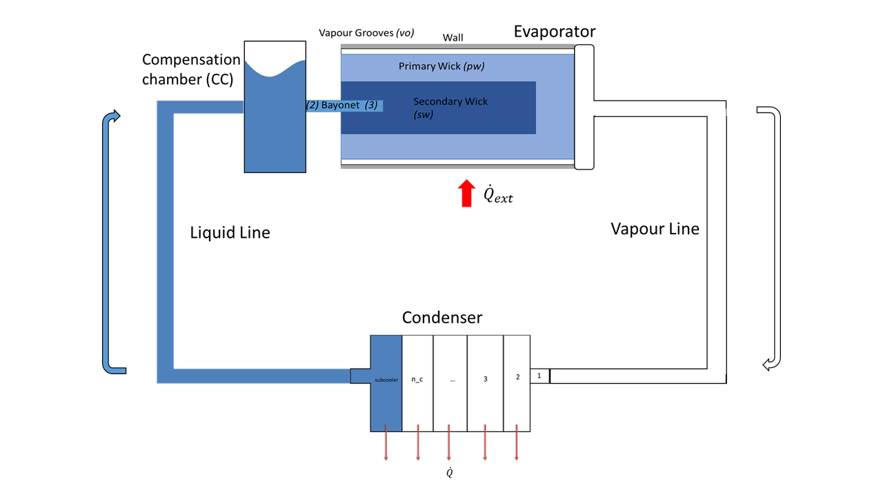
Fig. 1 - LHP schematic.
In the present investigation, a 1-D lumped parameter model in Octave programming language, has been developed.

Lumped Parameter Model (LPM)

A lumped parameter model simplifies the behaviour of a physical system concentrating different entities in discrete points or nodes where the variables of interest are calculated, under some assumptions. In this way, the difficulties of integrating along actual geometries are avoided. Equivalent properties are attributed to each node taking into consideration the effective geometry. With the LPM, the electric thermal electrical [6] and hydraulic electrical [7] analogies are used to analyse the system. The principal features are listed in the following table.
Table 1 - Electric analogies. R_{t} is the thermal resistance, R_{d} is the pressure resistance (pressure drop) associated to the distributed losses and R_{c} is the pressure resistance (pressure drop) associated to the concentrated losses.
Value | Electrical | Thermal | Hydraulic
Potential  (value on the nodes) | $$V$$Electric Potential | $$T$$Temperature | $$P$$Pressure
Flux  (value travelling the net) | $$I$$Current | $$\dot{Q}$$Heat Transfer Rate | $${\dot{m}}_{v}$$Volumetric flow rate
Resistance | $$R$$ | $$R_{t}$$ | $$R_{d},R_{c}$$
Fundamental Law  (for Lumped Parameter Model) | $$∆V=RI$$  Ohm’s Law | $$∆T=\dot{Q}R_{t}$$  Newton’s Law | $$∆P={\dot{m}}_{v}(R_{d})$$  Poiseville’s Law
The result of this approach is a simplified Ordinary Differential Equation (ODE) system for transient conditions, or a normal algebraic system of equations for steady-state conditions.
Hence, an approximate but still very accurate solution is achieved, reducing significantly the computational time and allowing scientists and engineers to focus on the variation of controlling parameters, in order to design and optimise the device/components under consideration.

Mathematical Framework

The lumped parameter model developed for the simulation of the LHP behaviour comprehends a section for the start up and four additional sections (evaporator, liquid and vapour line and condenser) in accordance to the actual components division of the system (Fig. 1).
The general assumptions are:
- one dimensional domain;
- lumped parameter approach;
- liquid assumed as incompressible;
- vapour assumed as compressible and ideal gas;
- adiabatic transformations into the vapour line;
- all the LHP components have a cylindrical geometry;
- the pressure and temperature dependence of working fluid parameters, such as density, viscosity, thermal conductibility and so on, are calculated considering polynomial fits obtained using empirical data [8];

Start Up
Aiming to represent a real application, all the parts are at the beginning at same ambient temperature $T_{amb}.$There four different start-up scenarios, in this case it was chosen the most favorable one where liquid fills the wick and the bayonet and vapour is present in the vapour grooves (since the LHP is evacuated). In this case the loop will start immediately as soon as the external heat load is applied [9]. In this work although the term start-up will refer to the time that the LHP takes to dissipate all the heat in input, in other words the time it takes to reach steady state conditions.
Starting from the ambient temperature, the fluid assumes the saturation pressure corresponding to$P_{i}=f_{sat}(T_{amb})$. Since the LHP is an enclosed system with known filling ratio volume$v_{fr}$, this transient condition has to be treated as an isochoric heating, therefore pressure needs to be incremented alongside the temperature in order to get to the point when temperature is high enough to dissipate the required amount of heat.
The procedure is to chase the pressure corresponding to the new value of internal energy of the liquid-vapour mixture, given by the following equation:
$$u\left(t_{i+1}\right)=u\left(t_{i}\right)+\frac{\dot{q}∆t}{m_{evap}}$$
where the internal energy of the mixture is obtained by the following $u=xu_{v}+\left(1-x\right)u_{l}$ in which $x=(v_{fr}-v_{l})/(v_{v}-v_{l})$.
This operation will be repeated every time step aiming to respect the heat balance equation:
$${\dot{Q}}_{ext}={\dot{Q}}_{c}+{\dot{Q}}_{ll}+m_{evap}\frac{dT_{evap}}{dt}$$
where $Q_{c}$and $Q_{ll}$ are the heat dissipated respectively at the condenser and at the liquid line (the vapour line is adiabatic). From equation (2), considering the usage of a discrete time step, comes the parameter $\dot{q}$ in equation (1):
$$\dot{q}= {\dot{Q}}_{ext}-{\dot{Q}}_{c}-{\dot{Q}}_{ll}-m_{evap}\frac{dT_{evap}}{dt}$$
In the model, the last term on the right-hand side is treated as a discrete difference divided by the integration time step${ h}_{step}$.
To conclude the start-up calculations, the mass flow rate is obtained, considering the dependency from the temperature of the heat of vaporisation$h_{LV}$:
$$\dot{m}=\frac{{\dot{Q}}_{ext}}{h_{LV}}$$

Evaporator
It was chosen to de-couple the compensation chamber from the evaporator (the schematic configuration is represented in Fig. 2) and analyse these two domains separately.
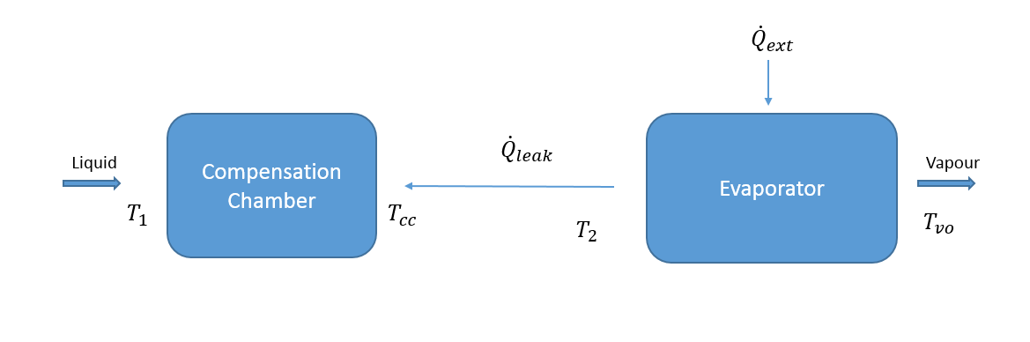
Fig. 2. Evaporation / Compensation Chamber schematic.
The parameter ${\dot{Q}}_{leak}$in Fig. 2 represents the amount of heat that goes wasted into vaporizing the liquid in the inner side of the primary wick. This vapour flows inside the CC carrying the ${\dot{Q}}_{leak}$ (thus the arrow in Fig. 2). The heat leakage is complex to predict, since it depends on the geometry, the distribution of the non-wicked passages inside the wicks, and the way that the CC and the actual evaporator are coupled. An initial value of ${\dot{Q}}_{leak}= 0.1{\dot{Q}}_{ext}$ was assumed, as suggested by the literature. There are no other ways for the heat in input to go that are not the liquid vaporization or the leaking in the CC [10].
Flowing inside the bayonet, liquid enters the compensation chamber, as shown in Fig. 2. Therefore the liquid inside the bayonet and the liquid inside the CC have the same temperature ($T_{cc}=T_{2}$ ). Since the compensation chamber contains both liquid and vapour, $T_{cc}$ was considered as the saturation temperature for that node.
Applying the energy balance equation to the compensation chamber domain:
$${\dot{Q}}_{ext}+{\dot{Q}}_{leak}=\dot{m}c_{p}\left(T_{1}-T_{cc}\right)+m_{cc}c_{p,cc}\frac{dT_{cc}}{dt}$$
which leaves $T_{cc}$as the only unknown.
Since CC contains both phases of the working fluid, it should also be at saturated conditions. Using the calculated value of $T_{cc}$, the pressure of the CC can be also calculated ($P_{cc}=f_{sat}(T_{cc})$).
As for the evaporator domain, Fig. 3 represents the thermal network used to analyse it. The indicted arrows on the thermal network represent the heat flow rate directions, similarly to what happens with the electrical currents in an electric circuit.
Writing the balance equation for every node:

$$\frac{dT_{vo}}{dt}=\left[-\frac{T_{vo}-T_{pw}}{R_{pwvo}}-\frac{T_{vo}-T_{wall}}{R_{vowall}}+\dot{m}c_{p,v}(T_{sat}-T_{vo})\right]\frac{1}{m_{vo}c_{p,v}}$$
$$\frac{dT_{pw}}{dt}=\left[-\frac{T_{pw}-T_{vo}}{R_{pwvo}}-\frac{T_{pw}-T_{wall}}{R_{wallpw}}-\frac{T_{pw}-T_{cc}}{R_{pw2}}-{\dot{Q}}_{leak}-\dot{m}h_{LV} \right]\frac{1}{m_{pw}c_{pw}}$$
$$\frac{dT_{wall}}{dt}=\left[-\frac{T_{wall}-T_{vo}}{R_{vowall}}-\frac{T_{wall}-T_{pw}}{R_{wallpw}}+{\dot{Q}}_{ext}\right]\frac{1}{m_{wall}c_{pwall}}$$

where the signs are derived according to the arrows directions in Fig. 3.
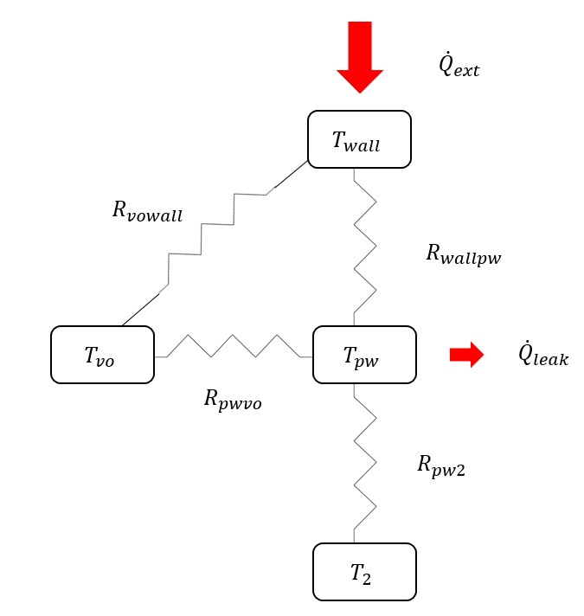
Fig. 3. Thermal Network schematic.
In equation (5) in addition to the sensible heat terms, there is also the enthalpy flows difference between inlet and outlet point of the vapour grooves. That is to take into account the amount of superheat that the vapour grooves may have. In fact, at the entrance of the groove, the vapour is at the saturation temperature due to the evaporation inside the primary wick. To express the evaporation phenomena in the primary wick, the removal of the latent heat is taken into account by the last term within the square brackets, in equation (6). Below the thermal resistances are reported:
$$R_{pwvo}=\frac{1}{h_{cvg}A_{vg}}+\frac{\ln\left(\frac{r_{pw}}{r_{sw}}\right)}{2πk_{pw}L_{pw}}$$ | $$R_{vowall}= \frac{1}{h_{cvg}A_{vg}}+\frac{\ln\left(\frac{r_{pw}+thick_{ev}}{r_{pw}}\right)}{2πk_{wall}L_{pw}}$$
$$R_{pw2}=\frac{\ln\left(\frac{r_{pw}}{r_{sw}}\right)}{2πk_{pw}L_{pw}}+\frac{\ln\left(\frac{r_{sw}}{r_{bay,e}}\right)}{2πk_{sw}L_{sw}}+\frac{1}{h_{c,bay}A_{bay}}$$
$$R_{wallpw}= \frac{\frac{\ln\left(\frac{r_{pw}}{r_{sw}}\right)}{2πL_{pw}k_{pw}}∙\frac{1}{h_{cvg}A_{vg}}}{\frac{1}{h_{cvg}A_{vg}}+\frac{\ln\left(\frac{r_{pw}}{r_{sw}}\right)}{2πL_{pw}k_{pw}}}+\frac{\ln\left(\frac{r_{pw}+thick_{ev}}{r_{pw}}\right)}{2πk_{wall}L_{pw}}$$
where $h_{c,vg}=3.66\frac{k_{l}}{2r_{vg}}$ is the convection coefficient inside the vapour grooves and $A_{vg}=rL_{vg}$ is the exchange surface, assumed as rectangular shape.
Equations (5), (6) and (7) constitute the ODE system that solves the temperature problem for the evaporator domain.
As for the pressure problem, starting from pressure $P_{1}$and using the electric-hydraulic analogy:

 | $$P_{2}=P_{1}-\dot{m}R_{d12}$$ | $$R_{d12}= \frac{8μ_{l}L_{cc}}{ρ_{l}πr_{cc,i}^{4}}$$
 | $$P_{3}=P_{2}-\dot{m}R_{d23}$$ | $$R_{d23}= \frac{8μ_{l}L_{bay}}{ρ_{l}πr_{bay,i}^{4}}$$
In order for the fluid to circulate inside the device, a positive $∆P_{cap}$ due to capillarity needs to be applied by the wicks, governed by the Laplace-Young equation [10]:
$$∆P_{cap}=\frac{2σ}{\overline{r}}cosθ$$
where $\overline{r}$ is the medium pore radius and $θ$is the angle of the menisci at the wick pore.
This $∆P_{cap}$ must compensate the sum of all the pressure drops along the LHP. Thus, the pressure balance equation is the following:
$$∆P_{cap}=∆P_{vo}+∆P_{vl}+∆P_{cond}+∆P_{ll}+∆P_{bay}$$
Since equation (10) has a geometry dependency, a tuning parameter $χ$ was added to act on the balance of that equation:
$$P_{sw}=P_{3}+χ{\frac{2σ}{\overline{r}}}_{sw}$$
$$P_{pw}=P_{sw}+χ{\frac{2σ}{\overline{r}}}_{pw}$$
The tuning parameter is calculated from the solution of Equation (15) at the previous time step:
$$χ =\frac{P_{pw}-P_{3}}{ΔP_{pw}+ΔP_{sw}}$$
This procedure is reasonable since the curvature of the menisci changes naturally in order to have a capillary pressure that balances the total pressure drop in the loop [11]. The parameter $χ$was used instead of $cosθ$since the focus of this work is not in the wick menisci.
To conclude the pressure problem for the evaporator, pressure drop inside the vapour grooves is calculated:
 | $$P_{vo}=P_{pw}-\dot{m}R_{dvg}$$ | $$R_{dvg}= \frac{8μ_{l}L_{vg}}{ρ_{v}πr_{vg,i}^{4}}$$

Vapour Line
In Fig. 4 a zoom of the vapour line schematic is provided, in which is evident the vapour chamber that collects the vapour form the different vapour grooves. Generally, the node differentiation for the vapour line (and following the liquid line as well) is made placing a node before and after every bend.

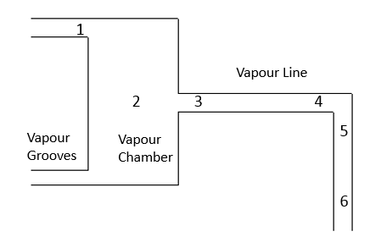
Fig. 4. Vapour Line schematic.
Recalling assumptions 4 and 5, vapour is assumed to be an ideal and compressible gas and the vapour line is adiabatic. Therefore polytrophic relations with exponent $n=k_{g}$ are used [12]:
$$Pv^{k_{g}}=cost → \frac{P}{ρ^{k_{g}}}=cost$$
$${TP}^{\frac{1-k_{a}}{k_{g}}}=cost$$
where $k_{g}=\frac{c_{p}}{c_{v}}$ is the adiabatic index.
The explanation of the iterative procedure will go through the use of the index $i$indicating the node number. From the evaporator solution, temperature and pressure at the start of the vapour line are known, hence:
$$P_{i+1}=P_{i}-\dot{m}{(R}_{d,i}+R_{c,i}) +gρ_{v}∆z_vl$$
where:
- $R_{d,i}=\frac{\left(8μ_{v} L_{i,i+1}\right)}{ρ_{v} πr_{vl}^{4}}$ is equal to zero for the first two nodes, where the pressure loss is due only to the cross-sectional area change;
- $R_{c,i}=\frac{\left(k_{c} v\right)}{2πr_{vl}^{2} }$ after the first two nodes is estimated only at the odd nodes (since the node subdivision accounts for the turns only);
- $gρ_{v}{∆z}_{vl}$is the pressure drop due to gravity, which depends from the position of the condenser with respect to the evaporator, i.e. if the latter is at a highest quote ${∆z}_{vl}$ will have a negative sign.
$$T_{i+1}=T_{i} {\left(\frac{P_{i}}{P_{i+1}}\right)}^{\frac{1-k_{g}}{k_{g}}}$$
$$ρ_{i+1}=ρ_{i} {\left(\frac{P_{i+1}}{P_{i}}\right)}^{\frac{1}{k_{g}}}$$
$$v_{i+1}=\frac{\dot{m}}{ρ_{i+1} πr_{i}^{2}}$$
The value $r_{i}$ is equal to $r_{VG}$ for the first node, $r_{vc}$ for the second node, and $r_{vl}$ for the remaining.
This procedure will be repeated for every node and will bring the values for temperature and pressure at the inlet of the condenser.

Condenser
The condenser is composed by a part where the actual condensation takes place, plus eventually a part used to subcool the liquid in order to match the rise of the temperature in the compensation chamber. The first node of the condenser is considered to have a vapour quality of unity, assuming that no premature condensation happens inside the vapour line.
Working fluid properties when the considered regime is two-phase flow are calculated using empirical relations as follows:
- Internal convective heat transfer coefficient (Shah’s Correlation [13]):

$$h_{c,i}=α_{f}\left[{(1-x)}^{0.8}+\frac{3.8x^{0.76}{(1-x)}^{0.04}}{P^{*^{0.38}}}\right]$$

where $α_{f}=0.023{Re}^{0.8}{Pr}^{0.3}\frac{k_{l}}{{2r}_{i}}$ is the liquid convection coefficient from Dittus-Boelter and $P^{*}$ is the reduced pressure;
- Two phase density is calculated as a weighted average density of the two-phase components with the vapour quality:
$$ρ_{2p}=xρ_{v}+\left(1-x\right)ρ_{l}$$
- Two phase viscosity is calculated as follows [14]:

$$μ_{2p}=μ_{l}-2.5μ_{l}{\left(\frac{xρ_{l}}{xρ_{l}+\left(1-x\right)ρ_{v}}\right)}^{2}+\left(\frac{xρ_{l}\left(1.5μ_{l}+μ_{v}\right)}{xρ_{l}+\left(1-x\right)ρ_{v}}\right)$$
Since it is a transient problem, the number of condenser nodes $n_{c}$ depends on the integration time step. Therefore $n_{c}$ is calculated considering that the mass of the single node needs to be equal to the mass of liquid corresponding to the quantity of working fluid passing through the node at each integration time step:
$$m_{i}= ρ_{l}πr_{i}^{2}L_{x}=ρ_{l}πr_{i}^{2}\frac{L_{cond}}{n_{c}}$$
$$n_{c}= \frac{ρ_{l}πr_{i}^{2}L_{cond}}{m_{i}}=\frac{ρ_{l}πr_{i}^{2}L_{cond}}{\dot{m}h_{step}}$$
Since the mass flow rate is a function of the external heat, the number of nodes are also function of the external heat. Therefore, the lower the heat input, the higher is the number of nodes and thus the computational time.
The iterative procedure is the following, starting from the pressure:

$$P_{i}=P_{i-1}- \dot{m}(R_{d}+R_{c})$$
where:
- $R_{d,i}=\frac{8μ_{2p}∆x}{ρ_{2p}πr_{vl}^{4}}$ is the distributed pressure drop, with $∆x$ the length discretisation of the condenser duct;
- $R_{c,i}=\frac{k_{c}v}{2πr_{i}^{2}}$ is the concentrated pressure drop due to turn or sudden change in the pipe section, therefore it is not always present.
For the temperature problem, the starting points are the equations of conservation for energy and mass:
Energy | $$\frac{dH}{dt}=\frac{d\left(m_{v}h_{v}+m_{l}h_{l}\right)}{dt}={\dot{Q}}_{c,i}+\dot{m}\left(h_{i-1}-h_{i}\right)$$
Mass | $$m_{i-1}+\frac{dm_{i}}{dt}=m_{i}$$
From the mass balance, since there is not mass input in time in a single control volume representing the node:
$$\frac{dm_{i}}{dt}=\frac{d\left(m_{v}+m_{l}\right)}{dt}=\frac{d\left(ρ_{l}V_{l}\right)}{dt}+\frac{d\left(ρ_{v}V_{v}\right)}{dt}=0$$
$$ρ_{l}\frac{dV_{l}}{dt}=-ρ_{v}\frac{dV_{v}}{dt}$$
This allows to unravel equation (29):
$$\frac{d(ρ_{v}V_{v}h_{v})}{dt}+\frac{d(ρ_{l}V_{l}h_{l})}{dt}={\dot{Q}}_{c,i}+\dot{m}\left(h_{i-1}-h_{i}\right)$$
Both vapour and liquid enthalpies are functions of the temperature only, and since only phase change processes are considered, the temperature is constant, as a result $h_{v}$ and $h_{l}$ can exit the derivative. Moreover, density values $ρ_{v}$ and $ρ_{l}$ are calculated from the two-phase relations as a function of the pressure difference between two nodes, thus they can exit the derivative too:
$$ρ_{l}h_{l}\frac{dV_{l}}{dt}+ρ_{v}h_{v}\frac{dV_{v}}{dt}={\dot{Q}}_{c,i}+\dot{m}\left(h_{i-1}-h_{i}\right)$$
$${-ρ}_{l}h_{LV}\frac{dV_{l}}{dt}=Q_{c,i}+\dot{m}\left(h_{i-1}-h_{i}\right)$$
where:
- $h_{LV}=h_{v}-h_{l}$ is the enthalpy of vaporisation;
- $h_{i-1}-h_{i}$ is the difference of enthalpy between two adjacent nodes, where the single node enthalpy is a function of the temperature and the vapour quality, $h_{i}=x_{i}h_{v,i}+\left(1-x_{i}\right)h_{l,i}$;
- $Q_{c,i}$ is the heat lost to the cold source at every node, defined accordingly to
$$Q_{c,i}=\frac{T_{c}-T_{i}{\left(P_{i}\right)}_{sat}}{R_{t,i}}$$
where the temperature of the node is calculated from the solution of the pressure problem (note that during phase change processes, the working fluid is under the saturation curve).
Coming back to equation (32), considering that$V_{l}=\frac{m_{l}}{ρ_{l}}=\frac{m_{tot}(1-x)}{ρ_{l}}$, it is possible to express the differential equation of the condenser as a function of vapour quality only:
$-h_{LV}\frac{d\left(\left(1-x\right)m_{tot}\right)}{dt}=\frac{T_{c}-T_{i}{\left(P_{i}\right)}_{sat}}{R_{t,i}}+\dot{m}\left(h_{i-1}-h_{i}\right)$
$-h_{LV}\frac{d\left(1-x\right)}{dt}m_{tot}-h_{LV}\left(1-x\right)\frac{dm_{tot}}{dt}=\frac{T_{c}-T_{i}{\left(P_{i}\right)}_{sat}}{R_{t,i}}+\dot{m}\left(h_{i-1}-h_{i}\right)$
Since the total mass is constant$\frac{dm_{tot}}{dt}=0$:
$$\frac{dx}{dt}=\frac{T_{c}-T_{i}{\left(P_{i}\right)}_{sat}}{R_{t,i}m_{i}h_{LV}}+\frac{\dot{m}}{m_{tot}}\frac{(h_{i-1}-h_{i})}{h_{LV}}$$
This approach, to the author’s best knowledge, is a novelty regarding the description of the condenser behaviour.
Summarising, the sequence for the condenser solution is the following (Fig. 5):
- node pressure $P_{i}$ is calculated;
- due to saturated relations, also temperature $T_{i}$ is obtained since phase change is occurring (while $T_{i-1}$is known from the previous node);
- supplying the differential equation (35) with the two temperatures, the vapour quality at the node is evaluated;
- using this last parameter, the fluid properties for the next node are calculated, thanks to the empirical relations for the two phase conditions, and therefore the cycle is closed.

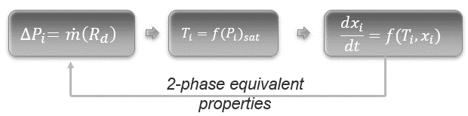
Fig. 5. Condenser solution procedure.

Liquid Line
The liquid is incompressible and subcooled and the temperature of the surroundings $T_{amb}$ is known from the boundary conditions.In this part of the model the starting point is the heat exchanged at the node:
$$Q_{ll,i}=\frac{T_{amb}-T_{i} }{R_{t,i}}$$
where:
- $R_{t,i}=\frac{1}{h_{ce,i}A_{e,i}}+\frac{1}{h_{ci,i}A_{i,i}}$;
- $h_{ci,i}=0.023{Re}^{0.8}{Pr}^{ndb}\frac{k_{l}}{{2r}_{i}}$ with ndb the Dittus-Boelter coefficient which is 0.4 for heating and 0.3 for cooling [15];
- $h_{ce,i}=10\frac{W}{m^{2}K}$natural or free convection coefficient.
For the pressure:
$$P_{i+1}-P_{i}=\dot{m}(R_{d,i}+R_{c,i}))-gρ_{l}{∆z}_{ll}$$
where $R_{c,i} ≠0$ when i is an odd number and $gρ_{v}{∆z}_{ll}$ is the pressure drop due to gravity, which in this case helps the fluid motion.
For consistency, the definitions of $R_{d,i}$ and $R_{c,i}$ are reported:
$$R_{d,i}=\frac{8μ_{l}∆x}{ρ_{l}πr_{ll}^{4}} R_{c,i}=\frac{k_{c}v}{2πr_{ll}^{2}}$$
To close the cycle:
$$Q_{amb,i}=\dot{m}\left(h_{i+1}-h_{i}\right)$$
$$∆h=\frac{Q_{amb,i}}{\dot{m}}=c_{p}∆T$$
$$T_{i+1}=T_{i}-\frac{Q_{amb,i}}{\dot{m}c_{p}}$$
The temperature of the last node of the liquid is going to be $T_{1}$ for the evaporator at the following time step, and thus the cycle is repeated.

Numerical validation

In order to prove the effectiveness of the model, a validation through literature was sought, with the purpose of replicating experimental results. Obviously, it is not expected a sterling precision since usually not all the physical/geometrical parameters are reported in the common papers.
Satisfactory results were obtained reproducing the results by Pouzet et al. [16], where they were interested in the response to both an upward and a downward swing of the externally applied heat, comparing experimental results with their simulations. Thus, the externally applied heat was varied from 200 W to 400 W and then back to 200 W.
But first of all, it was deemed appropriated to check the physical reliability of the model. To prove that, it was chosen to replicate qualitatively the following graph by Hoang and Ku [5]:

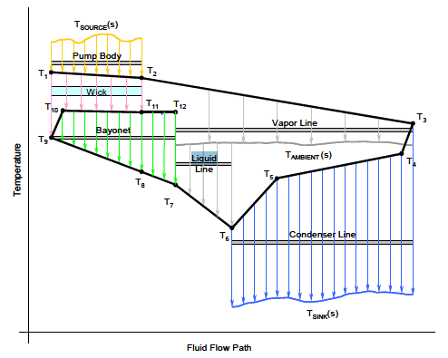
Fig. 6 - Qualitative temperatures trends comparison between Hoang and Ku (left) [5] and LOOPER (right).
Following will be presented the comparison between LOOPER model predictions with the numerical model predictions presented in the abovementioned paper as well as with the proposed experimental measurements.

Fig. 7 - Evaporator wall temperatures comparison

Fig. 8 - Compensation chamber temperature comparison

Fig. 9 - Mass flow rate comparison

Fig. 10 - Primary wick and vapour grooves temperatures comparison
From Fig. 6 the comparison shows that the model is able to capture the trend of the evaporator wall temperature with a small error, but is also able to predict the overshoot in the upward variation of external heat, in contradiction to the theoretical model of the paper. A bigger than expected overshoot is observed in the downward variation of the external heat, and it is the authors’ opinion that this is due to the bigger thermal inertia accumulated by the fluid that suddenly renders the dissipation of heat done by the condenser too high.
Fig. 7 shows the comparison of the compensation chamber temperature, which presents qualitatively the same pattern of the evaporator wall, in the sense that at the increase of heat load there is small overshoot, which is captured correctly. Whereas on the decrease of heat load the overshoot is again over predicted. The temperature error is similar to the error for the evaporator wall and it is within the expected range.
Taking a look at Fig. 8 regarding the variation of the mass flow rate, in LOOPER model is kept constant in every part of the loop, therefore if it is compared to the condenser outlet values of the paper a quite precise replica can be observed. Also the error in this case is lower since mass flow rate depends only from external heat and heat of vaporisation of the working fluid.
Quite interesting is Fig. 9 where primary wick temperature (liquid under the meniscus) and vapour grooves (vaporisation at the evaporator) are compared. The LOOPER model is able to predict the opposite behaviour of the two nodes, even if their temperature difference is bigger than the one measured by the paper. This inverse pattern between wick and vapour grooves allows the evaporator to be thermally stable.

Parametric Analysis

This part of the work gives important useful information for the design phase and it also illustrates the usefulness of the developed code as a design tool. The followed methodology is: starting from the reference geometry, increase and decrease of 20% one parameter at the time, to isolate its effect in the LHP operation. The parameters on which the variations were applied are the ones that can be changed by design, that: internal radius of the condenser$ri_{cond}$, thickness of the condenser pipe $thick_{cond}$, thickness of the evaporator wall$thickev$, length of the condenser${ L}_{cond}$, radius and length of the primary wick $r_{pw}, L_{pw}$, porosity, radius of vapour grooves $n_{vg}$, $r_{vg}$, liquid and vapour line internal radius $ri_{ll}, ri_{vl}$, initial pressure $P_{1}$, heat leakage $Q_{leak}$ and ambient temperature $T_{amb}$.
The results of this parametric analysis is the effect of the variation of the these parameters on the performance properties such as vapour quality, maximum temperature, total thermal resistance, total mass, start up time and maximum pressure.
The geometry is the same of the one used by Pouzet et al..
Firstly, it will be presented the effect of the variation of the single parameter on the performance of the LHP:

Table 2 - Effect on single parameters on performances

From Table 2 the flowing considerations are drown:
- condenser internal radius reduction hinders the vapour quality while helps the other factors, especially the startup time;
- condenser pipe thickness increase hinders all the factors, especially for the thermal resistance but besides the startup time. The effect here are quite strong;
- thickness of the evaporator shell plays an opposite effect on startup time with respect to thermal resistance and mass. Is not playing a significant role on maximum temperature and pressure or vapour quality;
- the longer the condenser is the better is for startup time and thermal resistance especially but also for temperature and pressure. Vapour quality in this case is not affected, but is the authors’ opinion that this is case sensitive;
- radius of the primary wick can influence quite a bit the thermal resistance, and a little bit the temperature but not the other factors;
- the longer the primary wick is the better is for the thermal resistance;
- variation of some parameters have negligible effects on the performance parameter, such as porosity, number of vapour grooves (which effects lightly the maximum pressure), vapour grooves radius and the heat leakage;
- starting pressure increase increases vapour quality, maximum temperature and pressure and most of all thermal resistance. It helps a lot the startup time;
- the radius of liquid line and vapour line don’t have particular physical influences, expect on the total mass;
- ambient temperature deeply affects maximum temperature and pressure.
Furthermore, with these data is possible to plot which design parameters plays a bigger impact on a single performance factor:

Fig. 11- Effect on vapour quality

Fig. 12 - Effect on maximum Temperature

Fig. 13 - Effect on total thermal resistance

Fig. 14 - Effect on total mass

Fig. 15 - Effect on start-up time

Fig. 16 - Effect on maximum Pressure
From the previous graphs it is clear how the thickness of the condenser pipe is a very important design parameter, since it influences the thermal resistance of the pipe. Other important parameters are internal radius of the condenser, ambient temperature, thickness of the evaporator wall, length of the primary wick.
Lastly, it was investigated how these design parameters affect the heat balance. The results shown in Fig. 17 remark the importance of $re_{cond}$. Also the initial pressure, the length of the condenser and the primary wick radius.

Fig. 17 - Effect on the resultant of the heat balance equation

Conclusions

A one-dimensional lumped parameter model characterizing thermally a Loop Heat Pipe has been created in an open source software such as Octave. Due to the lumped parameter approach and the mono dimensionality, it provides appreciable results with small computational time. In fact, depending on the external heat, it can have minor difference between the computational time and the simulated time.
A new strategy to express the phase change has been formulated utilizing the differential variation of the vapour quality, making possible to avoid using the specific heat in the phase change processes.
Moreover, validation processes has been carried out to prove the code reliability and results were satisfactory. Without some information about parameters both on the geometrical and the physical side, the model is able to capture trends of the main variables with reasonable accuracy.
In addition a parametric analysis between design and performance parameters has been carried out, allowing to a better understanding of the most important ones.
For future developments, experimental data with a precise knowledge of the configuration and boundary conditions are needed in order to improve the code precision. Moreover it could be interesting to perform more analysis with different fluids and materials.

Acknowledgments
The authors are grateful to Innovate UK and Tata Motors European Technical Centre Plc, for financing the research under the framework of project LOOPER Heat Pump Circuit Project and for supporting M. Bernagozzi with a fellowship (Ref: 132232).

References

[1] | L. Vasiliew, "Heat pipes in modern heat exchangers," Applied Thermal Engineering, vol. 25, no. 1-19, 2005.
[2] | Y. Zhang and A. Faghri, "Advances and Unsolved Issues in Pulsating Heat Pipes," Heat Transfer Engineering, vol. 29, no. 1, pp. 20-44, 2008.
[3] | M. Mochizuki, T. Nguyen, K. Mashiko, Y. Saito, T. Nguyen and V. Wuttijumnong, "A review of heat pipe application including new," Frontiers in Heat Pipes, vol. 2, pp. 1-15, 2011.
[4] | Y. Maydanik, " Loop heat pipes," Applied Thermal Engineering, no. 25, pp. 635-657, 2005.
[5] | T. T. Hoang and J. Ku, "HEAT AND MASS TRANSFER IN LOOP HEAT PIPES," in Proceedings of 2003 ASME Summer Heat Transfer Conference, Las Vegas, Nevada, USA, 2003.
[6] | A. F. Robertson and D. Gross, "An Electrical-Analog Method for Transient Heat-Flow Analysis," Journal of Research of the National Bureau of Standards, vol. 61, no. 2, August 1958.
[7] | K. W. Oh, K. Lee, B. Ahna and E. P. Furlani, "Design of pressure-driven microfluidic networks using electric circuit analogy," Lab on a Chip, vol. 12, no. 2, pp. 515-545, 2012.
[8] | P. Linstrom and W. Mallard, ebBook, NIST Standard Reference Database Number 69, NIST Chemistry W, Eds..
[9] | J. Ku, "Loop Heat Pipe Startup Behaviors," in 46th International Conference on Environmental Systems, Vienna, Austria, 10-14 July 2016, .
[10] | J. Ku, "Operating Characteritics of Loop Heat Pipes," in 29th International Conference on Enviromental System, Denver, Colorado, USA, 1999.
[11] | J. Ku, "Methods of Controlling the Loop Heat Pipe Operating Temperature," in 38th International Conference on Environmental Systems, San Francisco, California, June 29-July 2, 2008.
[12] | P. Hill and C. Peterson, Mechanics and Thermodynamics of Propulsion, Addison-Wesley, 1992.
[13] | R. Santa, "The Analysis of Two-Phase Condensation Heat Transfer Models Based on the Comparison of the Boundary Condition," Acta Polytechnica Hungarica 9(6) (2012) 167-180, vol. 9, no. 6, pp. 167-180, 2012.
[14] | M. Awad and Y. Muzychka, "Effective property models for homogeneous two-phase flows," Experimental Thermal and Fluid Science, vol. 33, no. 1, pp. 106-113, 2008.
[15] | F. P. Incropera, Fundamentals of Heat and Mass Transfer (4th ed.), New York: Wiley, 2000.
[16] | E. Pouzet, J. Joly, V. Platel, J. Grandpeix and C. Butto, "Dynamic response of a capillary pumped loop subjected to various heat load transients," International Journal of Heat and Mass Transfer, no. 47, pp. 2293-2316, 2004.

