Clinical scale activated carbon monolith as haemoperfusion column to augment the current haemodialysis

Introduction
Clinical scale activated carbon monolith with 30 mm diameter was tested for toxin marker removal and haemocompatibility in a large scale perfusion system.

Materials and methods

Materials
Healthy donor whole bloods (400 ml from each donor) with sodium heparin anticoagulation were purchased from Cambridge Bioscience Ltd (UK). Platelet activation regent phorbol 12-myristate 13-acetate (PMA) was purchased from Sigma-Aldrich. Leucocyte activator human recombine IL-6, IL-8; fluorophore conjugated antibodies including PE/CD61 (platelet specific antibody), APC /D62P (P-selectin specific), FITC/PAC-1 (activated glycoprotein IIb/IIIa fibrinogen binding site marker); were purchased from BD Biosciences, UK. BD Phosflow T cell Activation Kit, BD FACS Lysing Solution, Human C3a ELISA kit, Human C5a ELISA kit II and Human C4a ELISA kit were alsopurchased from BD Biosciences, UK. Fluorophore conjugated antibodies including PE/CD14 and APC/CD11b were purchased from BioLegend, UK. Nanoporous activated carbon monoliths were provided by Mast Carbon International, UK.

ex vivo perfusion set up
Prior to the perfusion, AC monoliths were pre-conditioned by circulating 400 ml of Baxter intravenous infusion saline solution (0.9% NaCl, 0.15% KCl & 0.2% MgCl) solution at the flow rate of 300 ml/min for 30 min using a MollerMedical Labo Var 225 pump. Donor blood (400 ml) was perfused through each monolith at the rate of 300 ml/min. A control with no AC monolith attached to the circulation was also included as control (tubing control). The perfusion set up is shown in Figure 1.
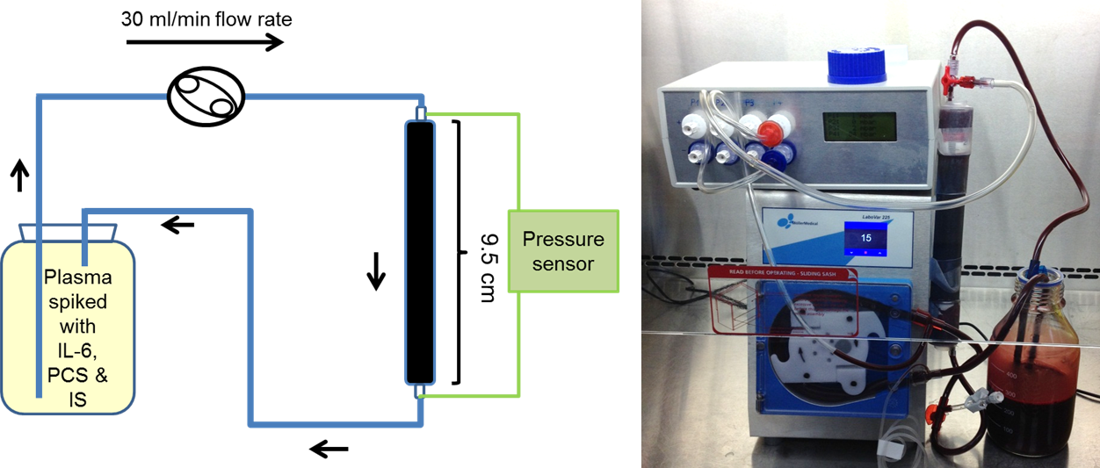
Figure 1 Clinical scale whole blood perfusion system set up

Biotoxin markers removal profiles:
Two albumin bound uraemic toxins markers (IS and PCS) and a middle molecular weight uraemic toxin marker interleukin-6 (IL-6) and tumor necrosis factor alpha (TNF-α) are selected as for biotoxin removal studies. Each donor whole blood (400 ml) was spiked with 1000 pg/ml IL-6, 1000 pg/ml TNF-α, 125 µM IS and 250 µM PCS and was perfused through the monolith or tubing only control. Blood samples were collected after 5, 30, 60 and 120 min of circulation.
The remaining IS and PCS were determined using high pressure liquid chromatography (HPLC) method modified from Henriette et al. [26]. In brief, a C-18 reverse phase column was used in the HPLC system with mobile phase A (0.2% trifluoracetic acid in HPLC grade water) and mobile phase B (0.2% trifluoracetic acid in HPLC grade acetonitrile). The mobile phase was pumped through the column with a gradient change from 85% mobile phase A and 15% mobile phase B to 80% mobile phase A and 20% mobile phase B was used to separate the PCS, IS and the 1-naphthalenesulfonic acid (internal standard) in the deproteinated plasma sample. IS and 1-naphthalenesulfonic acid were detected by the Waters fluorescence detector at the wavelength of 234 nm and PCS by the same detector at 298 nm. The remaining IL-6 and TNF-α concentrations were determined by enzyme-linked immunosorbent assay (ELISA) using BD Biosciences IL-6 ELISA set.

Complement activation
C3a, C4a and C5a were selected as complement activation marker. Whole blood samples (1 ml) collected from ex vivo perfusion with 10 µl of 5 mg/ml FUT-179 (Futhan, BD Biosciences, 552035) was centrifuged at 1000g for 15 minutes. After the centrifugation, the supernatant fraction of plasma was collected and stored at -80°C until analysis using BD Cytometric Bead Array (CBA) Human Anaphylatoxin kit (BD biosciences, 561418). The C3a, C4a and C5a CBA assay were performed according to manufacturer’s manual. In brief, 30 µl standards and diluted plasma samples (1/200) were incubated for 2 hours with C3a, C4a or C5a capture beads. After the incubation, the beads were washed using washing buffer provided in the kit. Detection reagent were then added and incubated for 1 hour. This if followed by washing of the beads before 300 µl washing buffer was used to resuspend the beads for flow cytometry analysis. The concentration of C3a, C4a and C5a were determined by interpolation from the corresponding standards.

Platelet activation
Donor blood (500 µl) were treated with 200 nM PMA 5 minutes and used as positive control. Blood sample (5µl) collected from ex vivo perfusion were incubated in the dark with PE/CD61 (10 µl), APC /D62P (10 µl) and FITC/PAC-1 (10 µl) antibody cocktail for 20 minutes before they were fixed using 1 ml of chilled 1% paraformaldehyde in PBS for 30 minutes at 4 °C. The fixed whole blood were then analysis using Accuri C6 with data acquisition run limit of 10,000 events on platelet gate and Forward Scatter (FSC) threshold of 10,000. The population of platelets and the fluoresce intensity of platelet activation markers were obtained using BD CSampler software (version 1.0.264.21).

Results

Toxin marker removal
Figure 3 Marker toxin concentration after perfusion through the monolith and tubing only control (SEM±, n=3). Two way ANOVA revealed that there is a significant difference in blood sample PCS, IS, IL-6 and TNF-α concentrations between tubing control and monolith at all of the time points, except from the IL-6 concentration at the first 5 minutes of perfusion.

Complement activation
Figure 4 Concentration of C3a (A), C4a (B) and C5a (C) in the plasma collected from whole blood perfusion through the ex vivo circuit with and without AC monolith (SEM±, n=3). Two way ANOVA revealed that there is no significant difference in blood sample C3a, C4a and C5a concentrations between tubing control and monolith at all of the time points.

Platelet activation
Figure 5 Percentage of PAC-1 positive population (A) and CD62P positive population (B) in the total population of platelet in the whole blood samples collected in ex vivo perfusion circuit with and without AC monolith. 200 nM PMA was used to activate the platelet (PMA) to serve as a positive control (SEM±, n=3). Two way ANOVA revealed that there is no significant difference in the percentages of platelet with elevated CD62p and PAC-1 markers in blood sample between tubing control and monolith at all of the time points.

Table 1 Full blood count of before and after 90 minutes of perfusion through AC monolith (Monolith) and Tubing control (Tubing).
 | Hb (g/L) | WBC (×10⁹/L) | PLT (×10⁹/L) | RBC (×10¹²/L) | HCT | MCV (fL) | MCH (pg) | MCHC (g/L)
Pre-monolith | 141 (119– 154) | 5.7 (4.6 –6.5) | 197 (157 – 258 ) | 4.7 (4.1 – 5.2) | 0.454 (0.383 – 0.477) | 91.9 (88.1 – 99.3) | 29.84(28.8 – 31.9) | 322 (333 – 311)
Post-monolith | 140 (119– 148) | 5.5 (4.6 – 6.5) | 85 (58 – 105) | 4.5 (4.1 – 5.1 ) | 0.428 (0.375 – 0.443) | 90.8 (98.4 – 90.4) | 29.5 (28.7 – 31.6) | 323 (317 – 336)
Pre-tubing | 132 (120– 152) | 6.7 (4.0 – 6.0) | 202 (123 – 321 ) | 4.6 (3.8 – 5.0 ) | 0.412 (0.369 – 0.477) | 93.1 (88.6 – 97.1) | 29.8 (27.6 – 31.6) | 319 (311 – 332)
Post-tubing | 135 (118– 153) | 6.2 (4.3 – 7.9) | 231 (115 – 370) | 4.6 (4.9 – 5.2) | 0.425 (0.366 – 0.479) | 92.9 (89. – 96.8) | 30.1 (27.9 –31.7) | 323 (311 – 341)
Two way ANOVA with multiple comparisons suggested that was no significant difference (p < 0.05) in all the blood parameters tested before and after perfusion through monolith; no significant difference (p < 0.05) in all the blood parameters tested before and after perfusion through tubing only control (n=6).

Table 2 Protein marker levels of the donor blood before and after 90 minutes of perfusion through AC monolith (Monolith) and Tubing control (Tubing).
 | Pre-monolith | Post-monolith | Pre-tubing | Post-tubing | Normal range
Total protein (g/l) | 74 (59 – 75) | 48 (45 – 51) | 70 (68 – 73) | 73 (67 – 73) | 66-87
Albumin (g/l) | 44 (36 – 49) | 30 (28 – 31) | 44 (42 – 48) | 44 (43 – 49) | 34-48
Globulin | 25 (23 – 31) | 17 (17 – 21) | 26 (25 – 26) | 25 (24 – 29) | 18-36
Alkaline Phophate | 54 (49 – 64) | 37 (35 – 57) | 39 (34 – 52 | 39 (35 – 52) | 40-129
ALT | 15 (13 – 22) | 9 (8 – 10) | 12 (12 – 16) | 13 (12 – 15) | 0-41

