Haemocompatibility assessments of an activated carbon monolith in small scale ex vivo model

Abstract
Techniques such as haemodialysis and peritoneal dialysis are life-saving treatments for patients with kidney failure. However, the removal of high molecular weight toxins such interlukin-6 (IL-6) and a wide selection of protein bound toxins such as p-cresyl sulphate (PCS) and indoxyl sulphate (IS) remains a major issues in the optimisation of these systems [1]. Evidence suggests that these toxins have most damaging effects but are poorly removed by current devices [2]. There is an urgent need for an effective haemoadsorbent capable of removing a large spectrum of biotoxins to improve the treatment of kidney failure.
The use of advanced nanoporous activated carbon as a haemoadsorbent for broad spectrum toxin removal has been explored [3-5]. However, when the adsorbents were used in the format of packed bed columns undesirable high column back pressure and cross-column pressure drop during haemoperfusion was observed [6]. Therefore the authors’ group are exploring the potential use of this ACM as an adjunct to improve the current HD treatment regime. This study investigated the haemocompatibility of a blood contacting synthetic, nanoporous activated carbon monolith (ACM) using an ex vivo whole blood perfusion model and assessing the parameters such as whole blood count, urea and electrolyte concentration, blood coagulation time, complement, platelet, granulocyte and T cell activation.

Introduction

Materials and methods

Materials
Platelet activation regent adenosine 5′-diphosphate sodium salt (ADP) and PAC-1 inhibitor Arg-Gly-Asp-Ser (RGDS) were purchased from Sigma-Aldrich. Leucocyte activator human recombine IL-6, IL-8; fluorophore conjugated antibodies including PE/CD61 (platelet specific antibody), APC /D62P (P-selectin specific), FITC/PAC-1 (activated glycoprotein IIb/IIIa fibrinogen binding site marker); were purchased from BD Biosciences, UK. BD Phosflow T cell Activation Kit, BD FACS Lysing Solution, Human C3a ELISA kit, Human C5a ELISA kit II and Human C4a ELISA kit were alsopurchased from BD Biosciences, UK. Fluorophore conjugated antibodies including PE/CD14 and APC/CD11b were purchased from BioLegend, UK. Nanoporous activated carbon monoliths were provided by Mast Carbon International, UK.

ex vivo perfusion set up
Prior to the perfusion, AC monoliths were pre-conditioned by circulating 20 ml of NaCl (0.9%) solution at the flow rate of 5 ml/min for 30 min using an ISMATEC multi-channel peristaltic pump (IPC8). Then freshly drawn healthy donor blood (20 ml) was perfused through each monolith at the rate of 1 ml/min. A control with no AC monolith attached to the circulation was also included as control (tubing control). Blood samples were collected at before perfusion (time 0) and after first pass, 15, 30, 45 and 60 min of perfusion.

Complement activation
C3a, C4a and C5a were selected as complement activation marker. Fresh blood collected from healthy donor were anticoagulated using EDTA were used for this study. Whole blood samples collected from ex vivo perfusion were centrifuged at 3500 rpm for 15 minutes. After the centrifugation, the supernatant fraction of plasma was collected and stored at -80°C until ELISA assay. The C3a, C4a and C5a ELISA assay were performed according to manufacturer’s manual. In brief, 100 µl standards and diluted plasma samples (1/2000 for C3a/C4a and 1/40 for C5a) were incubated for 2 hours in each well of 96 well plates with pre-coated C3a, C4a or C5a capture antibody. After the incubation, the plasma samples were removed from the wells which were then washed five times using washing buffer provided in the kit. Working detectors were then added and incubated for 1 hour. This if followed by aspirating and washing of the plate for 7 times before 50 µl 3,3’,5,5’ tetramethylbenzidine (TMB) subtract was added into each wells and incubated for 30 minutes. Finally the reaction was stopped by addition of 50 µl stop solution before the absorbance was read at 450 nm wavelength. The concentration of C3a, C4a and C5a were determined by interpolation from the corresponding standards.

Platelet activation
Donor blood was collected using 21 gauge needles and anticoagulated with sodium citrate. First 2 ml of blood collected was incubated with ADP (2 µM) for 5 minutes and used as positive control. Fresh whole blood sample (5µl) collected from ex vivo perfusion were incubated in the dark with PE/CD61 (10 µl), APC /D62P (10 µl) and FITC/PAC-1 (10 µl) antibody cocktail for 20 minutes before they were fixed using 1 ml of chilled 1% paraformaldehyde in PBS for 30 minutes at 4 °C. The fixed whole blood were then analysis using Accuri C6 with data acquisition run limit of 10,000 events on platelet gate and Forward Scatter (FSC) threshold of 10,000. The population of platelets and the fluoresce intensity of platelet activation markers were obtained using BD CSampler software (version 1.0.264.21).

Granulocyte activation
In order to determine the granulocyte activation after ex vivo whole blood perfusion experiments, lithium heparin anticoagulated donor blood were used. IL6 (50 ng/ml) and IL8 (50 ng/ml) were used to stimulate the granulocyte activation with 60 minutes of incubation with fresh whole blood. Blood samples (100 µl) were incubated with PE/CD14 (20 µl) and APC/CD11b (20 µl) antibody cocktails for 20 minutes before 1.5 ml Lyse/Fix buffer was added to fix the stained blood samples in the dark for 30 min. The mixtures were then centrifuge at 600g for 6 min for the removal of supernatant and the cells were washed with 2 ml stain buffer. After the washing, the cells were pelleted and resuspend in 300 µl stain buffer for analysis using Accuri C6.

T cell actiation
For T cell activation study, fresh blood collected from healthy donor was anticoagulated using EDTA for ex vivo perfusion. Whole blood (200 µl) collected from the ex vivo perfusion was lysed (red blood cells) and permeabilised (white blood cells) according to manufacturer’s manual. The permeablised white blood cells were collected and stained using PerCP/CD3, Alexa488/CD8, PE/CD4 antibody cocktail (20 µl) and Alexa647/STAT3 (20 µl) for 1 hour. After the staining, the cells were washed and resuspend in 200 µl stain buffer for analysis using Accuri C6.

Results

Complement activation
Figure 1 Concentration of C3a (A), C4a (B) and C5a (C) in the plasma collected from whole blood perfusion through the ex vivo circuit with and without AC monolith. (SEM±, n=3)

Platelet activation
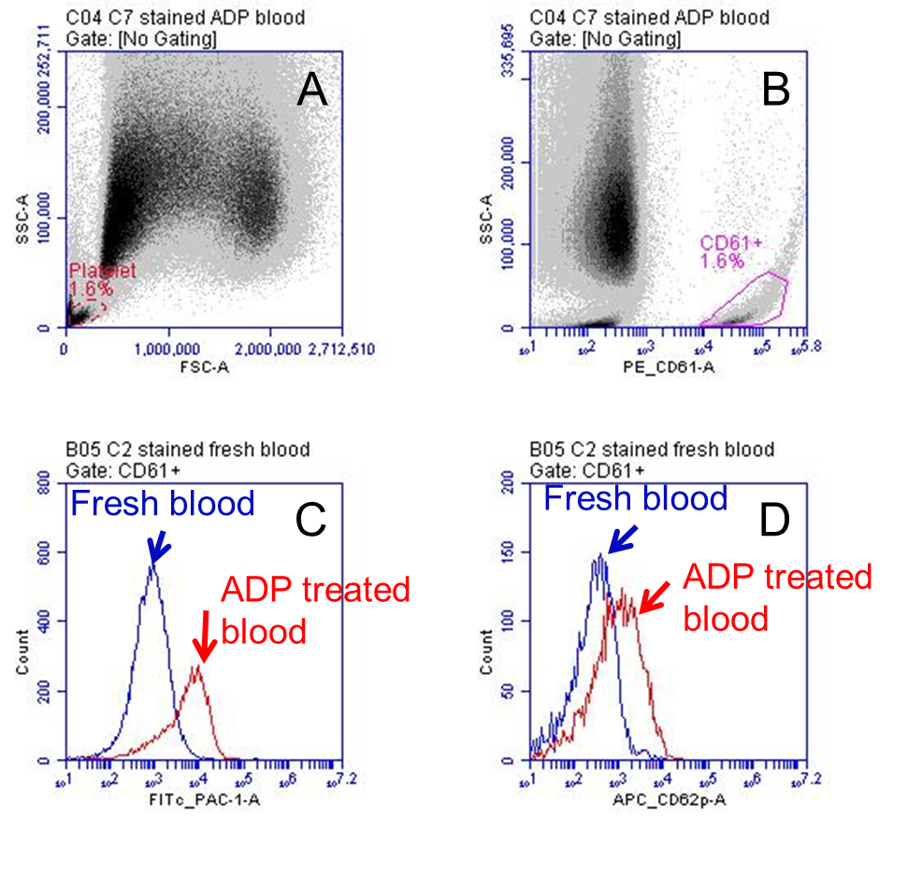
Figure 2 Gating on platelet population using FCS/SSC (A) and CD61/SSC (B) and PAC-1 positive platelet population (C) and CD62P positive platelet population (D).
Figure 3 Percentage of PAC-1 positive population (A) and CD62P positive population (B) in the total population of platelet in the whole blood samples collected in ex vivo perfusion circuit with and without AC monolith. (SEM±, n=3)

Figure 4 Expression of platelet activation markers PAC1 (a) and CD62p (b) in the platelets before and after the whole blood perfused monolith (Monolith) and tubing control (Tubing), 10 µM ADP was used to activated the platelet (ADP) to serve as a positive control.

Granulocyte activation
Figure 6 Percentage granulocyte population with elevated CD11b expression in the total population of granulocyte in the whole blood samples collected in ex vivo perfusion circuit with and without AC monolith. (SEM±, n=3)

T cell actiation
Figure 7 Percentage T cell population with phosphorylated Stat 3 protein in the total population of T cells in the whole blood samples collected in ex vivo perfusion circuit with and without AC monolith. (SEM±, n=3)

Table 1 Full blood count of before and after 60 minutes of perfusion through AC monolith (Monolith) and Tubing control (Tubing).
 | Pre-perfusion | Monolith | Tubng
HB (g/l) | 140.8 ± 16.8 | 137.2 ± 30.4 | 132.8 ± 26.6
WBC ×10⁹ cell/ml | 7.4 ± 1.5 | 7.4 ± 2.1 | 7.9 ± 2.2
PLT ×10⁹ cell/ml | 261 ± 54 | 230 ± 75 | 288 ± 111
RBC ×10¹² cell/ml | 4.76 ± 0.59 | 4.57 ± 1.09 | 4.40 ± 0.92
HCT | 0.416 ± 0.049 | 0.381 ± 0.095 | 0.365 ± 0.073
MCV (fL) | 87.54 ± 3.47 | 83.29 ± 3.46 | 83.33 ± 3.92
MCH (pg) | 29.6 ± 1.2 | 30.1 ± 1.04 | 30.3 ± 1.0
MCHC (g/l) | 338 ± 3 | 362 ± 13 | 364 ± 9
neutrophils | 4.4 ± 1.4 | 4.3 ± 1.0 | 4.3 ± 1.1
lymphocytes | 2.2 ± 1.0 | 2.3 ± 1.2 | 2.8 ± 0.9
monocytes | 0.6 ± 0.2 | 0.6 ± 0.3 | 0.7 ± 0.3
eosinophils | 0.1 ± 0.1 | 0.1 ± 0.1 | 0.2 ± 0.1
basophils | 0.0 ± 0.0 | 0.0 ± 0.0 | 0.1 ± 0.1

Table 2 Urea and Electrolyte level of the donor blood before and after 60 minutes of perfusion through AC monolith (Monolith) and Tubing control (Tubing).
 | Pre-perfusion | Monolith | Tubing | Normal range
Sodium (mmol/L) | 139 ± 2 | 139.7 ± 0.6 | 137.0 ± 1.7 | 135-146
Potassium (mmol/L) | 4.2 ± 0.2 | 4.1 ± 0.1 | 4.5 ± 0.2 | 3.2-5.1
Urea (mmol/L) | 4.8 ± 1.8 | 3.8 ± 1.4 | 4.8 ± 1.7 | 1.7-8.3
Creatine ((mmol/L)) | 66.7 ± 13.6 | 17.7 ± 5.0 | 69.0 ± 14.7 | 62-106
Total protein (g/l) | 75.7 ± 2.5 | 64 ± 2 | 74.7 ± 1.5 | 66-87
Albumin (g/l) | 46 ± 1 | 39.7 ± 0.6 | 45.3 ± 0.6 | 34-48
Bilirubin | 5.7 ± 0.6 | 4 ± 1 | 5. 7 ± 0.6
Alkaline Phophate | 44.7 ± 13.8 | 39.3 ± 11.7 | 44.3 ± 13.6
ALT | 22.7 ± 13.4 | 19.3 ± 11.2 | 23.0 ± 13.2

Table 3 Blood coagulation parameters before and after perfusion through monoth and tubing.
 | Pre-perfusion | Monolith | Tubing | Normal range
Fibrinogen (g/l) | 2.8 ± 0.5 | 2.1 ± 0.4 | 2.8 ± 0.6 | 2.0 – 4.0
APTT | 1.0 ± 0.1 | 1.0 ± 0.1 | 0.9 ± 0.1 | 0.8 – 1.2
INR | - 0.1 | 1.1 ± 0.1 | 1.0 ± 0.0 | 0.8 – 1.2

