**Carbon fibrous sorbents**

**Table 1. Influence of thermooxidative treatment conditions on the of PAN-fibers textural properties**

|  |  |  |  |  |  |  |
| --- | --- | --- | --- | --- | --- | --- |
| Sample | SBET,  m2/g | Vs,  cm3/g | Vme,  cm3/g | Vmi(TVFMP), cm3/g | Vmi(NLDFT), cm3/g | Vs(NLDFT), cm3/g |
| PAN-micro | 1044 | 0,441 | 0,031 | 0,373 | 0,347 | 0,367 |
| PAN-meso1 | 1493 | 1,006 | 0,716 | 0,402 | 0,265 | 0,881 |
| PAN-meso2 | 1777 | 0,887 | 0,259 | 0,499 | 0,452 | 0,755 |



**Figure 1. Adsorption-desorption isotherms on samples:**

**1) PAN-mezo1; 2) PAN-mezo2; 3) PAN-micro**

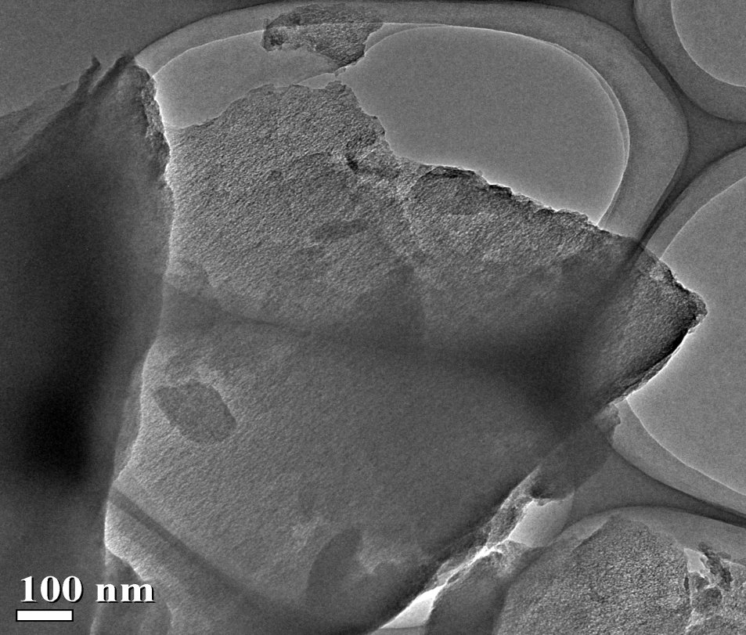

**Figure 2. TEM image of non activated PAN fiber**

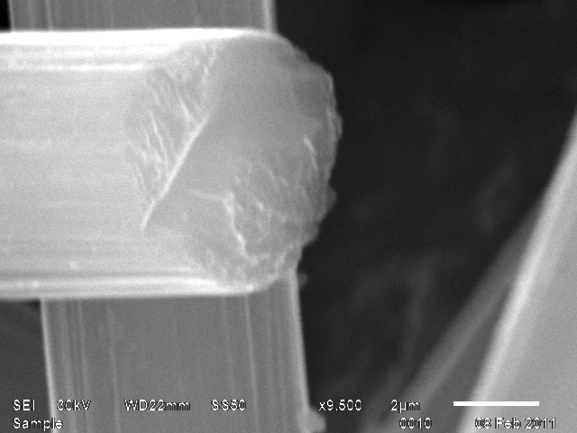

a

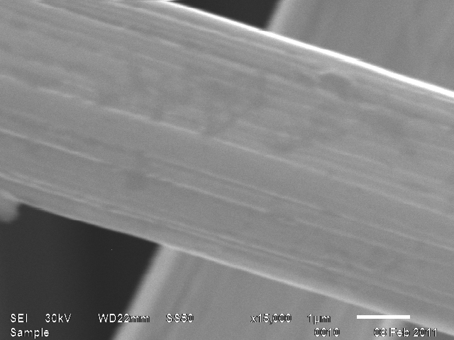

b

**Figure 3. SEM micrographs of the cross sections and external surface of PAN-micro (a) and PAN-mezo (b)**