Synthesis of novel nanocarbons (lead Omsk)

Table 1. Regulation of pore distribution by changing solvent in dehydrochlorination process
(chlorinated polyvinyl chloride was treated with КОН at 20 °С for 5 h.; thermal treatment conditions: carbonization – 400 °С, 30 min; activation - СО₂, 900 °С, 5 min).

Solvent | S BET,  m²/g | HK  calculations |  | Adsorption branch |  | Desorption  branch
 |  | Vmicro, сm³/g | H,  Å | Vmeso, сm³/g | Dmeso,  Å | Vmeso, сm³/g | Dmeso,  Å
dimethyl-sulfoxide | 1009 | 0.40 | 5.8 | 0.79 | 184 | 0.84 | 150
tetra-hydrofurane | 733 | 0.29 | 5.6 | 0.25 | 173 | 0.27 | 99
acetone | 766 | 0.30 | 5.2 | 0.19 | 300 | 0.20 | 212

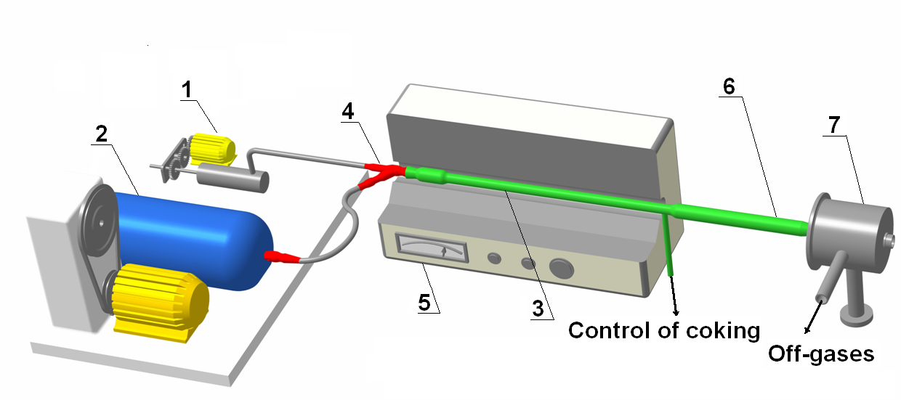
Fig.1. Scheme diagram of laboratory plant for nanoglobular carbon synthesis
1 - piston pump, 2 - compressor, 3 - quartz reactor, 4 - nozzle, 5 - electric furnace,
6 - air cooler, 7 - bag filter.
Catalytic gasoil with a high content of aromatic hydrocarbons and toluene were used as a raw material.
Modifying additives - polyethylenepolyamine and nitrogen-containing aromatic and heterocyclic compounds - were dissolved in the original hydrocarbon in an amount of 10 - 20% wt.

Table 1 Samples characteristics

Modified additives | Quantity of additives, % wt. | Total nitrogen,  Kjeldahl,  % wt | S_{SP},  m²/g,  GOST 25699.2-90 | Iodine number, g/kg,  GOST 25699.3-90 | А_{DBP},  sm³/100g,  GOST 25699.5-90
- | - | 0,2 | 46,6 | 74,2 | 96
Aniline | 20 | 0,7 | 44,2 | 69,2 | 92
Quinoline | 10 | 0,6 | 50,0 | 59,2 | 88
Polyethylene polyamine | 20 | 1,2 | 52,4 | 60,8 | 70
Cobalt phthalocyanine | 0,02 | 0,2 | 38,5 | 60,8 | 80
Cobalt phthalocyanine | 0,1 | 0,4 | 39,3 | 54,2 | 90
Cobalt phthalocyanine | 0,5 | 0,5 | 64,6 | 58 | 90

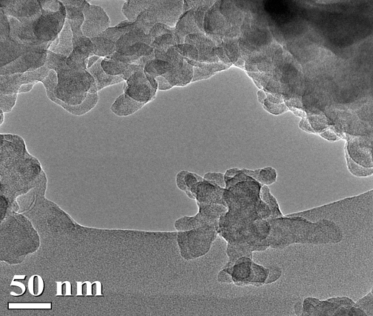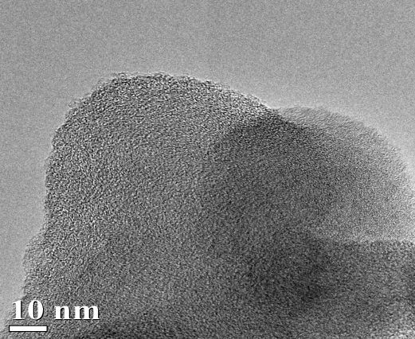
Fig.2. TEM image of nanoglobular carbon from a toluene

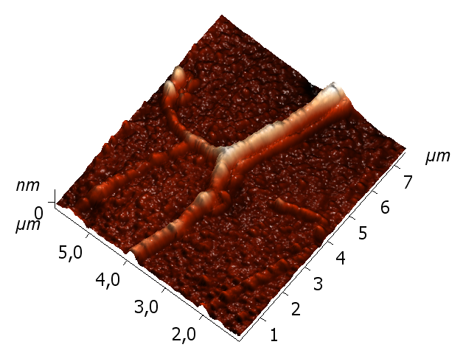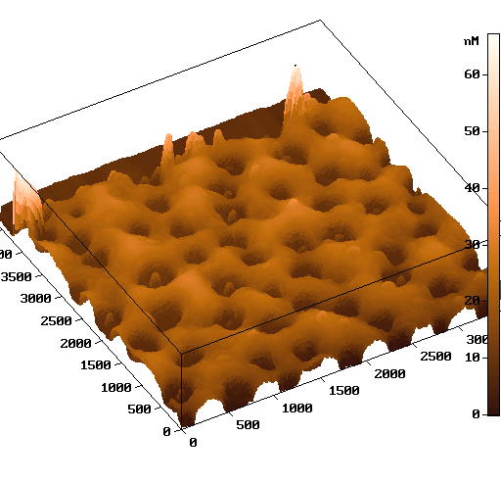
Fig. 1. AFM analysis of carbon films: a) “openwork” carbon coating,
b) carbon-carbon composite with carbon nanotubes on thin carbon film.
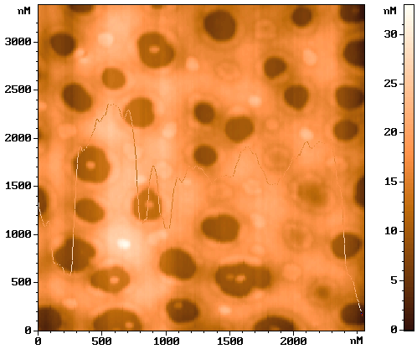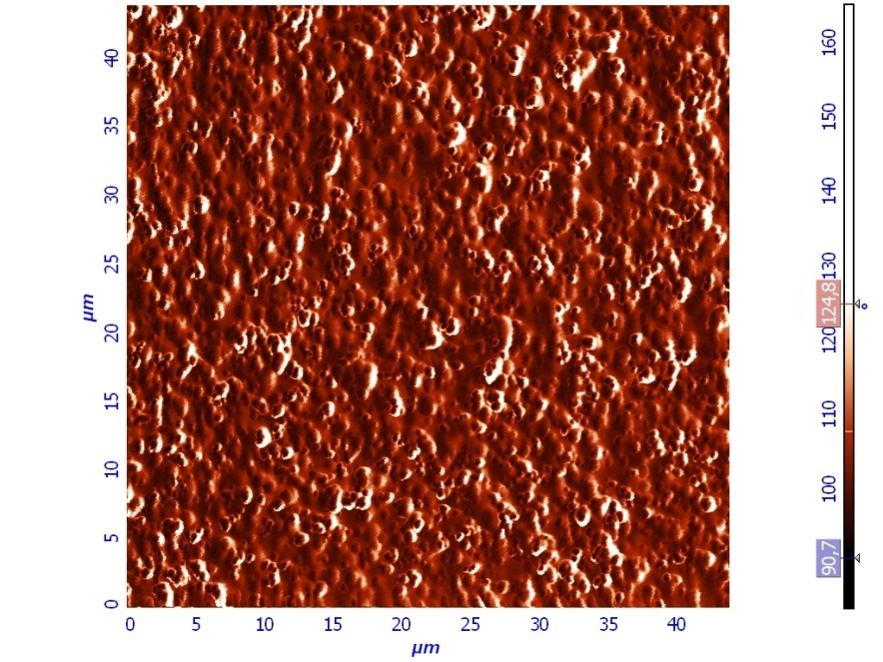
Fig. 2. AFM images: a) “openwork” carbon coating, thin film 10 nm,
b) composite with carbon black nanoparticles distributed in carbon matrix.
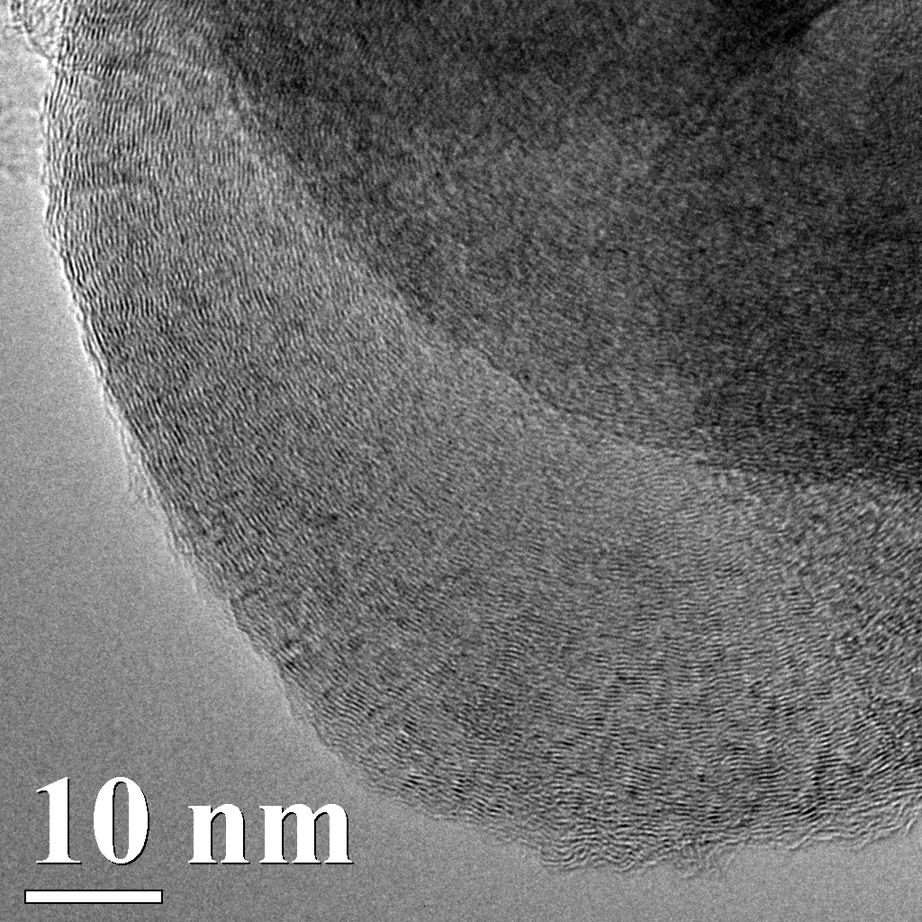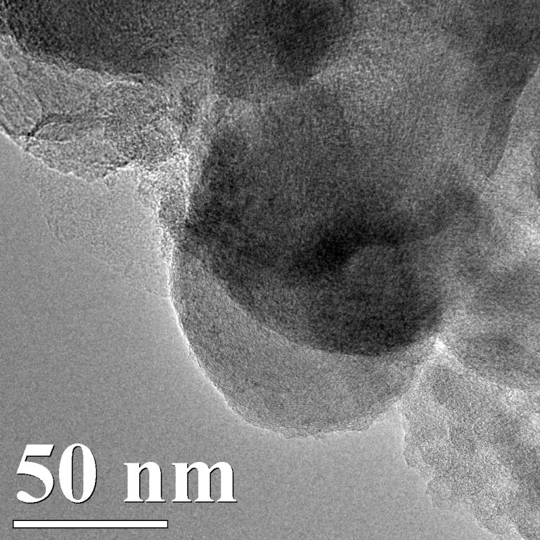
Fig. 3. TEM images of carbon-carbon composite with carbon black
particles distributed in the amorphous carbon matrix

Table 2. Composition and porous structure of carbon material based on polychlorovinylene and diethylamine (activation CO₂, 900 °C)
Agent | N,  % wt | S _{BET},  m²/g | НК method |  | Desorption branch
 |  |  | Vmicro, сm³/g | D,  Å | Vmeso, сm³/g | Dmeso,  Å
КОН | - | 1100 | 0,37 | 8,5 | 0,35 | 50
Diethylamine | 4,8 | 650 | 0,25 | 4,4 | 0,07 | 47

